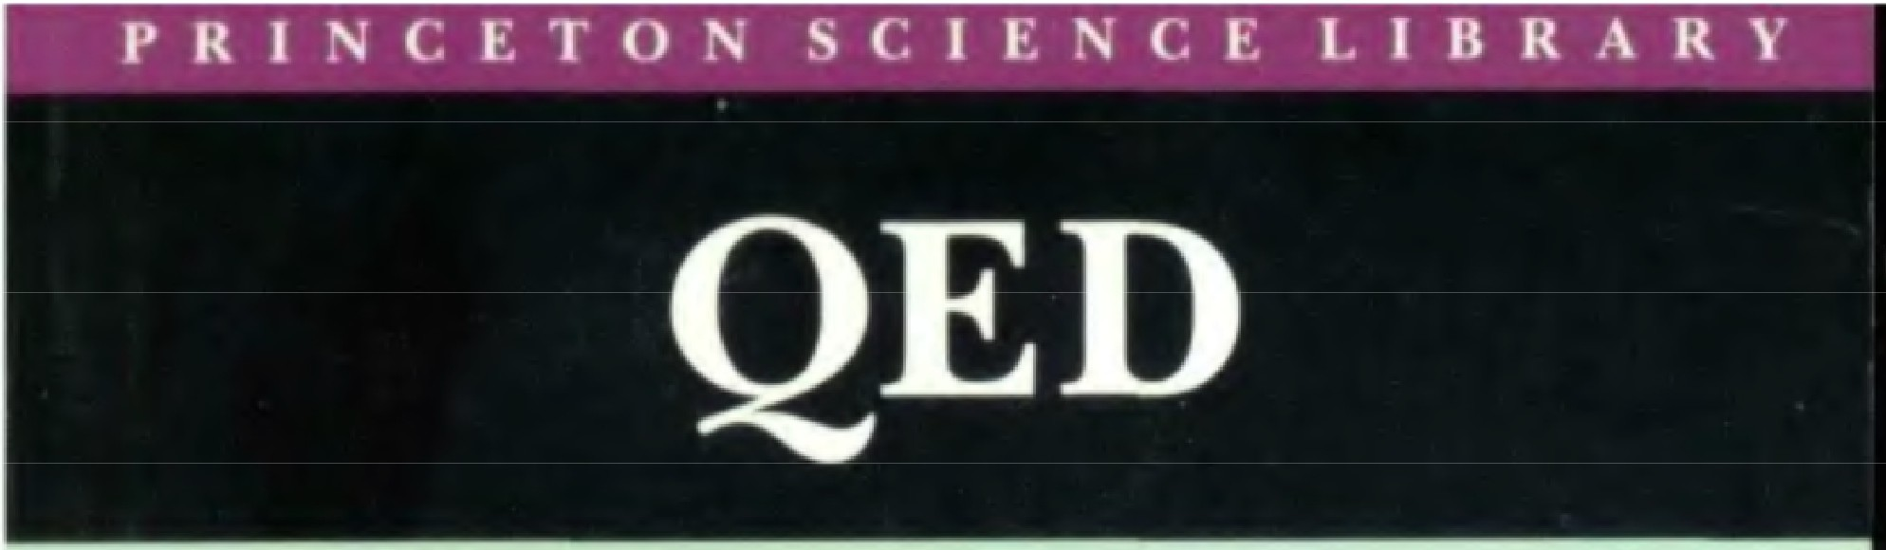
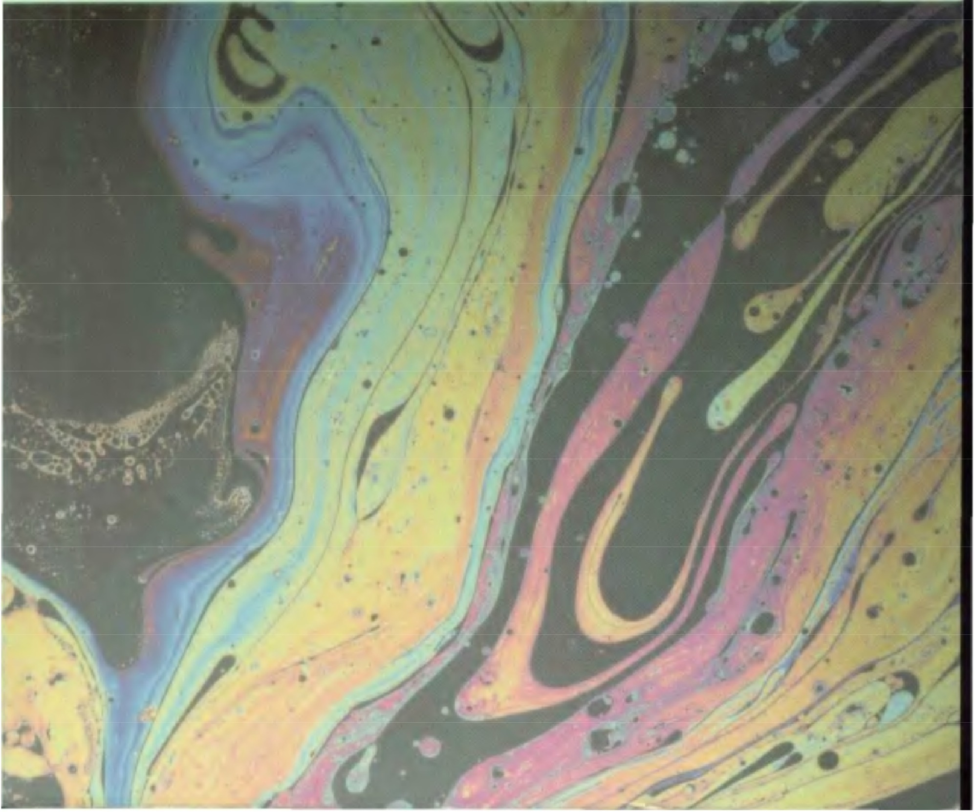


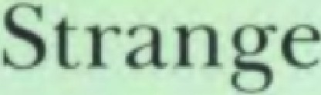

t


i 1
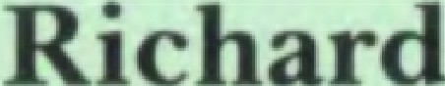
- 

I love this area of physics and I think it's wonderful: it is called quantum electrodynamics, or QED for short
My main purpose in these lectures is to describe as ac-curately as I can the strange theory of light and matter-or more specifically, the interaction of light and electrons. It's going to take a long time to explain all the things I want to. However, there are four lectures, so I'm going to take my time, and we will get everything all right.
Physics has a history of synthesizing many phenomena into a few theories. For instance, in the early days there were phenomena of motion and phenomena of heat; there were phenomena of sound, of light, and of gravity. But it was soon discovered, after Sir Isaac Newton explained the laws of motion, that some of these apparently different things were aspects of the same thing. For example, the phenomena of sound could be completely understood as the motion of atoms in the air. So sound was no longer considered something in addition to motion. It was also discovered that heat phenomena are easily understandable from the laws of motion. In this way, great globs of physics theory were synthesized into a simplified theory. The the-ory of gravitation, on the other hand, was not understand-able from the laws of motion, and even today it stands isolated from the other theories. Gravitation is, so far, not understandable in terms of other phenomena.
After the synthesis of the phenomena of motion, sound, and heat, there was the discovery of a number of phenom-ena that we call electrical and magnetic. In 1873 these phe-nomena were synthesized with the phenomena of light and optics into a single theory by James Clerk Maxwell, who proposed that light is an electromagnetic wave. So at that stage, there were the laws of motion, the laws of electricity and magnetism, and the laws of gravity.
Around 1900 a theory was developed to explain what matter was. It was called the electron theory of matter, and

it said that there were little charged particles inside of atoms. This theory evolved gradually to include a heavy nucleus with electrons going around it.
Attempts to understand the motion of the electrons going around the nucleus by using mechanical laws-anal-ogous to the way Newton used the laws of motion to figure out how the earth went around the sun-were a real failure: all kinds of predictions came out wrong. (Incidentally, the theory of relativity, which you all understand to be a great revolution in physics, was also developed at about that time. But compared to this discovery that Newton's laws of mo-tion were quite wrong in atoms, the theory of relativity was only a minor modification.) Working out another system to replace Newton's laws took a long time because phe-nomena at the atomic level were quite strange. One had to lose one's common sense in order to perceive what was happening at the atomic level. Finally, in 1926, an "uncom-mon-sensy" theory was developed to explain the "new type of behavior" of electrons in matter. It looked cockeyed, but in reality it was not: it was called the theory of quantum mechanics. The word "quantum" refers to this peculiar aspect of nature that goes against common sense. It is this aspect that I am going to tell you about.
The theory of quantum mechanics also explained all
kinds of details, such as why an oxygen atom combines with two hydrogen atoms to make water, and so on. Quantum mechanics thus supplied the theory behind chemistry. So, fundamental theoretical chemistry is really physics.
Because the theory of quantum mechanics could explain all of chemistry and the various properties of substances, it was a tremendous success. But still there was the problem of the interaction of light and matter. That is, Maxwell's theory of electricity and magnetism had to be changed to be in accord with the new principles of quantum mechanics that had been developed. So a new theory, the quantum

theory of the interaction of light and matter, which is called by the horrible name "quantum electrodynamics," was fi-nally developed by a number of physicists in 1929.
But the theory was troubled. If you calculated something roughly, it would give a reasonable answer. But if you tried to compute it more accurately, you would find that the correction you thought was going to be small (the next term in a series, for example) was in fact very large-in fact, it was infinity! So it turned out you couldn't really compute anything beyond a certain accuracy.
By the way, what I have just outlined is what I call a "physicist's history of physics," which is never correct. What I am telling you is a sort of conventionalized myth-story that the physicists tell to their students, and those students tell to their students, and is not necessarily related to the actual historical development, which I do not really know! At any rate, to continue with this "history," Paul Dirac, using the theory of relativity, made a relativistic theory of the electron that did not completely take into account all the effects of the electron's interaction with light. Dirac's theory said that an electron had a magnetic moment-something like the force of a little magnet-that hada strength of ex-actly l in certain units. Then in about 1948 it was discovered in experiments that the actual number was closer to 1.00118 (with an uncertainty of about 3 on the last digit). It was known, of course, that electrons interact with light, so some small correction was expected. It was also expected that this correction would be understandable from the new theory of quantum electrodynamics. But when it was calculated, instead of l.00118 the result was infinity-which is wrong,
experimentally!
Well, this problem of how to calculate things in quantum electrodynamics was straightened out by Julian Schwinger, Sin-Itiro Tomonaga, and myself in about 1948. Schwinger was the first to calculate this correction using a new "shell

game"; his theoretical value was around 1.00116, which was close enough to the experimental number to show that we were on the right track. At last, we had a quantum theory of electricity and magnetism with which we could calculate! This is the theory that I am going to describe to you.
The theory of quantum electrodynamics has now lasted for more than fifty years, and has been tested more and more accurately over a wider and wider range of condi-tions. At the present time I can proudly say that there is no significant difference between experiment and theory!
Just to give you an idea of how the theory has been put through the wringer, I'll give you some recent numbers: experiments have Dirac's number at 1.00115965221 (with an uncertainty of about 4 in the last digit); the theory puts it at l .00115965246 (with an uncertainty of about five times as much). To give you a feeling for the accuracy of these numbers, it comes out something like this: If you were to measure the distance from Los Angeles to New York to this accuracy, it would be exact to the thickness of a human hair. That's how delicately quantum electrodynamics has, in the past fifty years, been checked-both theoretically and experimentally. By the way, I have chosen only one number to show you. There are other things in quantum electro-dynamics that have been measured with comparable ac-curacy, which also agree very well. Things have been checked at distance scales that range from one hundred times the size of the earth down to one-hundredth the size of an atomic nucleus. These numbers are meant to intim-idate you into believing that the theory is probably not too far off! Before we're through, I'll describe how these cal-culations are made.
I would like to again impress you with the vast range of phenomena that the theory of quantum electrodynamics describes: It's easier to say it backwards: the theory de-

scribes all the phenomena of the physical world except the gravitational effect, the thing that holds you in your seats (actually, that's a combination of gravity and politeness, I think), and radioactive phenomena, which involve nuclei shifting in their energy levels. So if we leave out gravity and radioactivity (more properly, nuclear physics), what have we got left? Gasoline burning in automobiles, foam and bubbles, the hardness of salt or copper, the stiffness of steel. In fact, biologists are trying to interpret as much as they can about life in terms of chemistry, and as I already explained, the theory behind chemistry is quantum electro-dynamics.
I must clarify something: When I say that all the phe-nomena of the physical world can be explained by this theory, we don't really know that. Most phenomena we are familiar with involve such tremendous numbers of electrons that it's hard for our poor minds to follow that complexity. In such situations, we can use the theory to figure roughly what ought to happen and that 1S what happens, roughly, in those circumstances. But if we arrange in the laboratory an experiment involving just a few electrons in simple cir-cumstances, then we can calculate what might happen very accurately, and we can measure it very accurately, too. Whenever we do such experiments, the theory of quantum electrodynamics works very well.
We physicists are always checking to see if there is some-
thing the matter with the theory. That's the game, because if there is something the matter, it's interesting! But so far, we have found nothing wrong with the theory of quantum electrodynamics. It is, therefore, I would say, the jewel of physics-our proudest possession.
The theory of quantum electrodynamics is also the pro-totype for new theories that attempt to explain nuclear phenomena, the things that go on inside the nuclei of atoms. If one were to think of the physical world as a stage,

then the actors would be not only electrons, which are out-side the nucleus in atoms, but also quarks and gluons and so forth---dozens of kinds of particles-inside the nucleus. And though these "actors" appear quite different from one another, they all act in a certain style-a strange and pe-culiar style-the "quantum" style. At the end, I'll tell you a little bit about the nuclear particles. In the meantime, I'm only going to tell you about photons-particles of light-andelectrons, to keep it simple. Because it's the way they act that is important, and the way they act is very interesting.
So now you know what I'm going to talk about. The next question is, will you understand what I'm going to tell you? Everybody who comes to a scientific lecture knows they are not going to understand it, but maybe the lecturer has a nice, colored tie to look at. Not in this case! (Feynman is not wearing a tie.)
What I am going to tell you about is what we teach our physics students in the third or fourth year of graduate school-and you think I'm going to explain it to you so you can understand it? No, you're not going to be able to un-derstand it. Why, then, am I going to bother you with all this? Why are you going to sit here all this time, when you won't be able to understand what I am going to say? It is my task to convince you not to turn away because you don't understand it. You see, my physics students don't under-stand it either. That is because I don't understand it. No-body does.
I'd like to talk a little bit about understanding. When we have a lecture, there are many reasons why you might not understand the speaker. One is, his language is bad-he doesn't say what he means to say, or he says it upside down-and it's hard to understand. That's a rather trivial matter, and I'll try my best to avoid too much of my New York accent.

Another possibility, especially if the lecturer is a physicist, is that he uses ordinary words in a funny way. Physicists often use ordinary words such as "work" or "action" or "energy" or even, as you shall see, "light'' for some technical purpose. Thus, when I talk about "work" in physics, I don't mean the same thing as when I talk about "work" on the street. During this lecture I might use one of those words without noticing that it is being used in this unusual way. I'll try my best to catch myself-that's my job--but it is an error that is easy to make.
The next reason that you might think you do not un-derstand what I am telling you is, while I am describing to you how Nature works, you won't understand why Nature works that way. But you see, nobody understands that. I can't explain why Nature behaves in this peculiar way.
Finally, there is this possibility: after I tell you something, you just can't believe it. You can't accept it. You don't like it. A little screen comes down and you don't listen anymore. I'm going to describe to you how Nature is-and if you don't like it, that's going to get in the way of your under-standing it. It's a problem that physicists have learned to deal with: They've learned to realize that whether they like a theory or they don't like a theory is not the essential question. Rather, it is whether or not the theory gives pre-dictions that agree with experiment. It is not a question of whether a theory is philosophically delightful, or easy to understand, or perfectly reasonable from the point of view of common sense. The theory of quantum electrodynamics describes Nature as absurd from the point of view of com-mon sense. And it agrees fully with experiment. So I hope you can accept Nature as She is-absurd.
I'm going to have fun telling you about this absurdity, because I find it delightful. Please don't turn yourself off because you can't believe Nature is so strange. Just hear me all out, and I hope you'll be as delighted as I am when we're through.

How am I going to explain to you the things I don't explain to my students until they are third-year graduate students? Let me explain it by analogy. The Maya Indians were interested in the rising and setting of Venus as a morning "star" and as an evening "star"-they were very interested in when it would appear. After some years of observation, they noted that five cycles of Venus were very nearly equal to eight of their "nominal years" of 365 days (they were aware that the true year of seasons was different and they made calculations of that also). To make calcu-lations, the Maya had invented a system of bars and dots to represent numbers (including zero), and had rules by which to calculate and predict not only the risings and settings of Venus, but other celestial phenomena, such as lunar eclipses.
In those days, only a few Maya priests could do such elaborate calculations. Now, suppose we were to ask one of them how to do just one step in the process of predicting when Venus will next rise as a morning star-subtracting two numbers. And let's assume that, unlike today, we had not gone to school and did not know how to subtract. How would the priest explain to us what subtraction is?
He could either teach us the numbers represented by the bars and dots and the rules for "subtracting" them, or he could tell us what he was really doing: "Suppose we want to subtract 236 from 584. First, count out 584 beans and put them in a pot. Then take out 236 beans and put them to one side. Finally, count the beans left in the pot. That number is the result of subtracting 236 from 584."
You might say, "My Quetzalcoatl! What tedium counting
beans, putting them in, taking them out-what ajob!"
To which the priest would reply, "That's why we have the rules for the bars and dots. The rules are tricky, but they are a much more efficient way of getting the answer than by counting beans. The important thing is, it makes no difference as far as the answer is concerned: we can

predict the appearance of Venus by counting beans (which is slow, but easy to understand) or by using the tricky rules (which is much faster, but you must spend years in school to learn them)."
To understand how subtraction works-as long as you don't have to actually carry it out-is really not so difficult. That's my position: I'm going to explain to you what the physicists are doing when they are predicting how Nature will behave, but I'm not going to teach you any tricks so you can do it efficiently. You will discover that in order to make any reasonable predictions with this new scheme of quantum electrodynamics, you would have to make an aw-ful lot of little arrows on a piece of paper. It takes seven years-four undergraduate and three graduate-to train our physics students to do that in a tricky. efficient way. That's where we are going to skip seven years of education in physics: By explaining quantum electrodynamics co you in terms of what we are really doing, I hope you will be able to understand it better than do some of the students!
Taking the example of the Maya one step further, we could ask the priest why five cycles of Venus nearly equal 2,920 days, or eight years. There would be all kinds of theories about why, such as, "20 is an important number in our counting system, and if you divide 2,920 by 20, you get 146, which is one more than a number that can be represented by the sum of two squares in two different ways," and so forth. But that theory would have nothing to do with Venus, really. In modern times, we have found that theories of this kind are not useful. So again, we are not going to deal with why Nature behaves in the peculiar way that She does; there are no good theories to explain that.
What I have done so far is to get you into the right mood to listen to me. Otherwise, we have no chance. So now we're off, ready to go!

We begin with light. When Newton started looking at light, the first thing he found was that white light is a mix-ture of colors. He separated white light with a prism into various colors, but when he put light of one color-red, for instance-through another prism, he found it could not be separated further. So Newton found that white light is a mixture of different colors, each of which is pure in the sense that it can't be separated further.
(In fact, a particular color of light can be split one more time in a different way, according to its so-called "polari-zation." This aspect of light is not vital to understanding the character of quantum electrodynamics, so for the sake of simplicity I will leave it out-at theexpense of not giving you an absolutely complete description of the theory. This slight simplification will not remove, in any way, any real understanding of what I will be talking about. Still, I must be careful to mention all of the things I leave out.)
When I say "light" in these lectures, I don't mean simply the light we can see, from red to blue. It turns out that visible light is just a part of a long scale that's analogous to a musical scale in which there are notes higher than you can hear and other notes lower than you can hear. The scale of light can be described by numbers---called the fre-quency-and as the numbers get higher, the light goes from red to blue to violet to ultraviolet. We can't see ultraviolet light, but it can affect photographic plates. It's still light-only the number is different. (We shouldn't be so pro-vincial: what we can detect directly with our own instru-ment, the eye, isn't the only thing in the world!) If we continue simply to change the number, we go out into X-rays, gamma rays, and so on. If we change the number in the other direction, we go from blue to red to infrared (heat) waves, then television waves, and radio waves. For me, all of that is "light." I'm going to use just red light for most of my examples, but the theory of quantum electro-

dynamics extends over the entire range I have described, and is the theory behind all these various phenomena.
Newton thought that light was made up of particles-he called them "corpuscles"-and he was right (but the rea-soning that he used to come to that decision was erroneous). We know that light is made of particles because we can take a very sensitive instrument that makes clicks when light shines on it, and if the light gets dimmer, the clicks remain just as loud-there are just fewer of them. Thus light is something like raindrops-each little lump oflight is called a photon-and if the light is all one color, all the "rain-drops" are the same size.
The human eye is a very good instrument: it takes only about five or six photons to activate a nerve cell and send a message to the brain. If we were evolved a little further so we could see ten times more sensitively, we wouldn't have to have this discussion-we would all have seen very dim light of one color as a series of intermittent little flashes of equal intensity.
You might wonder how it is possible to detect a single photon. One instrument that can do this is called a pho-tomultiplier, and I'll describe briefly how it works: When a photon hits the metal plate A at the bottom (see Figure 1), it causes an electron to break loose from one of the atoms in the plate. The free electron is strongly attracted to plate B (which has a positive charge on it) and hits it with enough force to break loose three or four electrons. Each of the electrons knocked out of plate B is attracted to plate C (which is also charged), and their collision with plate C knocks loose even more electrons. This process is repeated ten or twelve times, until billions of electrons, enough to make a sizable electric current, hit the last plate,
L. This current can be amplified by a regular amplifier and sent through a speaker to make audible clicks. Each time

a photon of a given color hits the photomultiplier, a click of uniform loudness is heard.
If you put a whole lot of photomultipliers around and let some very dim light shine in various directions, the light goes into one multiplier or another and makes a click of full intensity. It is all or nothing: if one photomultiplier

FIGURE I. A photomultiplier can detect a single photon. When a photon strikes plate A, an electron is knocked loose and attracted to positively charged plate B, knocking more elec-trons loose. This process continues until bil-lions of electrons strike the last plate, L, and produce an electric current, which is amplified by a regular amplifier. If a speaker is connected to the amplifier, clicks of uniform loudness are heard each time a photon of a given color hits plate A.

L
l �Peal<er
C\�'s
A� one photon

goes off at a given moment, none of the others goes off at the same moment (except in the rare instance that two photons happened to leave the light source at the same time). There is no splitting of light into "half particles" that go different places.
I want to emphasize that light comes in this form-par-ticles. It is very important to know that light behaves like particles, especially for those of you who have gone to school, where you were probably told something about light behaving like waves. I'm telling you the way it does behave-like particles.
You might say that it's just the photomultiplier that de-tects light as particles, but no, every instrument that has been designed to be sensitive enough to detect weak light has always ended up discovering the same thing: light is made of particles.

I am going to assume that you are familiar with the prop-erties of light in everyday circumstances-things like, light goes in straight lines; it bends when it goes into water; when it is reflected from a surface like a mirror, the angle at which the light hits the surface is equal to the angle at which it leaves the surface; light can be separated into colors; you can see beautiful colors on a mud puddle when there is a little bit of oil on it; a lens focuses light, and so on. I am going to use these phenomena that you are familiar with in order to illustrate the truly strange behavior of light; I am going to explain these familiar phenomena in terms of the theory of quantum electrodynamics. I told you about the photomultiplier in order to illustrate an essential phe-nomenon that you may not have been familiar with-that light is made of particles-but by now, I hope you are familiar with that, too!
Now, I think you are all familiar with the phenomenon
that light is partly reflected from some surfaces, such as water. Many are the romantic paintings of moonlight re-flecting from a lake (and many are the times you got your-self in trouble because of moonlight reflecting from a lake!). When you look down into water you can see what's below the surface (especially in the daytime), but you can also see a reflection from the surface. Glass is another example: if you have a lamp on in the room and you're looking out through a window during the daytime, you can see things outside through the glass as well as a dim reflection of the lamp in the room. So light is partially reflected from the surface of glass.
Before I go on, I want you to be aware of a simplification I am going to make that I will correct later on: When I talk about the partial reflection of light by glass, I am going to pretend that the light is reflected by only the surface of the glass. In reality, a piece of glass is a terrible monster of complexity-huge numbers of electrons are jiggling about.

When a photon comes down, it interacts with electrons throughout the glass, not just on the surface. The photon and electrons do some kind of dance, the net result of which is the same as if the photon hit only the surface. So let me make that simplification for a while. Later on, I'll show you what actually happens inside the glass so you can under-stand why the result is the same.
Now I'd like to describe an experiment, and tell you its surprising results. In this experiment some photons of the same color-let's say, red light-are emitted from a light source (see Fig. 2) down toward a block of glass. A pho-tomultiplier is placed at A, above the glass, to catch any

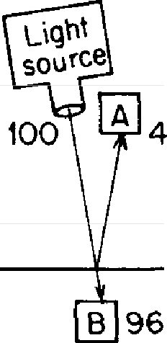
FIG u RE 2. An experiment lo measure the partial reflection of light by a smg/,e surface of glass. For every JOO photons that /,eave the light source, 4 are reflected by the front surface and end up in the photomultiplier at A, while the other 96 are transmitted by the front sur-face and end up in the photomultiplier at B.

GLASS

photons that are reflected by the front surface. To measure how many photons get past the front surface, another pho-tomultiplier is placed at B, inside the glass. Never mind the obvious difficulties of putting a photomultiplier inside a block of glass; what are the results of this experiment?
For every I00 photons that go straight down toward the glass at 90°, an average of 4 arrive at A and 96 arrive at B. So "partial reflection" in this case means that 4% of the pho-tons are reflected by the front surface of the glass, while the other 96% are transmitted. Already we are in great diffi-culty: how can light be partly reflected? Each photon ends

up at A or B-how does the photon "make up its mind" whether it should go to A or B? (Audience laughs.) That may sound like a joke, but we can't just laugh; we're going to have to explain that in terms of a theory! Partial reflec-tion is already a deep mystery, and it was a very difficult problem for Newton.
There are several possible theories that you could make up to account for the partial reflection of light by glass. One of them is that 96% of the surface of the glass is "holes" that let the light through, while the other 4% of the surface is covered by small "spots" of reflective material (see Fig. 3). Newton realized that this is not a possible explanation.1 In just a moment we will encounter a strange feature of partial reflection that will drive you crazy if you try to stick to a theory of "holes and spots"--or to any other reasonable theory!
Another possible theory is that the photons have some kind of internal mechanism-"wheels" and "gears" inside that are turning in some way-so that when a photon is "aimed" just right, it goes through the glass, and when it's not aimed right, it reflects. We can check this theory by trying to filter out the photons that are not aimed right by putting a few extra layers of glass between the source and the first layer of glass. After going through the filters, the photons reaching the glass should all be aimed right, and
1 How did he know? Newton was a very great man: he wrote, "Because I can polish glass." You might wonder, how the heck could he tell that because you can polish glass, it can't be holes and spots? Newton polished his own lenses and mirrors, and he knew what he was doing with polishing: he was making scratches on the surface of a piece of glass with powders of increasing fineness. As the scratches become finer and finer, the surface of the glass changes its appearance from a dull grey (because the hght is scattered by the large scratches), to a transparent clanty (because the extremely fine scratches let the light through). Thus he saw that it is impossible to accept the proposition that light can be affected by very small irregularities such as scratches or holes and spots; m fact, he found the contrary to be true. The finest scratches and therefore equally small spots do not affect the light. So the holes and spots theory is no good.

none of them should reflect. The trouble with that theory is, it doesn't agree with experiment: even after going through many layers of glass, 4% of the photons reaching a given surface reflect off it.
Try as we might to invent a reasonable theory that can

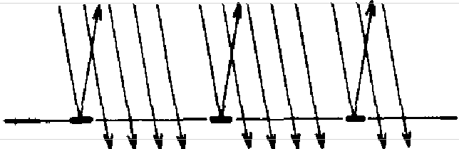
GLASS
FIGURE 3. One theory to explain partzal reflection b-y a single suiface involves a suiface made up mainly of "holes" that let light through, with a few "spots" that reflect the light.

explain how a photon "makes up its mind" whether to go through glass or bounce back, it is impossible to predict which way a given photon will go. Philosophers have said that if the same circumstances don't always produce the same results, predictions are impossible and science will collapse. Here is a circumstance-identical photons are al-ways coming down in the same direction to the same piece of glass-that produces different results. We cannot predict whether a given photon will arrive at A or B. All we can predict is that out of 100 photons that come down, an average of 4 will be reflected by the front surface. Does this mean that physics, a science of great exactitude, has been reduced to calculating only the probability of an event, and not predicting exactly what will happen? Yes. That's a retreat, but that's the way it is: Nature permits us to cal-culate only probabilities. Yet science has not collapsed.
While partial reflection by a single surface is a deep mystery and a difficult problem, partial reflection by two or more surfaces is absolutely mind-boggling. Let me

show vou why. We'll do a second experiment, in which we will measure the partial reflection of light by two surfaces. We replace. the block of glass with a very thin sheet of glass-its two surfaces are exactly parallel to each other-andwe place the photomultiplier below the sheet of glass, in line with the light source. This time, photons can reflect from either the front surface or the back surface to end up at A; all the others will end up at B (see Fig. 4). We might

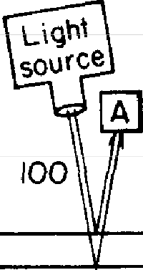
Otol6

B 100 to 94, •.,
FIGURE 4. An experiment to measure the par-tial reflection of light by two surfaces of glass. Photons can get to the photomultiplier at A by reflecting off either the front surface or the back surface of the sheet of glass; alternatively, they cou/.d go through both surfaces and end up hitting the photomultiplier at B. Depending on the thick-ness of the glass, 0 to 16 photons out of every 100 get to the photomultiplier at A. These results pose difficulties for any reasonable theory, including the one in Figure 3. It appears that partial re-flection can be "turned off" or "amplified'' by the presence of an additional surface.

expect the front surface to reflect 4% of the light and the back surface to reflect 4% of the remaining 96%, making a total of about 8%. So we should find that out of every 100 photons that leave the light source, about 8 arrive at A.
What actually happens under these carefully controlled experimental conditions is, the number of photons arriving at A is rarely 8 out of 100. With some sheets of glass, we consistently get a reading of 15 or 16 photons-twice our expected result! With other sheets of glass, we consistently get only I or 2 photons. Other sheets of glass have a partial reflec-tion of I 0%; some eliminate partial reflection altogether! What can account for these crazy results? After checking the various sheets of glass for quality and uniformity, we discover that they differ only slightly in their thickness.

To test the idea that the amount of light reflected by two surfaces depends on the thickness of the glass, let's do a series of experiments: Starting out with the thinnest possi-ble layer of glass, we'll count how many photons hit the photomultiplier at A each time I00 photons leave the light source. Then we'll replace the layer of glass with a slightly thicker one and make new counts. After repeating this process a few dozen times, what are the results?
With the thinnest possible layer of glass, we find that the number of photons arriving at A is nearly always zero---sometimes it's 1. When we replace the thinnest layer with a slightly thicker one, we find that the amount of light reflected is higher�loser to the expected 8%. After a few more replacements the count of photons arriving at A in-creases past the 8% mark. As we continue to substitute still
"thicker" layers of glass-we're up to about 5 millionths of an inch now-the amount of light reflected by the two sur-faces reaches a maximum of 16%, and then goes down, through 8%, back to zero-if the layer of glass is just the right thickness, there is no reflection at all. (Do that with spots!)
With gradually thicker and thicker layers of glass, partial reflection again increases to 16% and returns to zero---a cycle that repeats itself again and again (see Fig. 5). Newton discovered these oscillations and did one experiment that could be correctly interpreted only if the oscillations contin-ued for at least 34,000 cycles! Today, with lasers (which pro-duce a very pure, monochromatic light), we can see this cycle still going strong after more than 100,000,000 repeti-tions-which corresponds to glass that is more than 50 me-ters thick. (We don't see this phenomenon every day be-cause the light source is normally not monochromatic.)
So it turns out that our prediction of 8% is right as an overall average (since the actual amount varies in a regular pattern from zero to 16%), but it's exactly right only twice each cycle-like a stopped clock (which is right twice a day).

How can we explain this strnnge feature of partial reflection that depends on the thickness of the glass? How can the front surface reflect 4% of the light (as confirmed in our first experiment} when, by putting a second surface at just the right distance below, we can somehow "turn off" the

Percentage of reflection
::�

16%b

Thickness of glass --
F1cuRE 5. The results of an experiment carefully measuring the relationship between the thickness of a sheet of glass and partial reflection demonstrate a phenomenon called "interference." As the thickness of the glass increases, partial reflection goes through a repeating cycle of zero to 16%, with no signs of dying out.

reflection? And by placing that second surface at a slightly different depth, we can "amplify" the reflection up to 16% I Can it be that the back surface exerts some kind of influence or effect on the ability of the front surface to reflect light? What if we put in a third surface?
With a third surface, or any number of subsequent sur-faces, the amount of partial reflection is again changed. We find ourselves chasing down through surface after surface with this theory, wondering if we have finally reached the last surface. Does a photon have to do that in order to "decide" whether to reflect off the front surface?
Newton made some ingenious arguments concerning this problem,2 but he realized, in the end, that he had not yet developed a satisfactory theory.
2 It is very fortunate for us that Newton convinced himself that light is "corpuscles," because we can see what a fresh and intelligent mind looking

For many years after Newton, partial reflection by two surfaces was happily explained by a theory of waves,3 but when experiments were made with very weak light hitting photomultipliers, the wave theory collapsed: as the light got dimmer and dimmer, the photomultipliers kept making

at this phenomenon of partial reflection by two or more surfaces has to go through to try to explain it. (Those who believed that light was waves never had to wrestle with it.) Newton argued as follows: Although light appears to be reflected from the first surface, it cannot be reflected from that surface. If it were, then how could light reflected from the first surface be captured again when the thickness is such that there was supposed to be no reflection at all? Then light must be reflected from the second surface. But to account for the fact that the thickness of the glass deter-mines the amount of partial reflection, Newton proposed this idea: Light striking the first surface sets off a kind of wave or field that travels along with the light and predisposes it to reflect or not reflect off the second surface. He called this process "fits of easy reflection or easy transmission'' that occur in cycles, depending on the thickness of the glass.
There are two difficulties with this idea: the first is the effect of addi-tional surfaces-each new surface affects the reflection-which I described in the text. The other problem is that light certainly reflects off a lake, which doesn't have a second surface, so light must be reflecting off the front surface. In the case of single surfaces, Newton said that light had a predisposition to reflect. Can we have a theory in which the light knows what kind of surface it is hitting, and whether it is the only surface?
Newton didn't emphasize these difficulties with his theory of "fits of reflection and transmission," even though it is clear that he knew his theory was not satisfactory. In Newton's time, difficulties with a theory were dealt with briefly and glossed over-a different style from what we are used to in science today, where we point out the places where our own theory doesn't fit the observations of experiment. I'm not trying to say anything against Newton; I just want to say something in favor of how we com-municate with each other in science today.
3 This idea made use of the fact that waves can combine or cancel out, and the calculations based on this model matched the results of Newton's experiments, as well as those done for hundreds of years afterwards. But when instruments were developed that were sensitive enough to detect a single photon, the wave theory predicted that the "clicks"of the photo-multiplier would get softer and softer, whereas they stayed at full strength-they just occurred less and less often. No reasonable model could explain this fact, so there was a period for a while in which you had to be clever: You had to know which experiment you were analyzing in order to tell if light was waves or particles. This state of confusion was called the "wave-particle duality" of light, and it was jokingly said by someone that light was waves on Mondays, Wednesdays, and Fridays; it was particles on Tuesdays, Thursdays, and Saturdays, and on Sundays, we think about it! It is the purpose of these lectures to tell you how this puzzle was finally "resolved."

full-sized clicks-there were just fewer of them. Light be-haved as particles.
The situation today is, we haven't got a good model to explain partial reflection by two surfaces; we just calculate the probability that a particular photomultiplier will be hit by a photon reflected from a sheet of glass. I have chosen this calculation as our first example of the method provided by the theory of quantum electrodynamics. I am going to show you "how we count the beans"-what the physicists do to get the right answer. I am not going to explain how the photons actually "decide" whether to bounce back or go through; that is not known. (Probably the question has no meaning.) I will only show you how to calculate the correct probability that light will be reflected from glass of a given thickness, because that's the only thing physicists know how to do! What we do to get the answer to this problem is analogous to the things we have to do to get the answer to every other problem explained by quantum electrodynamics.
You will have to brace yourselves for this-not because
it is difficult to understand, but because it is absolutely ridiculous: All we do is draw little arrows on a piece of paper-that's all!
Now, what does an arrow have to do with the chance that a particular event will happen? According to the rules of "how we count the beans," the probability of an event is equal to the square of the length of the arrow. For example, in our first experiment (when we were measuring partial reflection by the front surface only), the probability that a photon would arrive at the photomultiplier at A was 4%. That corresponds to an arrow whose length is 0.2, because
0.2 squared is 0.04 (see Fig. 6).
In our second experiment (when we were replacing thin sheets of glass with slightly thicker ones), photons bouncing off either the front surface or the back surface arrived at

A. How do we draw an arrow to represent this situation? The length of the arrow must range from zero to 0.4 to represent probabilities of zero to 16%, depending on the thickness of the glass (see Fig. 7).
We start by considering the various ways that a photon

FIGURE 6. The strange feature of partial reflection by two surfaces has forced physicists away from making ab-solute predictions to merely calculating the probability of an event. Quantum electrodynamics provides a method for domg this-drawing little arrows on a piece of paper. The probability of an event is represented by the area of the square on an arrow. For example, an arrow repre-senting a probability of 0.04 (4%) has a length of 0.2.

�
�-2

could get from the source to the photomultiplier at A. Since I am making this simplification that the light bounces off either the front surface or the back surface, there are two possible ways a photon could get to A. What we do in this case is to draw two arrows-one for each way the event can happen-and then combine them into a "final arrow"
0 2
16¾
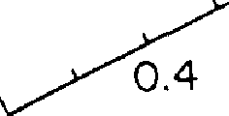
� 0.1 [J
0%
()
0
03

FIGURE 7. Arrows representing probabilities from 0% lo 16% have lengths of from O to 0.4.

whose square represents the probability of the event. If there had been three different ways the event could have happened, we would have drawn three separate arrows before combinmg them.
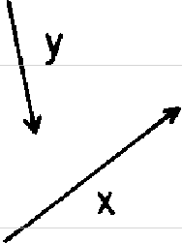
Now, let me show you how we combine arrows. Let's say we want to combine arrow x with arrow y (see Fig. 8). All

Dy
final arrow
FIGURE 8 Arrows that represent each possible way an event could happen are drawn and then combined ("added") m the following manner At-tach the head of one arrow to the tail of another� without changing the direction of either one-and draw a "final arrow" from the tail of the first arrow to the head of the last one

we have to do is put the head of x against the tail of y (without changing the direction of either one), and draw the final arrow from the tail of x to the head of y. That's all there is to it. We can combine any number of arrows in this manner (technically, it's called "adding arrows"). Each arrow tells you how far, and in what direction, to move in a dance. The final arrow tells you what single move to make to end up in the same place (see Fig. 9).
Now, what are the specific rules that determine the length and direction of each arrow that we combine in order to make the final arrow? In this particular case, we will be combining two arrows-one representing the reflection from the front surface of the glass, and the other repre-senting the reflection from the back surface.
Let's take the length first. As we saw in the first experi-

ment (where we put the photomultiplier inside the glass), the front surface reflects about 4% of the photons that come down. That means the "front reflection" arrow has a length of 0.2. The back surface of the glass also reflects 4%, so the "back reflection" arrow's length is also 0.2.

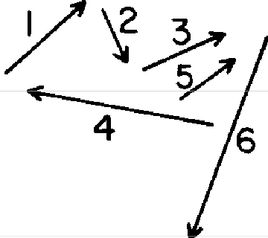
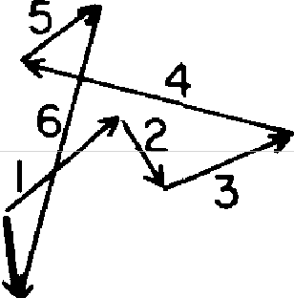
final
orrow

*
fIGUU 9. Any ni,aber of arrows can be added
M
-.anner describltl in Figure 8
To determine the direction of each arrow, let's imagine that we have a stopwatch that can time a photon as it moves. This imaginary stopwatch has a single hand that turns around very, very rapidly. When a photon leaves the source, we start the stopwatch. As long as the photon moves, the stopwatch hand turns (about 36,000 times per inch for red light); when the photon ends up at the photo-multiplier, we stop the watch. The hand ends up pomting in a certain direction. That 1s the dtrectlon we will draw the arrow.
We need one more rule in order to compute the answer correctly: When we are considering the path of a photon bouncing off the front surface of the glass, we reverse the direction of the arrow. In other words, whereas we draw the back reflection arrow pointing in the same direction as the stopwatch hand, we draw the front reflection arrow in the opposite direction.
Now, let's draw the arrows for the case of light reflecting from an extremely thin layer of glass. To draw the front

28 Chapter I
reflection arrow, we imagine a photon leaving the light source (the stopwatch hand starts turning), bouncing off the front surface, and arriving at A (the stopwatch hand stops). We draw a little arrow of length 0.2 in the direction opposite that of the stopwatch hand (see Fig. 10).

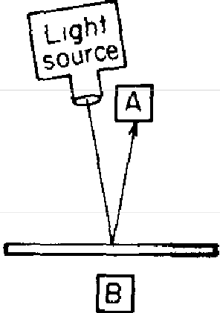
stopwatch
E)

_5?.1--
front reflect1on arrow
FIG URE 10. In an experiment measuring reflection by two sur-faceJ, we can say that a single photon can arrive at A in two ways-via the front or back surface. An arrow of length 0.2 is drawn for each way, with its direction de-termined by the hand of a "stop-watch" that times the photon as it moves. The ''front reflection" arrow is drawn in the direction opposite to that of the stopwatch hand when it stops turning.

To draw the back reflection arrow, we imagine a photon leaving the light source (the stopwatch hand starts turning), going through the front surface and bouncing off the back surface, and arriving at A (the stopwatch hand stops). This time, the stopwatch hand is pointing in almost the same direction, because a photon bouncing off the back surface of the glass takes only slightly longer to get to A-it goes through the extremely thin layer of glass twice. We now draw a little arrow of length 0.2 in the same direction that the stopwatch hand is pointing (see Fig. 11).
Now let's combine the two arrows. Since they are both the same length but pointing in nearly opposite directions, the final arrow has a length of nearly zero, and its square is even closer to zero. Thus, the probability of light reflect-ing from an infinitesimally thin layer of glass is essentially zero (see Fig. 12).

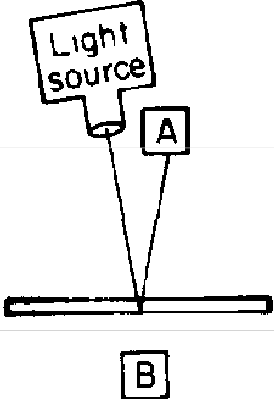
FIGURE 11. A photon bovncmg off the back surface of a thin layer of glass takes slightly longer to get to A. Thus, the stopwatch hand ends up in a slightly different direction than it did when it timed the front reflection photon. The "back reflec-tion" arrow is drawn in the same direction as the sto-pwatch hand.
E)
stopwatch

02
back reflection arrow

0.2

.0025�
FIGURE 12. The final arrow, whose square represents the probability of reflection lry an extremely thin layer of glass, is drawn by adding the front reflection arrow and the back reflection arrow. The result 1S nearly zero.

When we replace the thinnest layer of glass with a slightly thicker one, the photon bouncing off the back surface takes a little bit longer to get to A than in the first example; the stopwatch hand therefore turns a little bit more before it stops, and the back reflection arrow ends up in a slightly greater angle relative to the front reflection arrow. The final arrow is a little bit longer, and its square is corre-spondingly larger (see Fig. 13).
As another example, let's look at the case where the glass is just thick enough that the stopwatch hand makes an extra half turn as it times a photon bouncing off the back surface. This time, the back reflection arrow ends up pointing in exactly the same direction as the front reflection arrow. When we combine the two arrows, we get a final arrow whose length is 0.4, and whose square is 0.16, representing a probability of 16% (see Fig. 14).
If we increase the thickness of the glass just enough so

30 Chapter 1

stopwatch
E)

front ref lect1on arrow

stopwatch
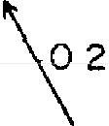
back reflection
or row
0
FIGURE 13. The final arrow for a slightly thicker sheet of glass is a little longer, due to the greater relative angle between the front and back reflectwn ar-rows This is because a photon boucing off the back surface takes a lzttle longer to reach A, compared to the previous example

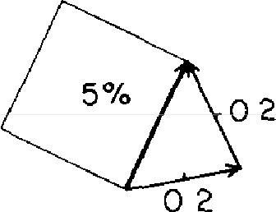

stopwatch stopwatch
---

02 �
FIGURE 14. Whenthelayerof glass zs;ust thick enough to allow the stopwatch hand timing the back reflecting photon to make an extra half turn, the front and back reflection arrows end up pointing in the same direction, resulting in a final arrow of length O 4, which represents a probability of 16%.

front reflection arrow
0 G
back reflectron
arrow

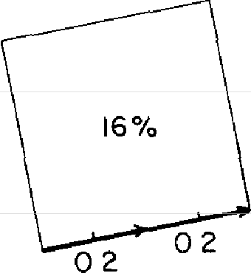

that the stopwatch hand timing the back surface path makes an extra full turn, our two arrows end up pointing in op-posite directions again, and the final arrow will be zero (see Fig. 15). This situation occurs over and over, whenever the thickness of the glass is just enough to let the stopwatch hand timing the back surface reflection make another full turn.

FIGURE 15. When the sheet of glass zs JUSt the right thickness to allow the stop-watch hand timing the back reflecting photon to make one
E) E)

or more extra full turns, the final arrow zs again zero, and there zs no reflectzon at all.
stopwatch

02 .-

ffont reflect 10n arrow
stopwatch

02
�
back reflection arrow

02
0�

If the thickness of the glass is just enough to let the stopwatch hand timing the back surface reflection make an extra¼ or¾ of a turn, the two arrows will end up at right angles. The final arrow in this case is the hypoteneuse of a right triangle, and according to Pythagoras, the square on the hypoteneuse is equal to the sum of the squares on
the other two sides. Here is the value that's right "twice a day"- 4% + 4% makes 8% (see Fig. 16).
Notice that as we gradually increase the thickness of the glass, the front reflection arrow always points in the same direction, whereas the back reflection arrow gradually changes its direction. The change in the relative direction of the two arrows makes the final arrow go through a re-

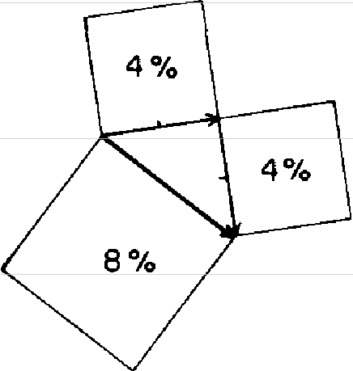
FIGURE 16. When the front and back reflec-tion arrows are at nght angles to each other, the final arrow IS the hypoteneu.se ofa nght tnangle. Thu.s its square IS the sum of the other two squares-8%.


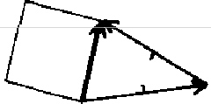
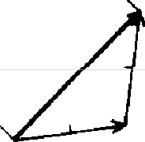

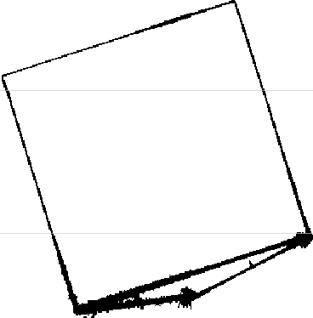
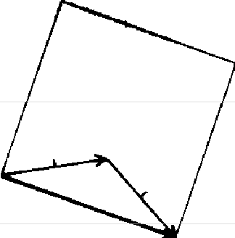

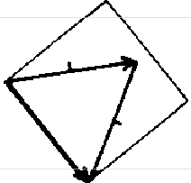
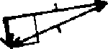
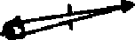

FIGURE I 7. As thin sheets of glass are replaced by slightly thicker ones, the stopwatch hand timing a photon reflecting off the back surface turns slightly more, and the relative angle between the front and back reflection arrows changes Th1S cau.ses the final arrow to change zn length, and its square to change m size from Oto 16% back to 0, over and over

peating cycle of length zero to 0.4; thus the square on the final arrow goes through the repeating cycle of zero to 16% that we observed in our experiments (see Fig. 17).
I have just shown you how this strange feature of partial reflection can be accurately calculated by drawing some damned little arrows on a piece of paper. The technical word for these arrows is "probability amplitudes," and I feel more dignified when I say we are "computing the prob-ability amplitude for an event." I prefer, though, to be more honest, and say that we are trying to find the arrow whose square represents the probability of something happening. Before I finish this first lecture, I would like to tell you about the colors you see on soap bubbles. Or better, if your car leaks oil into a mud puddle, when you look at the brownish oil in that dirty mud puddle, you see beautiful colors on the surface. The thin film of oil floating on the mud puddle is something like a very thin sheet of glass-it reflects light of one color from zero to a maximum, de-pending on its thickness. If we shine pure red light on the film of oil, we see splotches of red light separated by narrow bands of black (where there's no reflection) because the oil film's thickness is not exactly uniform. If we shine pure blue light on the oil film, we see splotches of blue light separated by narrow bands of black. If we shine both red and blue light onto the oil, we see areas that have just the right thickness to strongly reflect only red light, other areas of the right thickness to reflect only blue light; still other areas have a thickness that strongly reflects both red and blue light (which our eyes see as violet), while other areas have the exact thickness to cancel out all reflection, and
appear black.
To understand this better, we need to know that the cycle of zero to 16% partial reflection by two surfaces repeats more quickly for blue light than for red light. Thus at

certain thicknesses, one or the other or both colors are strongly reflected, while at other thicknesses, reflection of both colors is cancelled out (see Fig. 18). The cycles of reflection repeat at different rates because the stopwatch hand turns around faster when it times a blue photon than

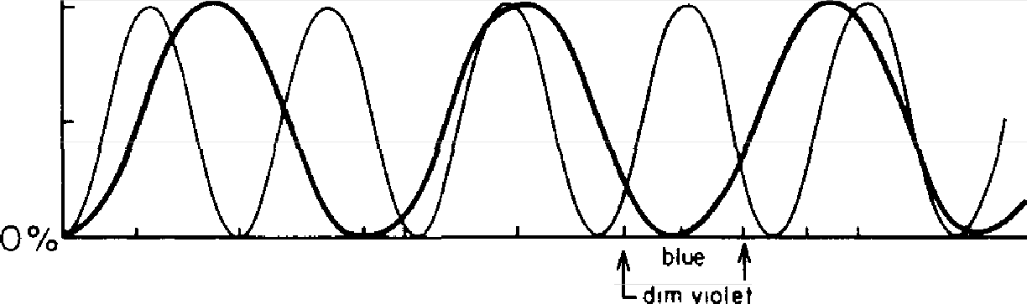
Percentage of Reflection

16%

8%
t

-red
-blue

bluish red violet
blue black violet (dim violet l

Th1ckness-
VIOiet block reddish VIOiet

F1GuRE 18. As the thickness of a layer increases, the two surfaces produce a partwl reflection of monochromatic light whose probalnlzty fluctuates m a cycle from 0% to 16% Smee the speed of the imaginary stopwatch hand zs different for different colors of light, the cycle repeats itself at different rates. Thus when two colors such as pure red and pure blue are aimed at the layer, a given thickness will reflect only red, only blue, both red and blue zn different proportions (which produce vanous hues of violet), or neither color (black). If the layer zs of varying thicknesses, such as a drop of oil spreading out on a mud puddle, all of the combinations will occur In sunlight, which consists of all colors, all sorts of combznatzons occur, which produce lots of colors

it does when timing a red photon. In fact, that's the only difference between a red photon and a blue photon (or a photon of any other color, including radio waves, X-rays, and so on)-the speed of the stopwatch hand.
When we shine red and blue light on a film of oil, patterns of red, blue, and violet appear, separated by borders of black. When sunlight, which contains red, yellow, green,

and blue light, shines on a mud puddle with oil on it, the areas that strongly reflect each of those colors overlap and produce all kinds of combinations which our eyes see as different colors. As the oil film spreads out and moves over the surface of the water, changing its thickness in various locations, the patterns of color constantly change. (If, on the other hand, you were to look at the same mud puddle at night with one of those sodium streetlights shining on it, you would see only yellowish bands separated by black-because those particular streetlights emit light of only one color.)
This phenomenon of colors produced by the partial re� flection of white light by two surfaces is called iridescence, and can be found in many places. Perhaps you have won-dered how the brilliant colors of hummingbirds and pea-cocks are produced. Now you know. How those brilliant colors evolved is also an interesting question. When we admire a peacock, we should give credit to the generations of lackluster females for being selective about their mates. (Man got into the act later and streamlined the selection process in peacocks.)
In the next lecture I will show you how this absurd proc� ess of combining little arrows computes the right answer for those other phenomena you are familiar with: light travels in straight lines; it reflects off a mirror at the same angle that it came in ("the angle of incidence is equal to the angle of reflection"); a lens focuses light, and so on. This new framework will describe everything you know about light.

2

Photons: Particles of Light

This is the second in a series of lectures about quantum electrodynamics, and since it's clear that none of you were here last time (because I told everyone that they weren't going to understand anything), I'll briefly summarize the first lecture.
We were talking about light. The first important feature about light is that it appears to be particles: when very weak monochromatic light (light of one color) hits a detector, the detector makes equally loud clicks less and less often as the light gets dimmer.
The other important feature about light discussed in the first lecture is partial reflection of monochromatic light. An average of 4% of the photons hitting a single surface of glass is reflected. This is already a deep mystery, since it is impossible to predict which photons will bounce back and which will go through. With a second surface, the results are strange: instead of the expected reflection of 8% by the two surfaces, the partial reflection can be amplified as high as 16% or turned off, depending on the thickness of the glass.
This strange phenomenon of partial reflection by two surfaces can be explained for intense light by a theory of waves, but the wave theory cannot explain how the detector

makes equally loud clicks as the light gets dimmer. Quan-tum electrodynamics "resolves" this wave-particle duality by saying that light is made of particles (as Newton origi-nally thought), but the price of this great advancement of science is a retreat by physics to the position of being able to calculate only the probability that a photon will hit a de-tector, without offering a good model of how it actually happens.
In the first lecture I described how physicists calculate the probability that a particular event will happen. They draw some arrows on a piece of paper according to some rules, which go as follows:
-GRAND PRINCIPLE: Theprobability of an event is equal to the square of the length of an arrow called the "prob-ability amplitude." An arrow of length 0.4, for example, represents a probability of 0.16, or 16%.
-GENERAL RULE fordrawing arrows if an event can hap-pen in alternative ways: Draw an arrow for each way, and then combine the arrows ("add" them) by hooking the head of one to the tail of the next. A "final arrow" is then drawn from the tail of the first arrow to the head of the last one. The final arrow is the one whose square gives the probability of the entire event.
There were also some specific rules for drawing arrows in the case of partial reflection by glass (they can be found on --pages 26 and 27).
All of the preceding is a review of the first lecture.
What I would like to do now is show you how this model of the world, which is so utterly different from anything you've ever seen before (that perhaps you hope never to see it again), can explain all the simple properties of light that you know: when light reflects off a mirror, the angle of incidence is equal to the angle of reflection; light bends when it goes from air into water; light goes in straight lines;

light can be focused by a lens, and so on. The theory also describes many other properties of light that you are prob-ably not familiar with. In fact, the greatest difficulty I had in preparing these lectures was to resist the temptation to derive all of the things about light that took you so long to learn about in school-such as the behavior of light as it goes past an edge into a shadow (called diffraction)-but since most of you have not carefully observed such phe-nomena, I won't bother with them. However, I can guar-antee you (otherwise, the examples I'm going to show you would be misleading) that every phenomenon about light that has been observed in detail can be explained by the theory of quantum electrodynamics, even though I'm going to describe only the simplest and most common phe-nomena.
We start with a mirror, and the problem of determining how light is reflected from it (see Fig. 19). At S we have a source that emits light of one color at very low intensity (let's use red light again). The source emits one photon at a time. At P, we place a photomultiplier to detect photons. Let's put it at the same height as the source-drawing ar-rows will be easier if everything is symmetrical. We want to calculate the chance that the detector will make a click after a photon has been emitted by the source. Since it is possible that a photon could go straight across to the de-tector, let's place a screen at Q to prevent that.
Now, we would expect that all the light that reaches the detector reflects off the middle of the mirror, because that's the place where the angle of incidence equals the angle of reflection. And it seems fairly obvious that the parts of the mirror out near the two ends have as much to do with the reflection as with the price of cheese, right?
Although you might think that the parts of the mirror near the two ends have nothing to do with the reflection of the light that goes from the source to the detector, let

(a)

tight
source
s

C!',t
screen

�
Q

,,ofo.
�,e.c.,
detector
Iphotomulhplilr)
p


angle of 1nc1de of reflection
MIRROR

( b)
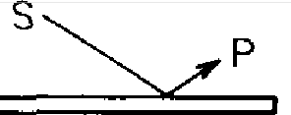
FIGURE 19. The classical view of the worl.d says that a mirror will reflect light where the angle of incidence is equal to the angle of reflection, even if the source and the detector are at different levels, as in (b).

us look at what quantum theory has to say. Rule: The prob-ability that a particular event occurs is the square of a final arrow that is found by drawing an arrow for each way the event could happen, and then combining ("adding") the arrows. In the experiment measuring the partial reflection of light by two surfaces, there were two ways a photon could get from the source to the detector. In this experiment, there are millions of ways a photon could go: it could go down to the left-hand part of the mirror at A or B (for example) and bounce up to the detector (see Fig. 20); it could bounce off the part where you think it should, at G; or, it could go down to the right-hand part of the mirror at K or M and bounce up to the detector. You might think

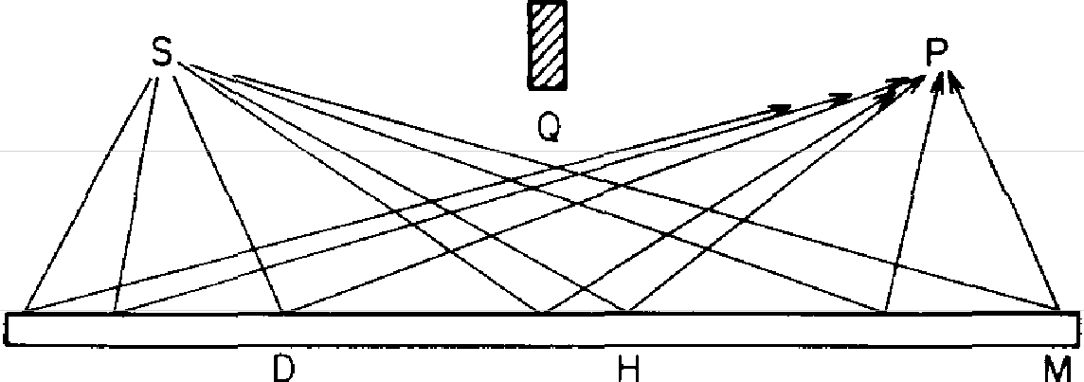
A B
G
K
FIGURE 20. The quantum view of the world says that light has an equal amplitude to re/fret from every part of the mirror, from A to M.

I'm crazy, because for most of the ways I told you a photon could reflect off the mirror, the angles aren't equal. But I'm not crazy, because that's the way light really goesl How can that be?
To make this problem easier to understand, let's suppose that the mirror consists of only a long strip from left to right-it's just as well that we forget, for a moment, that the mirror also sticks out from the paper (see Fig. 21). While

_{t}-i --- _;;.:.----I_;;.:.----j% I;.;..---:I:z , :z z :;..--::;..--: :z: ;.... :;..--: .-::;::::i
j j I i
j t I
ABC DE FG HI J KL M

FIGURE 21. To calculate more easily where the light goes, we shall tem-poranly consider only a strip of mirror divided into little squares, with one path for each square. This simplification in no way detracts from an accurate analysis of the situation.

there are, in reality, millions of places where the light could reflect from this strip of mirror, let's make an approxi-mation by temporarily dividing the mirror into a definite number of little squares, and consider only one path for each square--our calculation gets more accurate (but harder to do) as we make the squares smaller and consider more paths.

Now, let's draw a little arrow for each way the light could go in this situation. Each little arrow has a certain length and a certain direction. Let's consider the length first. You might think that the arrow we draw to represent the path that goes to the middle of the mirror, at G, is by far the longest (since there seems to be a very high probability that any photon that gets to the detector must go that way), and the arrows for the paths at the ends of the mirror must be very short. No, no; we should not make such an arbitrary rule. The right rule-what actually happens-is much sim-pler: a photon that reaches the detector has a nearly equal chance of going on any path, so all the little arrows have nearly the same length. (There are, in reality, some very slight variations in length due to the various angles and distances involved, but they are so minor that I am going to ignore them.) So let us say that each little arrow we draw will have an arbitrary standard length-I will make the length very short because there are many of these arrows representing the many ways the light could go (see Fig. 22).

FIGURE 22. Each way the light can go will be represented in our calculation by an arrow of an arbitrary standard length, as shown.

Although it is safe to assume that the length of all the arrows will be nearly the same,-their directions will clearly differ because their timing is different-as you remember from the first lecture, the direction of a particular arrow is determined by the final position of an imaginary stop-watch that times a photon as it moves along that particular path. When a photon goes way off to the left end of the mirror, at A, and then up to the detector, it clearly takes more time than a photon that gets to the detector by re-flecting in the middle of the mirror, at G (see Fig. 23). Or,

imagine for a moment that you were in a hurry and had to run from the source over to the mirror and then to the detector. You'd know that it certainly isn't a good idea to go way over to A and then all the way up to the dectector; it would be much faster to touch the mirror somewhere in the middle.

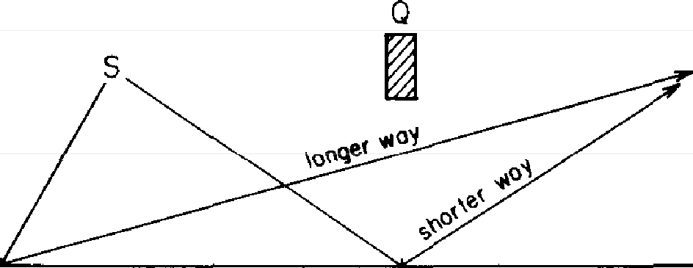
p

A G
FIGURE 23. While the length of each arrow is essentially the same, the direction will be different because the time it takes for a photon to go on each path IS different. Clearly, it takes longer to go from S to A to P than from S to G to P.

To help us calculate the direction of each arrow, I'm going to draw a graph right underneath my sketch of the mirror (see Fig. 24). Directly below each place on the mirror where the light could reflect, I'm going to show, vertically, how much time it would take if the light went that way. The more time it takes, the higher the point will be on the graph. Starting at the left, the time it takes a photon to go on the path that reflects at A is pretty long, so we plot a point pretty high up on the graph. As we move toward the center of the mirror, the time it takes for a photon to go the particular way we're looking at goes down, so we plot each successive point lower than the previous one. After we pass the center of the mirror, the time it takes a photon to go on each successive path gets longer and longer, so we plot our points correspondingly higher and higher. To aid the eye, let's connect the points: they form a symmetrical

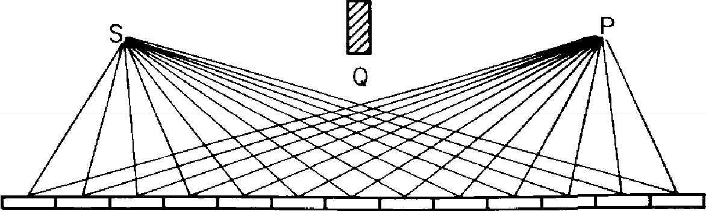
A 8 C D E F G H J K L M
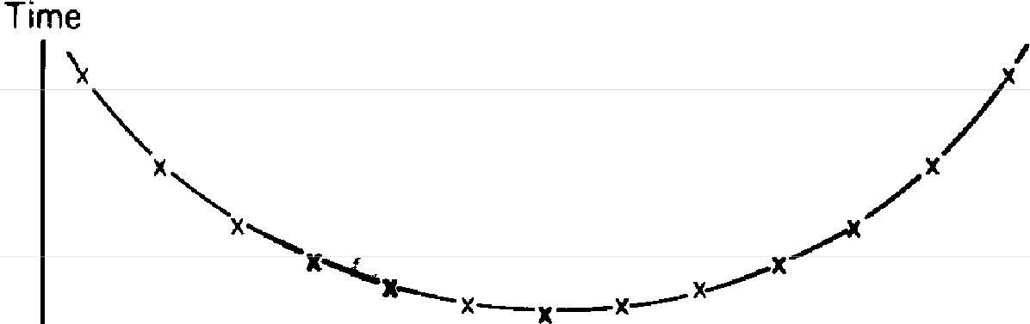

A BCD EFG H J K L M

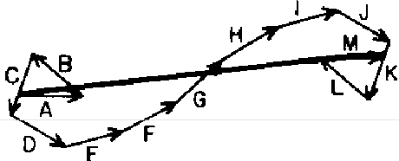
FIGURE 24. Each path the light coul.d go (in this simplified situation) is shown at the top, with a point on the graph below it showing the time it takes a photon to go from the source to that point on the mirror, and then to the photomultiplier. Below the graph is the dtrectwn of each arrow, and at the bottom is the result of adding all the arrows. It is evident that the major contribution to the final arrow's length is made by arrows E through I, whose directions are nearly the same because the timing of their paths is nearly the same. This also happens to be where the total time is least. It is there[ore approximately right to say that light goes where the time is least.

curve that starts high, goes down, and then goes back up agam.
Now, what does that mean for the direction of the little arrows? The direction of a particular arrow corresponds to the amount of time it would take a photon to get from

the source to the detector following that particular path. Let's draw the arrows, starting at the left. Path A takes the most time; its arrow points in some direction (Fig. 24). The arrow for path B points in a different direction because its time is different. At the middle of the mirror, arrows F, G, and H point in nearly the same direction because their times are nearly the same. After passing the center of the mirror, we see that each path on the right side of the mirror corresponds to a path on the left side whose time is exactly the same (this is a consequence of putting the source and the detector at the same height, and path G exactly in the
middle). Thus the arrow for path J, for example, has the
same direction as the arrow for path D.
Now, let's add the little arrows (Fig. 24). Starting with arrow A, we hook the arrows to each other, head to tail. Now, if we were to take a walk using each little arrow as a step, we wouldn't get very far at the beginning, because the direction from one step to the next is so different. But after a while the arrows begin to point in generally the same direction, and we make some progress. Finally, near the end of our walk, the direction from one step to the next is again quite different, so we stagger about some more.
All we have to do now is draw the final arrow. We simply connect the tail of the first little arrow to the head of the last one, and see how much direct progress we made on our walk (Fig. 24). And behold-we get a sizable final ar-row! The theory of quantum electrodynamics predicts that light does, indeed, reflect off the mirror!
Now, let's investigate. What determines how long the final arrow is? We notice a number of things. First, the ends of the mirror are not important: there, the little arrows wander around and don't get anywhere. If I chopped off the ends of the mirror-parts that you instinctively knew I was wasting my time fiddling around with-it would hardly affect the length of the final arrow.

So where is the part of the mirror that gives the final arrow a substantial length? It's the part where the arrows are all pointing in nearly the same direction-because their time is almost the same. If you look at the graph showing the time for each path (Fig. 24), you see that the time is nearly the same from one path to the next at the bottom of the curve, where the time is least.
To summarize, where the time is least is also where the time for the nearby paths is nearly the same; that's where the little arrows point in nearly the same direction and add up to a substantial length; that's where the probability of a photon reflecting off a mirror is determined. And that's why, in approximation, we can get away with the crude picture of the world that says that light only goes where the time is least (and it's easy to prove that where the time is least, the angle of incidence is equal to the angle of re-flection, but I don't have the time to show you).
So the theory of quantum electrodynamics gave the right answer-the middle of the mirror is the important part for reflection-but this correct result came out at the expense of believing that light reflects all over the mirror, and hav-ing to add a bunch of little arrows together whose sole purpose was to cancel out. All that might seem to you to be a waste of time-some silly game for mathematicians only. After all, it doesn't seem like "real physics" to have something there that only cancels out!
Let's test the idea that there really is reflection going on all over the mirror by doing another experiment. First, let's chop off most of the mirror, and leave about a quarter of it, over on the left. We still have a pretty big piece of mirror, but it's in the wrong place. In the previous experiment the arrows on the left side of the mirror were pointing in di-rections very different from one another because of the large difference in time between neighboring paths (Fig. 24). In this experiment I am going to make a more detailed calculation by taking intervals on that left-hand part of the

mirror that are much closer together-fine enough that there 1s not much difference in time between neighboring paths (see Fig. 25). With this more detailed picture, we see that some of the arrows point more or less to the right; the others point more or less to the left. If we add all the arrows together, we have a bunch of arrows going around in what is essentially a circle, getting nowhere.

A B C

0
FIGURE 25. To test the zdea that there zs really reflection happening at the ends of the mirror (but zt is 1ust cancelling out), we do an expenment with a large piece of mirror that ts located m the wrong place for reflection from S to P This piece of mirror zs divuled into much smaller sections, so that the timing from one path to the next is not very different When all the arrows are added, they get nowhere they go zn a circle and a,il,d up to nearly nothing.

But let's suppose we carefully scrape the mirror away in those areas whose arrows have a bias in one direction-let's say, to the left-so that only those places whose arrows point generally the other way remain (see Fig. 26). When we add up only the arrows that point more or less to the right, we get a series of dips and a substantial final arrow-ac-cording to the theory, we should now have a strong re-flection! And indeed, we do-the theory is correct! Such a mirror is called a diffraction grating, and it works like a charm.
Isn't it wonderful-you can take a piece of mirror where

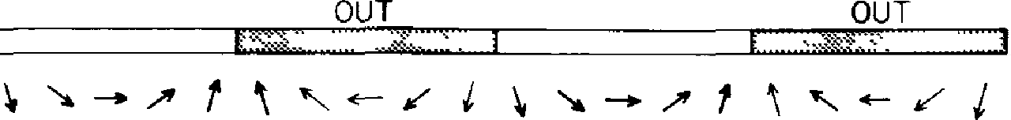
A B C

'CJC_J
FIGURE 26. If only the arrows with a bias ma particular direction-such as to the nght-are added, while the others are disregarded (by etching away the mirror zn those places), then a substantial amount of light reflects from thl.S piece of mirror located in the wrong place Such an etched mirror is called a diffraction grating

you didn't expect any reflection, scrape away part of it, and it reflects!1
The particular grating that I just showed you was tailor-made for red light. It wouldn't work for blue light; we would have to make a new grating with the cut-away strips spaced closer together because, as I told you in the first lecture, the stopwatch hand turns around faster when it times a blue photon compared to a red photon. So the cuts that were especially designed for the "red'' rate of turning don't fall in the right places for blue light; the arrows get kinked up and the grating doesn't work very well. But as a matter of accident, it happens that if we move the pho-tomultiplier down to a somewhat different angle, the grat-ing made for red light now works for blue light. It's just a

1 The areas of the mirror whose arrows pomt generally to the left also make a strong reflection (when the areas whose arrows pomt the other way are erased) It's when both left-biased and nght-b1ased areas reflect together that they cancel out This 1s analogous to the case of partial reflecuon by two surfaces while either surface will reflect on its own, 1f the thtckness ts such that the two surfaces contnbute arrows pomtmg m opposite directions, reflection 1s cancelled out

lucky accident, a consequence of the geometry involved (see Fig. 27).
If you shine white light down onto the grating, red light comes out at one place, orange light comes out slightly above it, followed by yellow, green, and blue light-all the

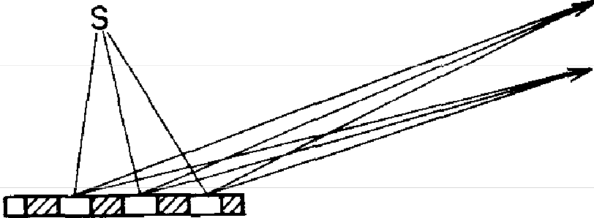
Blue Red

FIG u RE 27. A diffraction grating with grooves at the right distance for red light also works for other colors, if the detector is in a different place. Thus it is possible to see different colors reflecting from a grooved surface-such as a phonograph record-depending on the angle.

colors of the rainbow. Where there is a series of grooves close together, you can often see colors-for example, when you hold a phonograph record (or better, a videodisc)-under bright light at the correct angles. Perhaps you have seen those wonderful silvery signs (here in sunny California they're often on the backs of cars): when the car moves, you see very bright colors changing from red to blue. Now you know where the colors come from: you're looking at a grating-a mirror that's been scratched in just the right places. The sun is the light source, and your eyes are the detector. I could go on to easily explain how lasers and holograms work, but I know that not everyone has seen these things, and I have too many other things to talk about.2
2 I can't resist telling you about a grating that Nature has made: salt crystals are sodium and chlorine atoms packed in a regular pattern.

So a grating shows that we can't ignore the parts of a mirror that don't seem to be reflecting; if we do some clever things to the mirror, we can demonstrate the reality of the reflections from all parts of the mirror and produce some striking optical phenomena.

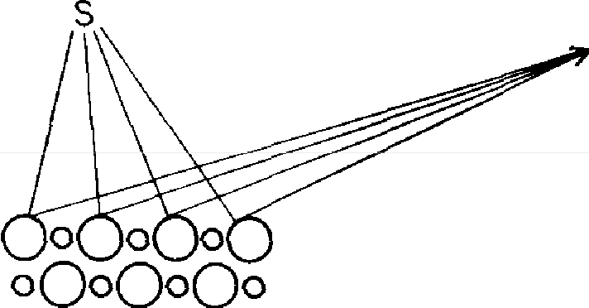
p

FIGURE 28. Nature has made many types of diffraction gratings in the form of crystals. A salt crystal reflects X-rays (light for which the imagi-nary stopwatch hand moves extremely fast-per-haps 10,000 tzmes faster than for vistble light) at various angles, from which can be determined the exact arrangement and spacings of the individual atoms.

More importantly, demonstrating the reality of reflection from all parts of the mirror shows that there is an ampli-tude-an arrow-for every way an event can happen. And in order to calculate correctly the probability of an event in different circumstances, we have to add the arrows for every way that the event could happen-not just the ways we think are the important ones!

Their alternating pattern, like our grooved surface, acts like a grating when light of the right color (X-rays, in this case) shines on it. By finding the specific locations where a detector picks up a lot of this special re-flection (called diffraction), one can determine exactly how far apart the grooves are, and thus how far apart the atoms are (see Fig. 28). It is a beautiful way of determining the structure of all kinds of crystals as well as confirming that X-rays are the same thing as light. Such experiments were first done in I 914. It was very exciting to see, in detail, for the first time how the atoms are packed together in different substances.

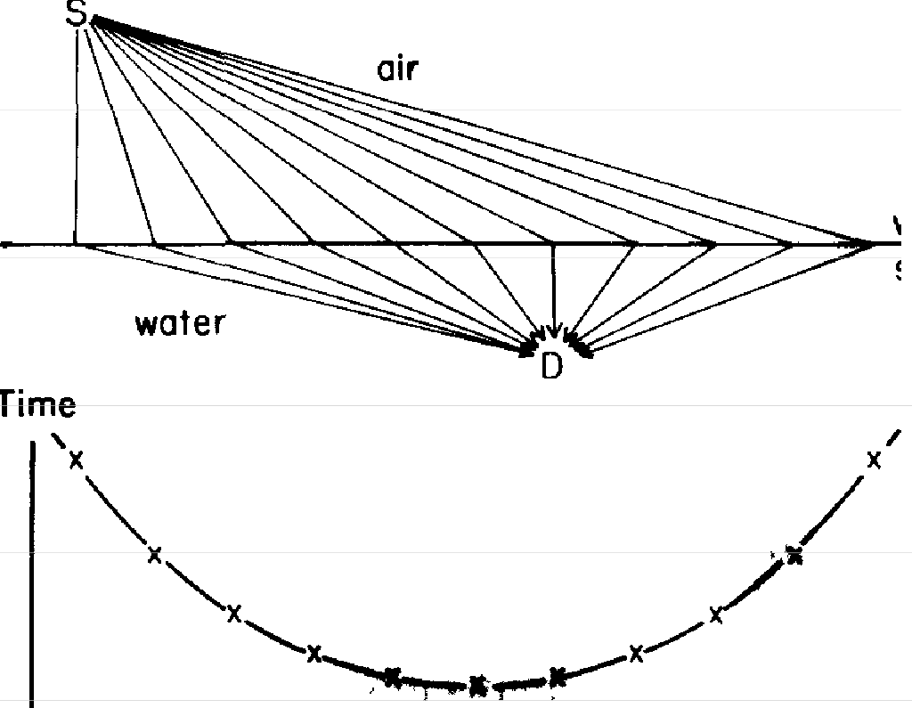
Now, I would like to talk about something more familiar than gratings----about light going from air into water. This time, let's put the photomultiplier underwater-we sup-pose the experimenter can arrange that! The source of light is in the air at S, and the dectector is underwater, at D (see Fig. 29). Once again, we want to calculate the prob-ability that a photon will get from the light source to the detector. To make this calculation, we should consider all

water surface

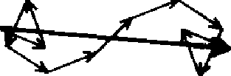

FIGURE 29. Quantum theory says that light can go from a source in air to a detector in water in many ways. If the problem IS simplified as in the case of the mirror, a graph showing the timing of each path can be draum, with the direction of e<Mh arrow below it. Once again, the major contribution toward the length of the final arrow comes from those paths whose arrows point in nearly the same direction because their timing is nearly the same; once again, this is where the time is least.

the ways the light could go. Each way the light could go contributes a little arrow and, as in the previous example, all the little arrows have nearly the same length. We can again make a graph of the time it takes a photon to go on each possible path. The graph will be a curve very similar to the one we made for light reflecting off a mirror: it starts up high, goes down, and then back up again; the most important contributions come from the places where the arrows point in nearly the same direction (where the time is nearly the same from one path to the next), which is at the bottom of the curve. That is also where the time is the least, so all we have to do is find out where the time is least.
It turns out that light seems to go slower in water than it does in air (I will explain why in the next lecture), which makes the distance through water more "costly," so to speak, than the distance through air. It's not hard to figure out which path takes the least time: suppose you're the lifeguard, sitting at S, and the beautiful girl is drowning, at D (Fig. 30). You can run on land faster than you can swim in water. The problem is, where do you enter the water in order to reach the drowning victim the fastest? Do you run down to the water at A, and then swim like

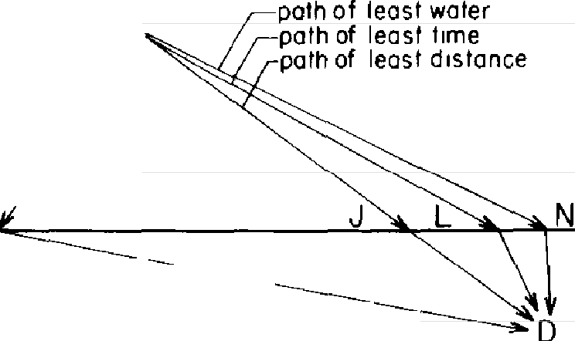
A
s
air
PCJth Of cerrainty
not feast f
1rne1
water

FIGURE 30. Fmdzng the path of least time for light 1S like finding the path of least time for a lifeguard running and then swimming to rescue a drowning victim: the path of least distance has too much water in it; the path of least water has too much land in it; the path of least time is a compromise between the two.

hell? Of course not. But running directly toward the victim and entering the water at J is not the fastest route, either.
While it would be foolish for a lifeguard to analyze and calculate under the circumstances, there is a computable position at -which the time is minimum: it's a compromise
between taking the direct path, through J, and taking the
path with the least water, through N. And so it is with
light-the path of least time enters the water at a point between J and N, such as L.
Another phenomenon of light that I would like to men-tion briefly is the mirage. When you're driving along a road that is very hot, you can sometimes see what looks like water on the road. What you're really seeing is the sky, and when you normally see sky on the road, it's because the road has puddles of water on it (partial reflection of light by a single surface). But how can you see sky on the road when there's no water there? What you need to know is that light goes slower through cooler air than through warmer air, and for a mirage to be seen, the observer must be in the cooler air that is above the hot air next to the road surface (see Fig. 31). How it is possible to look down and see the sky can be understood by finding the path of least time. I'll let you play with that one at home-it's fun to think about, and pretty easy to figure out.


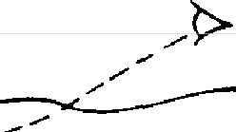
COOLER AIR
- -
WARMER AIR
ROAD

FIGURE 31. Finding the path of least time explains how a mirage works. Light goes faster through warm air than through cool azr. Some of the sky appears to be on the road because some of the light from the sky reaches the eye by coming up from the road. The only other time sky appears to be on the road zs when water is reflecting it, and thus a mirage appears to be water.

In the examples I showed you of light reflecting off a mirror and of light going through air and then water, I was making an approximation: for the sake of simplicity, I drew the various ways the light could go as double straight lines-two straight lines that form an angle. But we don't have to assume that light goes in straight lines when it is in a uniform material like air or water; even that is explainable by the general principle of quantum theory: the probability of an event is found by adding arrows for all the ways the event could happen.
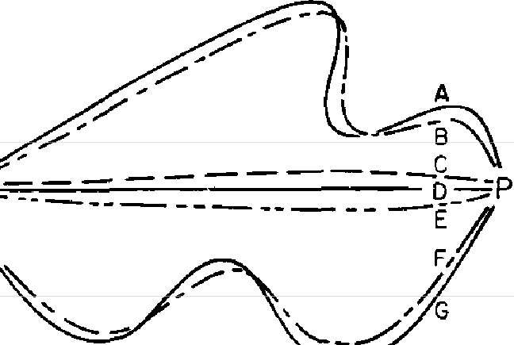
So for our next example, I'm going to show you how, by adding little arrows, it can appear that light goes in a straight line. Let's put a source and a photomultiplier at S and P, respectively (see Fig. 32), and look at all the ways

s

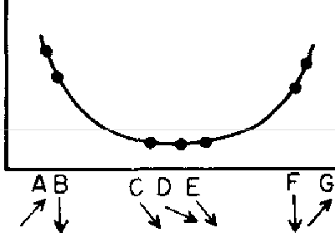
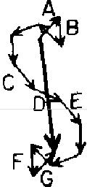
FIGURE 32. Quantum theory can be used to show why light appears to travel tn straight lines. When all possible paths are considered, each crooked path has a nearb-y path of considerably less distance and therefore much less time (and a substantially different direction for the arrow) Only the paths near the straight-line path at D have arrows pomtmg m nearly the same direction, because their timmg.s are nearly the same. Only such arrows are important, because zt ts from them that we accumulate a large final arrow.

the light could go-in all sorts of crooked paths-to get from the source to the detector. Then we draw a little arrow for each path, and we're learning our lesson weW
For each crooked path, such as path A, there's a nearby path that's a little bit straighter and distinctly shorter-that is, it takes much less time. But where the paths become nearly straight-at C, for example-a nearby, straighter path has nearly the same time. That's where the arrows add up rather than cancel out; that's where the light goes. It is important to note that the single arrow that repre-sents the straight-line path, through D (Fig. 32), is not enough to account for the probability that light gets from the source to the detector. The nearby, nearly straight paths-through C and E, for example-also make impor-tant contributions. So light doesn't really travel only in a straight line; it "smells" the neighboring paths around it, and uses a small core of nearby space. (In the same way, a mirror has to have enough size to reflect normally: if the mirror is too small for the core of neighboring paths, the light scatters in many directions, no matter where you put
the mirror.)
Let's investigate this core of light more closely by putting a source at S, a photomultiplier at P, and a pair of blocks between them to keep the paths of light from wandering
too far away (see Fig. 33). Now, let's put a second photo-multiplier at Q, below P, and assume again, for the sake of simplicity, that the light can get from S to Q only by paths of double straight lines. Now, what happens? When the gap
between the blocks is wide enough to allow many neigh-boring paths to P and to Q, the arrows for the paths to P add up (because all the paths to P take nearly the same time), while the paths to Q cancel out (because those paths have a sizable difference in time). Thus the photomultiplier at Q doesn't click.
But as we push the blocks closer together, at a certain

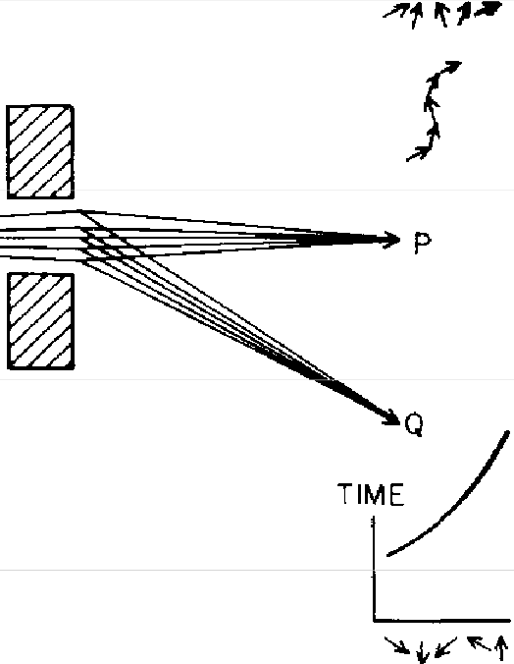
s
TIMLE

0
FIGURE 33. Light travels m not ;ust the strazght-lme path, but m the nearby paths as well. When two blocks are separated enough to allow for these nearby paths, the photons proceed normally to P, and hardly ever go to Q.

point, the detector at Q starts clicking] When the gap is nearly closed and there are only a few neighboring paths, the arrows to Q also add up, because there is hardly any difference in time between them, either (see Fig. 34). Of course, both final arrows are small, so there's not much light either way through such a small hole, but the detector at Q clicks almost as much as the one at P! So when you try to squeeze light too much to make sure it's going in only a straight line, it refuses to cooperate and begins to spread out.³
� This is an example of the "uncertainty principle": there is a kmd of "complementarity" between knowledge of where the light goes between the blocks and where it goes afterwards-preCise knowledge of both is impossible. I would like to put the uncertainty principle in its h1stoncal place: When the revolutionary ideas of quantum physics were first commg

TIME

�
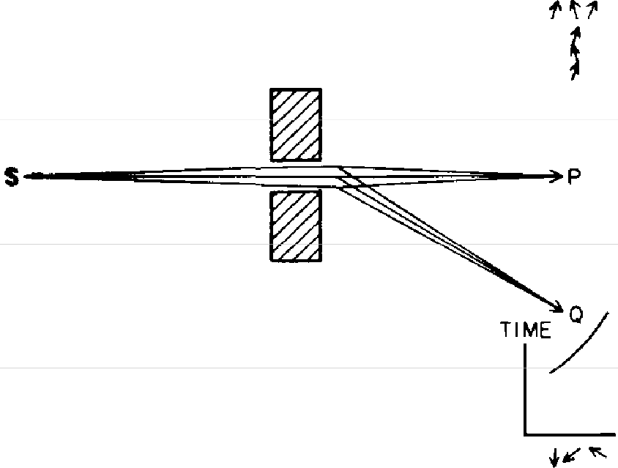

J
FIGURE 34. When light is restncted so much that only a few paths are possible, the light that is able to get through the narrow slit goes to Q almost as much as to P, because there are not enough arrows representing the paths to Q to cancel each other out.

So the idea that light goes in a straight line is a convenient approximation to describe what happens in the world that is familiar to us; it's similar to the crude approximation that says when light reflects off a mirror, the angle of incidence is equal to the angle of reflection.
Just as we were able to do a clever trick to make light reflect off a mirror at many angles, we can do a similar

out, people still tned to understand them m terms of old-fashioned ideas (such as, light goes in straight Imes) But at a certam pomt the old-fash-ioned ideas would begm to Lui, so a warnmg was developed that said, in effect, "Your old-fashioned ideas are no damn good when. ." If you get nd of all the old-fashioned ideas and instead use the ideas that I'm ex-plainmg m these lectures-adding arrows for all the ways an event can happen-there 1s no need for an uncertamty principle!

trick to get light to go from one point to another in many ways.
First, to simplify the situation, I'm going to draw a vertical dashed line (see Fig. 35) between the light source and the detector (the line means nothing; it's just an artificial line)

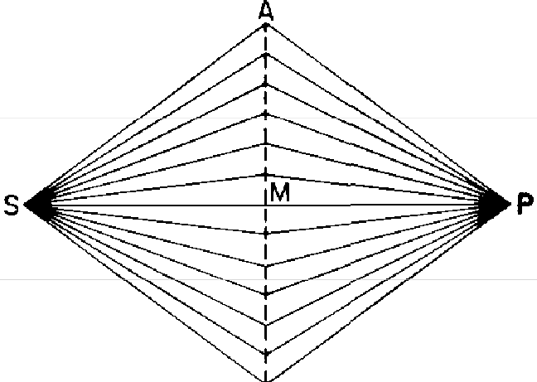
TIME
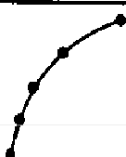
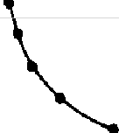
A

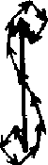
M

FIGURE 35. Analym of all possible pathsfromS toP zs simplified to include only double straight lines (in a single plane). The effect zs the same as zn the more complicated, real case: there zs a time curve with a mznzmum, where most of the contnbutwn to the final arrow is made.

and say that the only paths we're going to look at are double straight lines. The graph that shows the time for each path looks the same as in the case of the mirror (but I'll draw it sideways, this time): the curve starts at A, at the top, and then it comes in, because the paths in the middle are shorter and take less time. Finally, the curve goes back out again. Now, let's have some fun. Let's "fool the light," so that all the paths take exactly the same amount of time. How can we do this? How can we make the shortest path, through M, take exactly the same time as the longest path,
through A?
Well, light goes slower in water than it does in air; it also goes slower in glass (which is much easier to handle!). So, if we put in just the right thickness of glass on the shortest path, through M, we can make the time for that path exactly

the same as for the path through A. The paths next to M, which are just a little longer, \\on't need quite as much glass (see Fig. 36). The nearer ½e get to A, the less glass we ha\e to put in to slow up the light. By carefulh calculating and putting in just the right thickness of glass to compensate for the time along each path, we can make all the times the same. When we draw the arrows for each way the light

TIME
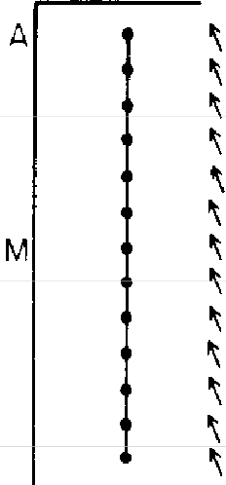
A
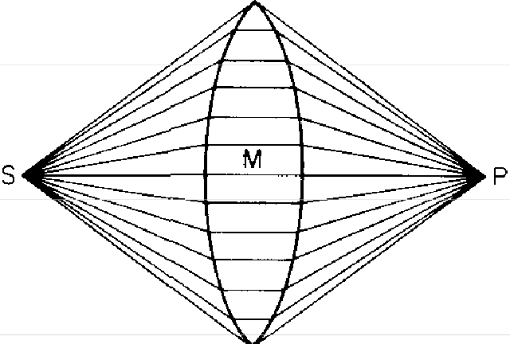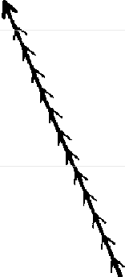

FIGURE 36. A "trzck" can be played on Nature by slowing down the light that takes shorter paths glass of yust the right thickness is inserted so that all the paths will take exactly the same time. This causes all of the arrows to point in the same direction, and to produce a whopping final arrow--lots of light 1 Such a piece of glass made to greatly increase the probability of light getting from a source to a single point is called a focusing lens

could go, we find we have succeeded in straightening them all out-and there are, in reality, millions of tiny arrows-so the net result is a sensationally large, unexpectedly enor-mous final arrow[ Of course you know what I'm describing; it's a focusing lens. By arranging things so that all the times are equal, we can focus light-we can make the probability very high that light will arrive at a particular point, and very low that it will arrive anywhere else.
I have used these examples to show you how the theory of quantum electrodynamics, which looks at first like an absurd idea with no causality, no mechanism, and nothing

real to it, produces effects that you are familiar ,\ith: light bouncing off a mirror, light bending when it goes from air into ,, ater, and light focused by a lens. It also produces other effects that you may or may not ha,e seen, such as the diffracuon grating and a number of other things. In fact, the theor)' continues to be successful at explaining every phenomenon of light.
I have shown you with examples how to calculate the probabilit)' of an e,ent that can happen in alternative ways: we draw an arrow for each way the event can happen, and add the arrows. "Adding arrows" means the arrows are placed head to tail and a "final arrow" is drawn. The square of the resulting final arrow represents the probability of the event.
In order to give you a fuller flavor of quantum theory, I would now like to show you how physicists calculate the probability of compound events-events that can be broken down into a series of steps, or events that consist of a num-ber of things happening independently.
An example of a compound event can be demonstrated by modifying our first experiment, in which we aimed some red photons at a single surface of glass to measure partial reflection. Instead of putting the photomultiplier at A (see Fig. 37), let's put in a screen with a hole in it to let the photons that reach point A go through. Then let's put in a sheet of glass at B, and place the photomultiplier at C. How do we figure out the probability that a photon will get from the source to C?
We can think of this event as a sequence of two steps. Step 1: a photon goes from the source to point A, reflecting off the single surface of glass. Step 2: the photon goes from point A to the photomultiplier at C, reflecting off the sheet of glass at B. Each step has a final arrow-an "amplitude" (I'm going to use the words interchangeably)-that can be calculated according to the rules we know so far. The am-

plitude for the first step has a length of 0.2 (whose square is 0.04, the probability of reflection by a single surface of glass), and is turned at some angle-let's say, 2 o'clock (Fig. 37).
To calculate the amplitude for the second step, we tem-porarily put the light source at A and aim the photons at the layer of glass above. We draw arrows for the front and back surface reflections and add them-let's say we end up with a final arrow with a length of 0.3, and turned toward 5 o'clock.

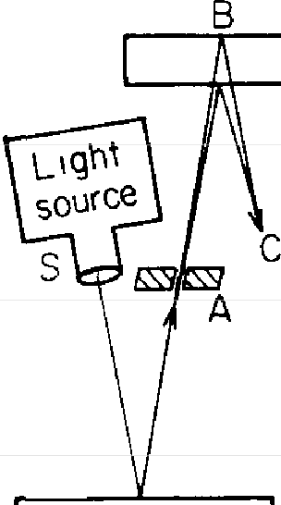
GLASS

GLASS

.,, ·1· .+.
I I I
�,' �I �I I
I I I
e1 ol 01

,._ I
"'-I �,

o,s 'o^{-I}, o,s
."!:: I :'.:I :'::I
c, c, cl
::::i, ::::i, ::ii
� .2 | I | .06y.2
 | -�
Step1: | Step 2: | S to C
S to A | A to C | combined

Fie URE 3 7. A compound event can be analyzed as a succession of steps. In this example, the path of a photon going from S to C can be divided into two step:.: 1) a photon gets from S to A, and 2) the photon gets from A to C. Each step can be analyzed separately to produce an arrow that can be regarded in a new way: as a umt arrow (an arrow of length 1 pointed at 12 o'clock) that has gone through a shrink and turn. In this example, the shrink and tum for Step 1 are 0.2 and 2 o'clock; the shrink and turn for Step 2 are 0.3 and 5 o'clock. To get the amplitude for the two steps in succession, we shrink and tum in succession: the unit arrow is shrunk and turned to produce an arrow of length 0.2 turned to 2 o'clock, which itself i,s shrunk and turned (as if it were the unit arrow) by 0.3 and 5 o'clock to produce an arrow of length 0.06
and turned to 7 o'clock. This process of successive shrinking and turning is
called "multiplying" arrows.

Now, how do we combine the two arrows to draw the amplitude for the entire event? We look at each arrow in a new way: as instructions for a shrink and turn.
In this example, the first amplitude has a length of 0.2 and is turned toward 2 o'clock. If we begin with a "unit arrow"-an arrow oflength 1 pointed straight up--we can shrink this unit arrow from 1 down to 0.2, and turn it from 12 o'clock to 2 o'clock. The amplitude for the second step can be thought of as shrinking the unit arrow from 1 to
0.3 and turning it from 12 o'clock to 5 o'clock.
Now, to combine the amplitudes for both steps, we shrink and turn in succession. First, we shrink the unit arrow from 1 to 0.2 and turn it from 12 to 2 o'clock; then we shrink the arrow further, from 0.2 down to three-tenths of that, and turn it by the amount from 12 to 5-that is, we turn it from 2 o'clock to 7 o'clock. The resulting arrow has a length of 0.06 and is pointed toward 7 o'clock. It represents a probability of 0.06 squared, or 0.0036.
Observing the arrows carefully, we see that the result of shrinking and turning two arrows in succession is the same as adding their angles (2 o'clock + 5 o'clock) and multi-plying their lengths (0.2 * 0.3). To understand why we add the angles is easy: the angle of an arrow is determined by the amount of turning by the imaginary stopwatch hand. So the total amount of turning for the two steps in succes-sion is simply the sum of the turning for the first step plus the additional turning for the second step.
Why we call this process "multiplying arrows" takes a bit more explanation, but it's interesting. Let's look at multi-plication, for a moment, from the point of view of the Greeks (this has nothing to do with the lecture). The Greeks wanted to use numbers that were not necessarily integers, so they represented numbers with lines. Any number can be expressed as a transformation of the unit line-by ex-panding it or shrinking it. For example, if Line A is the

unit line (see Fig. 38), then line B represents 2 and line C
represents 3.
Now, how do we multiply 3 times 2? We apply the trans-formations in succession: starting with line A as the unit line, we expand it 2 times and then 3 times (or 3 times and then 2 times-the order doesn't make any difference). The re-sult is line D, whose length represents 6. What about mul-tiplying 1/3 times 1/2? Taking line D to be the unit line, now, we shrink it to 1/2 (line C) and then to 1/3 of that. The result is line A, which represents 1/6.

A B C
D
FIGllRE 38. We can express any number as a transformation of the unit line through expansion or shrinkage. If A is the unit line, then B represents 2 (expansion), and C represents 3 (expansion). Multiplying lines is achieved through successive transformations. For example, multiplying 3 b-y 2 means that the unit line is expanded 3 times and then 2 times, producing the answer, an expansion of 6 (line D). If D is the unit line, then lzne C represents 1/2 (shrinkage), line B represents 1/3 (shrinkage), and multiplying 112 by 1/3 means the unit line D is shrunk to 1/2, and then to 1 /3 of that, producing the answer, a shrinkage to 1/6 (line A).

Multiplying arrows works the same way (see Fig. 39). We apply transformations to the unit arrow in succession-it just happens that the transformation of an arrow involves two operations, a shrink and turn. To multiply arrow V times arrow W, we shrink and turn the unit arrow by the prescribed amounts for V, and then shrink it and turn it the amounts prescribed for W-again, the order doesn't make any difference. So multiplying arrows follows the

.� •i'- � ... ·t- A
I I
I I
3
31 I 3 3 31 3

0.. :0:1:,
�... .£..
..º...',,
.e..

0 ol 0 0
_t
_o, , 0

c -1 C: ·1: 'cl c

::,
c: I
:::i,
::, ::, :>I ::,
I

I
� XyV
�
V * w = X
\:
-w *
'.-<
x�
-V = x

FIGURE 39. Mathematicians found that multiplying arrow.s can al.so be expressed as suaesswe transformations (for our purpose.-,, successive shrinks and turns) of the unit arrow. As in normal multiplication, the order is not important: the answer, arrow X, can be obtained by multiplying arrow V by arrow W or arrow W by arrow V.

4 Mathematicians have tried to find all the objects one could possibly find that obey the rules of algebra (A + B = B + A, A * B = B * A,
and so on). The rules were originally made for positive integers, used for counting things like apples or people. Numbers were improved with the invention of zero, fractions, irrational numbers-numbers that cannot be expressed as a ratio of two integers-and negative numbers, and contin-ued to obey the original rules of algebra. Some of the numbers that mathematicians invented posed difficulties for people at first-the idea of half a person was difficult to imagine-but today, there's no difficulty at all: nobody has any moral qualms or discomforting gory feelings when they hear that there is an average of 3.2 people per square mile in some regions. They don't try to imagine the 0.2 people; rather, they know what
3.2 means: if they multiply 3.2 by IO, they get 32. Thus, some things that satisfy the rules of algebra can be interesting to mathematicians even though they don't always represent a real situation. Arrows on a plane can be "added" by putting the head of one arrow on the tail of another, or "multiplied" by successive turns and shrinks. Since these arrows obey the same rules of algebra as regular numbers, mathematicians call them numbers. But to distinguish them from ordinary numbers, they're called "complex numbers." For those of you who have studied mathematics enough to have come to complex numbers, I could have said, "the prob-ability of an event is the absolute square of a complex number. When an event can happen in alternative ways, you add the complex numbers; when it can happen only as a succession of steps, you multiply the complex numbers." Although it may sound more impressive that way, I have not said any more than I did before-I just used a different language.

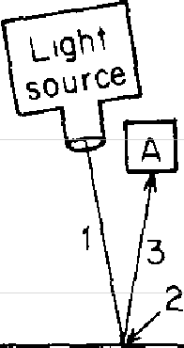

Let's go back to the first experiment from the first lec-ture-partial reflection by a single surface-with this idea of successive steps in mind (see Fig. 40). We can divide the path of reflection into three steps: 1) the light goes from the source down to the glass, 2) it is reflected by the glass, and 3) it goes from the glass up to the detector. Each step can be considered as a certain amount of shrinking and turning of the unit arrow.
I
GLASS \
rt]

:J !II

�1\
�...
51
�::",'

0
::,1,
01

._ I -:: I ol
2 ��
-:: I

.::'. I Cl
'
·;; I :,

::,�
to -cl ·
Cl
::, I
Step 2�tep 3
Step 1

Step\ Step2 Step 3

FIGURE 40. Reflection uy a single surface can be divided into three steps, each with a shrink and/or turn of the unit arrow. The net result, an arrow of length 0.2 pointed zn some direction, is the same as before, but our method of analysis is more detailed now.

You'll remember that in the first lecture, we did not con-sider all of the ways the light could reflect off the glass, which requires drawing and adding lots and lots of little tiny arrows. In order to avoid all that detail, I gave the impression that the light goes down to a particular point on the surface of the glass-that it doesn't spread out. When light goes from one point to another, it does, in reality, spread out (unless it's fooled by a lens), and there is some shrinkage of the unit arrow associated with that. For the moment, however, I would like to stick to the sim-plified view that light does not spread out, and so it is ap-

propriate to disregard this shrinkage. It is also appropriate to assume that since the light doesn't spread out, every photon that leaves the source ends up at either A or B.
So: in the first step there is no shrinking, but there is turning-it corresponds to the amount of turning by the imaginary stopwatch hand as it times the photon going from the source to the front surface of the glass. In this example, the arrow for the first step ends up with a length of I at some angle-let's say, 5 o'clock.
The second step is the reflection of the photon by the glass. Here, there is a sizable shrink-from 1 to 0.2-and half a turn. (These numbers seem arbitrary now: they de-pend upon whether the light is reflected by glass or some other material. In the third lecture, I'll explain them, too!) Thus the second step is represented by an amplitude of length 0.2 and a direction of 6 o'clock (half a turn).
The last step is the photon going from the glass up to the detector. Here, as in the first step, there is no shrinking, but there is turning-let's say this distance is slightly shorter than in step 1, and the arrow points toward 4 o'clock.
We now "multiply" arrows 1, 2, and 3 in succession (add the angles, and multiply the lengths). The net effect of the three steps-I) turning, 2) a shrink and half a turn, and
3) turning-is the same as in the first lecture: the turning from steps I and 3-(5 o'clock plus 4 o'clock) is the same amount of turning that we got then when we let the stop-watch run for the whole distance (9 o'clock); the extra half turn from step 2 makes the arrow point in the direction opposite the stopwatch hand, as it did in the first lecture, and the shrinking to 0.2 in the second step leaves an arrow whose square represents the 4% partial reflection observed for a single surface.
In this experiment, there is a question we didn't look at in the first lecture: what about the photons that go to B-the ones that are transmitted by the surface of the glass?

The amplitude for a photon to arrive at B must have a length near 0.98, since 0.98 * 0.98 = 0.9604, which is close enough to 96%. This amplitude can also be analyzed by breaking it down into steps (see Fig. 41).
The first step is the same as for the path to A-the photon goes from the light source down to the glass-the unit arrow is turned toward 5 o'clock.
The second step is the photon passing through the sur-face of the glass: there is no turning associated with trans-mission, just a little bit of shrinking-to 0.98.

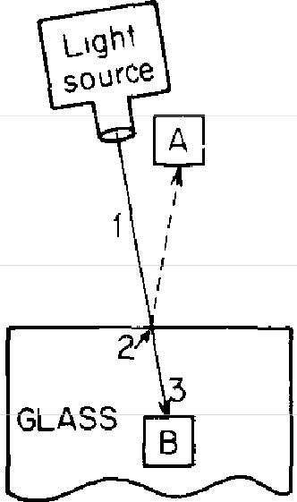
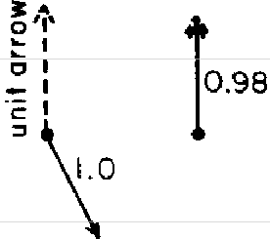
�A
ol
_��,I
1
�

1.0
�e,.,.
,_sr,
cl
Step 3 A ..,Step 2
f
\_step 1

Step I Step 2 Step 3

FIGURE 41. Transmission by a single suiface can also be divided into three steps, with a shnnk and/or turn for each step. An arrow of length 0.98 has a square of about 0.96, representing a probabilty of transmission of 96% (which, combined with the 4% probability of reflection, accounts for JOO% of the light).

The third step-the photon going through the interior of the glass-involves additional turning and no shrinking. The net result is an arrow of length 0.98 turned in some direction, whose square represents the probability that a
photon will arrive at B-96%.
Now let's look at partial reflection by two surfaces again. Reflection from the front surface is the same as for a single surface, so the three steps for front surface reflection are the same as we saw a moment ago (Fig. 40).

Reflection from the back surface can be broken down into seven steps (see Fig. 42). It involves turning equal to the total amount of turning of the stopwatch hand timing a photon over the entire distance (steps I, 3, 5, and 7), shrinking to 0.2 (step 4), and two shrinks to 0.98 (steps 2 and 6). The resulting arrow ends up in the same direction as before, but the length is about 0.192 (0.98 * 0.2 * 0.98), which I approximated as 0.2 in the first lecture.

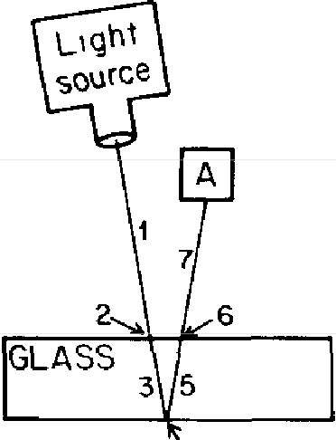
FIGURE 42. Reflection from the back sur-face of a lnyer of glnss can be divided into seven steps. Steps I, 3, 5, and 7 involve turn-ing only; steps 2 and 6 involve shrinks to 0.98, and step 4 involves a shnnk to 0.2. The result is an arrow of length 0.192-which was ap-proximated as O.2 in the first /,ecture-turned at an ang/,e that corresponds to the total amount of turning by the imaginary stopwatch
hand.
4

In summary, here are the rules for reflection and trans-mission of light by glass: I) reflection from air back to air (off a front surface) involves a shrink to 0.2 and half a turn;
2) reflection from glass back to glass (off a back surface) also involves a shrink to 0.2, but no turning; and 3) trans-mission from air to glass or from glass to air involves a shrink to 0.98 and no turning in either case.
Perhaps it is too much of a good thing, but I cannot resist showing you a cute further example of how things work and are analyzed by these rules of successive steps. Let us move the detector to a location below the glass, and con-sider something we didn't talk about in the first lecture-the probability of transmission by two surfaces of glass (see Fig. 43).
Of course you know the answer: the probability of a

photon to arrive at Bis simply 100% minus the probability to arrive at A, which we worked out beforehand. Thus, if we found the chance to arrive at A is 7%, the chance to arrive at B must be 93%. And as the chance for A varies from zero through 8% to 16% (due to the different thick-nesses of glass), the chance for B changes from 100% through 92% to 84%.

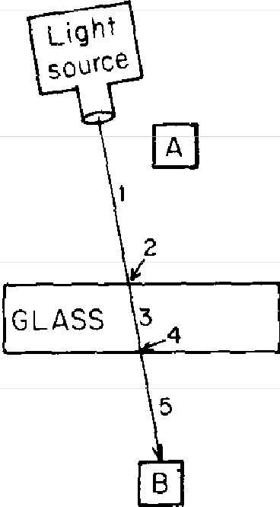
FIGURE 43. Transmission by two surfaces can be broken down into five steps. Step 2 shrinks the unit arrow to 0.98, step 4 shrinks the 0.98 arrow to 0.98 of that (about 0.96); steps I, 3, and 5 involve turning only. The resulting arrow of length 0.96 has a square
of about 0.92, representing a probability of transmission by two surfaces of 92% (which corresponds to the expected 8% reflection, which is right only "twice a day"). When the thickness of the layer is right to produce a prob-
ability of 16% reflection, with a 92% proba-bility of transmission, 108% of the light is accounted for! Something is wrong with this analysis!

That is the right answer, but we are expecting to calculate all probabilities by squaring a final arrow. How do we cal-culate the amplitude arrow for transmission by a layer of glass, and how does it manage to vary in length so appro-priately as to fit with the length for A in each case, so the probability for A and the probability for B always add up to exactly 100%? Let us look a little into the details.
For a photon to go from the source to the detector below the glass, at B, five steps are involved. Let's shrink and turn the unit arrow as we go along.
The first three steps are the same as in the previous example: the photon goes from the source to the glass (turning, no shrinking); the photon is transmitted by the

front surface (no turning, shrinking to 0.98); the photon goes through the glass (turning, no shrinking).
The fourth step-the photon passes through the back surface of the glass-is the same as the second step, as far as shrinks and turns go: no turns, but a shrinkage to 0.98 of the 0.98, so the arrow now has a length of 0.96.
Finally, the photon goes through the air again, down to the detector-that means more turning, but no further shrinking. The result is an arrow of length 0.96, pointing in some direction determined by the successive turnings of the stopwatch hand.
An arrow whose length is 0.96 represents a probability of about 92% (0.96 squared), which means an average of 92 photons reach Bout of every 100 that leave the source. That also means that 8% of the photons are reflected by the two surfaces and reach A. But we found out in the first lecture that an 8% reflection by two surfaces is only right sometimes ("twice a day'')-that in reality, the reflection by two surfaces fluctuates in a cycle from zero to 16% as the thickness of the layer steadily increases. What happens when the glass is just the right thickness to make a partial reflection of 16%? For every I 00 photons that leave the source, 16 arrive at A and 92 arrive at B, which means 108% of the light has been accounted for-horrifying! Something is wrong.
We neglected to consider all the ways the light could get to B! For instance, it could bounce off the back surface, go up through the glass as if it were going to A, but then reflect off the front surface, back down toward B (see Fig. 44). This path takes nine steps. Let's see what happens successively to the unit arrow as the light goes through each step (don't worry; it only shrinks and turns!).
First step-photon goes through the air-turning; no shrinking. Second step-photon passes through the glass-no turning, but shrinking to 0.98. Third step-photon goes

through the glass-turning; no shrinking. Fourth step--reflection off the back surface-no turning, but shrinking to 0.2 of 0.98, or 0.196. Fifth step-photon goes back up through the glass-turning; no shrinking. Sixth step-pho-ton bounces off front surface (it's really a "back" surface, because the photon stays inside the glass)-no turning, but shrinking to 0.2 of 0.196, or 0.0392. Seventh step--photon

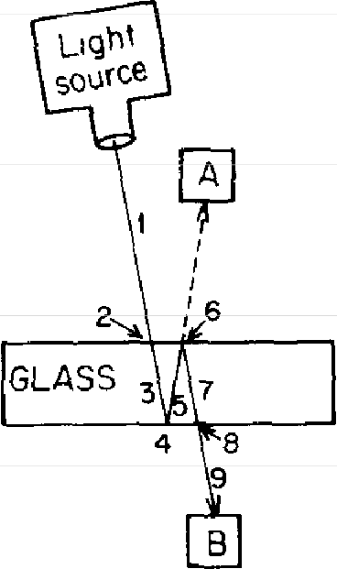
FIG u RE 11. Another way that light couU be transmitted by two surfaces mu.st be consid-ered m order to make the calculation more accurate. This path involves two shnnks of
0.98 (steps 2 and 8) and two shnnks of 0.2 (steps 4 and 6 ), resulting m an arrow of length 0.0384 (rounded off to 0.04).

goes back down through glass-more turning; no shrink-ing. Eighth step-photon passes through back surface-no turning, but shrinking to 0.98 of 0.0392, or 0.0384. Finally, the ninth step-photon goes through air to detector-turn-ing; no shrinking.
The result of all this shrinking and turning is an ampli-tude of length 0.0384--call it 0.04, for all practical pur-poses-and turned at an angle that corresponds to the total amount of turning by the stopwatch as it times the photon going through this longer path. This arrow represents a second way that light can get from the source to B. Now we have two alternatives, so we must add the two arrows-the arrow for the more direct path, whose length is 0.96, and the arrow for the longer way, whose length is 0.04-to make the final arrow.

The two arrows are usually not in the same direction, because changing the thickness of the glass changes the relative direction of the 0.04 arrow to the 0.96 arrow. But look how nicely things work out: the extra turns made by the stopwatch timing a photon during steps 3 and 5 (on its way to A) are exactly equal to the extra turns it makes timing a photon during steps 5 and 7 (on its way to B). That means when the two reflection arrows are cancelling each other to make a final arrow representing zero reflection, the ar-rows for transmission are reinforcing each ocher to make an arrow of length 0.96 + 0.04, or I-when the probability of reflection is zero, the probability of transmission is 100% (see Fig. 45). And when the arrows for reflection are rein-

Reflection

Transm1ss1on

02-0 2
0�

r
\ I
\ 16% \
I I
04\ \
\�

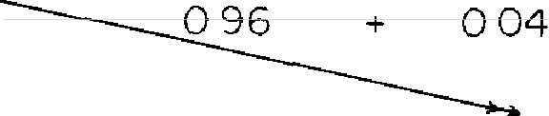
I
I I I
I I I
I
I
I
:
'
'
'
100%

I J I
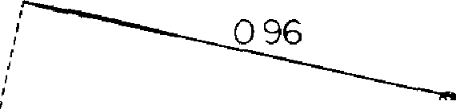
,'
- 004
I'
I
I'
I' 84 %
I'
I

'
'
'
I
I''

I I'
'
I I
I
' ''
'
/092
I
I
I

I
I
I f

I L'
I
'
--, '
I
'
---
I
I
I
I
I
I
I
-- ;I'

FIGURE 45. Nature always makes sure JOO% of the light is accounted for. When the thickness is right for the transmission arrows to accumulate, the arrows for reflection oppose each other; when the arrows for reflection accu-mulate, the arrows for transmission oppose each other.

forcing each other to make an amplitude of 0.4, the arrows for transmission are going against each other, making an amplitude of length 0.96 - 0.04, or 0.92-when reflection is calculated to be 16%, transmission is calculated to be 84% (0.92 squared). You see how clever Nature is with Her rules to make sure that we always come out with 100% of the photons accounted for!5
Finally, before I go, I would like to tell you that there is an extension to the rule that tells us when to multiply arrows: arrows are to be multiplied not only for an event that con-sists of a succession of steps, but also for an event that consists of a number of things happening concomitantly-independently and possibly simultaneously. For example, suppose we have two sources, X and Y, and two detectors, A and B (see Fig. 47), and we want to calculate the prob-

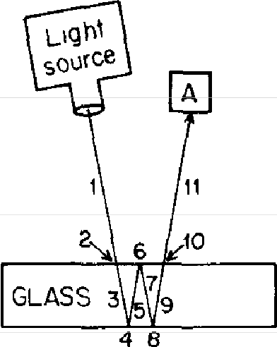
FIGURE 46. Yet other ways the light could reflect should be considered for a more accurate calculation. In this figure, shrinks of 0.98 oc-cur at steps 2 and 10; shrinks of 0.2 occur at steps 4, 6, and 8. The result i.s an arrow with a length of about 0.008, which is another al-ternative for reflection, and should there/ore be added to the other arrows which represent reflection (0.2 for the front surface and 0.192 for the back surface).

5 You'll notice that we changed 0.0384 to 0.04 and used 84% as the square of 0.92, in order to make 100% of the light accounted for. But when everything is added together, 0.0384 and 84% don't have to be rounded off-all the little bits and pieces of arrows (representing all the ways the light could go) compensate for each other and keep the answer correct. For those of you who like this sort of thing, here is an example of another way that the light could go from the light source to the detector at A-a series of three reflections (and two transmissions), resulting in a final arrow of length 0.98 * 0.2 * 0.2 * 0.2 * 0.98, or about 0.008-a very tiny arrow (see Fig. 46). To make a complete calculation of partial re-flection by two surfaces, you would have to add in that small arrow, plus an even smaller one that represents five reflections, and so on.

ability for the following event: after X and Y each lose a photon, A and B each gain a photon.
In this example, the photons travel through space to get to the detectors-they are neither reflected nor transmit-ted-so now is a good time for me to stop disregarding the fact that light spreads out as it goes along. I now present

X A
y 8

��e-..1·
�01-··

0�
�-7·
_'.: I

01 01 -1
:: I
'
--c.t:: -1 §1 I

�\5
§\5
25\_5

X to A Y toB X to A and Y to 8

FIGURE 4 7. If one of the ways a particular event can happen depends on a number of things happening independently, the amplitude for this way is calculnted by multiplying the arrows of the independent things. In this case, the final event is: after sources X and Y each lose a photon, photomultipliers A and B make a click. One way this event could happen is that a photon could go from X to A and a photon could go from Y to B (two independent things). To calculate the probability for this ''first way," the arrows for each independent thmg-X to A and Y to B-are multiplied to produce the amplitude for this particulnr way. (Analysis continued zn Fig. 48.)

you with the complete rule for monochromatic light travelling from one point to another through space-there is nothing approximate here, and no simplification. This is all there is to know about monochromatic light going through space (disregarding polarization): the angle of the arrow depends on the imaginary stopwatch hand, which rotates a certain number of times per inch (depending on the color of the photon); the length of the arrow is inversely proportional

to the distance the light goes-in other words, the arrow shrinks as the light goes along.6
Let's suppose the arrow for X to A is 0.5 in length and is pointing toward 5 o'clock, as is the arrow for Y to B (Fig. 47). Multiplying one arrow by the other, we get a final arrow of length 0.25, pointed at 10 o'clock.

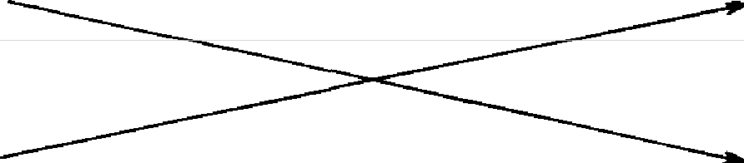
X A

y

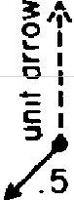
�,+,
01
::: I
y_01 ,,
B
�e,....
ol
T-·c:·oI 25

X to B Yto A X to B and Y to A

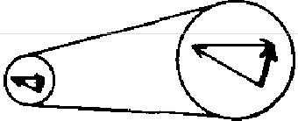
-

X ta A and
Y to B
11
( f1rst
way")
X to B and
Y to A ("second
way")

amplitude for
entire event (final arrow)

FIGURE 48. The other way the eventdescribedinFigure47 could happen-a photon goes from X to B and a photon goes from Y to A-also depends on two independent things happening, so the amplitude for this "second way" is also calculated fYJ multiplying the arrows of the independent things. The ''first way" and "second way" arrows are ultimately added together, resulting m the final arrow for the event. The probability of an event is always represented by a single final arrow-no matter how many arrows were drawn, multiplied, and added to achieve it.

6 This rule checks out with what they teach in school-the amount of light transmitted over a distance varies inversely as the square of the distance because an arrow that shrinks to half its original size has a square
one-fourth as big.

But wait! There is another way this event could happen: the photon from X could go to B, and the photon from Y could go to A. Each of these subevents has an amplitude, and these arrows must also be drawn and multiplied to produce an amplitude for this particular way the event could happen (see Fig. 48). Since the amount of shrinkage over distance is very small compared to the amount of turning, the arrows from X to B and Y to A have essentially the same length as the other arrows, 0.5, but their turning is quite different: the stopwatch hand rotates 36,000 times per inch for red light, so even a tiny difference in distance results in a substantial difference in timing.
The amplitudes for each way the event could happen are added to produce the final arrow. Since their lengths are essentially the same, it is possible for the arrows to cancel each other out if their directions are opposed to each other. The relative directions of the two arrows can be changed by changing the distance between the sources or the detectors: simply moving the detectors apart or to-gether a little bit can make the probability of the event amplify or completely cancel out, just as in the case of partial reflection by two surfaces:7
In this example, arrows were multiplied and then added to produce a final arrow (the amplitude for the event), whose square is the probability of the event. It is to be emphasized that no matter how many arrows we draw, add, or multiply, our objective is to calculate a single final arrow for the event. Mistakes are often made by physics students at first because they do not keep this important point in mind. They work for so long analyzing events involving a single photon that they begin to think that the arrow is

7 This phenomenon, called the Hanbury-Brown-Twiss effect, has been used to distinguish between a single source and a double source of radio waves in deep space, even when the two sources are extremely close together.

somehow associated with the photon. But these arrows are probability amplitudes, that give, when squared, the prob-ability of a complete event.8
ln the next lecture I will begin the process of simplifying and explaining the properties of matter-to explain where the shrinking to 0.2 comes from, why light appears to go slower through glass or water than through air, and so on-because I have been cheating so far: the photons don't really bounce off the surface of the glass; they interact with the electrons inside the glass. I'll show you how photons do nothing but go from one electron to another, and how reflection and transmission are really the result of an elec-tron picking up a photon, "scratching its head," so to speak, and emitting a new photon. This simplification of every-thing we have talked about so far is very pretty.
8 Keepmg this prmciple m mmd should help the student avmd being confused by thmgs such as the "reduc:uon of a wave packet" and s1m1lar magJC

3

Electrons and Their Interactions

This is the third of four lectures on a rather difficult sub-ject-the theory of quantum electrodynamics-and since there are obviously more people here tonight than there were before, some of you haven't heard the other two lec-llues and will find this lecture almost incomprehensible. Those of you who have heard the other two lectures will also find this lecture incomprehensible, but you know that that's all right: as I explained in the first lecture, the way we have to describe Nature is generally incomprehensible to us.
In these lectures I want to tell you about the part of physics that we know best, the interaction of light and elec� trons. Most of the phenomena you are familiar with involve the interaction of light and electrons-all of chemistry and biology, for example. The only phenomena that are not covered by this theory are phenomena of gravitation and nuclear phenomena; everything else is contained in this theory.
We found out in the first lecture that we have no satis-factory mechanism to describe even the simplest of phe-nomena, such as partial reflection of light by glass. We also have no way to predict whether a given photon will be reflected or transmitted by the glass. All we can do is cal-culate the probability that a particular event will happen-

whether the light will be reflected, in this case. (This is about 4%, when the light shines straight down on a single surface of glass; the probability of reflection increases as the light hits the glass at more of a slant.)
When we deal with probabilities under ordinary circum-stances, there are the following "rules of composition": 1) if something can happen in alternative ways, we add the probabilities for each of the different ways; 2) if the event occurs as a succession of steps---or depends on a number of things happening "concomitantly" (independently)-then we multiply the probabilities of each of the steps (or things). In the wild and wonderful world of quantum physics, probabilities are calculated as the square of the length of an arrow: where we would have expected to add the proba-bilities under ordinary circumstances, we find ourselves "adding" arrows; where we normally would have multiplied the probabilities, we "multiply" arrows. The peculiar an-swers that we get from calculating probabilities in this man-ner match perfectly the results of experiment. I'm rather delighted that we must resort to such peculiar rules and strange reasoning in order to understand Nature, and I enjoy telling people about it. There are no "wheels and gears" beneath this analysis of Nature; if you want to un-
derstand Her, this is what you have to take.
Before I go into the main part of this lecture, I'd like to show you another example of how light behaves. What I would like to talk about is very weak light of one color-onephoton at a time-going from a source, at S, to a de-tector, at D (see Fig. 49). Let's put a screen in between the source and the detector and make two very tiny holes a few millimeters apart from each other, at A and B. (If the source and detector are I 00 centimeters apart, the holes have to be smaller than a tenth of a millimeter.) Let's put A in line with S and D, and put B somewhere to the side of A, not in line with S and D.

When we close the hole at B, we get a certain number of clicks at D-which represents the photons that came through A (let's say the detector clicks an average of one time for every 100 photons that leave S, or 1%). When we close the hole at A and open the hole at B, we know from the second lecture that we get nearly the same number of clicks, on average, because the holes are so small. (When we "squeeze" light too much, the rules of the ordinary world-such as light goes in straight lines-fall apart.)

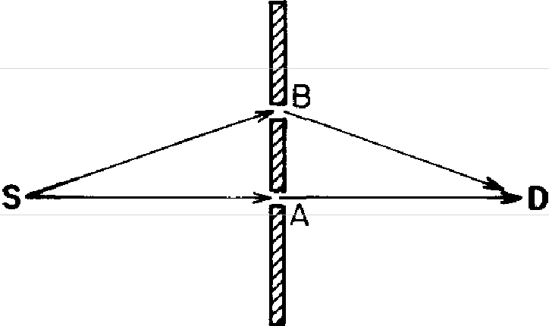
FIGURE 49. Two tzny holes (al A and B) zn a screen that zs between a source Sand a detector D let nearly the same amount of light through (zn thzs case 1 %) when one or the other hole zs open. When both holes are open, "znteiference" occurs. the detector clicks from zero to 4% of the time, depending on the separation of A and B-shown in Figure 51 (a).

When we open both holes we get a complicated answer, because interference is present: If the holes are a certain distance apart, we get more clicks than the expected 2% (the maximum is about 4%); if the two holes are a slightly different distance apart, we get no clicks at all.
One would normally think that opening a second hole would always increase the amount of light reaching the detector, but that's not what actually happens. And so say-ing that the light goes "either one way or the other" is false. I still catch myself saying, "Well, it goes either this way or that way," but when I say that, I have to keep in mind that

I mean in the sense of adding amplitudes: the photon has an amplitude to go one way, and an amplitude to go the other way. If the amplitudes oppose each other, the light won't get there-even though, in this case, both holes are open.
Now, here's an extra twist to the strangeness of Nature that I'd like to tell you about. Suppose we put in some special detectors-one at A and one at B (it is possible to design a detector that can tell whether a photon went through it)-so we can tell through which hole(s) the pho-ton goes when both holes are open (see Fig. 50). Since the

t.

S�1�D

*special detectors
FIGURE 50. When special detectors are put in at A and B to tell which way the light went when both holes are open, the experiment has been changed. Because a photon always goes through one hole or the other (when you are checking the holes), there are two distinguishable final conditions. 1) the de-tectors at A and D go off, and 2) the detectors at B and D go off The probabzlzty of either event happening ts about 1 %. The probabzlztzes of the two events are added in the normal way, which accounts for a 2% probability that the detector at D goes off-shown m Fzgure 5l(b).

probability that a single photon will get from S to D is affected only by the distance between the holes, there must be some sneaky way that the photon divides in two and then comes back together again, right? According to this hypothesis, the detectors at A and B should always go off together (at half strength, perhaps?), while the detector at D should go off with a probability of from zero to 4%, depending on the distance between A and B.

Here's what actually happens: the detectors at A and B never go off together-either A or B goes off. The photon does not divide in two; it goes one way or the other.
Furthermore, under such conditions the detector at D goes off 2% of the time-the simple sum of the probabilities for A and B (1% + 1%). The 2% is not affected by the spacing between A and B; the interference disappears when detectors are put in at A and B!
Nature has got it cooked up so we'll never be able to figure out how She does it: if we put instruments in to find out which way the light goes, we can find out, all right, but the wonderful interference effects disappear. But if we don't have instruments that can tell which way the light goes, the interference effects come back! Very strange, indeedl
To understand this paradox, let me remind you of a most
important principle: in order to correctly calculate the probability of an event, one must be very careful to define the complete event clearly-in particular, what the initial con-ditions and the final conditions of the experiment are. You look at the equipment before and after the experiment, and look for changes. When we were calculating the prob-ability that a photon gets from S to D with no detectors at A or B, the event was, simply, the detector at D makes a click. When a click at D was the only change in conditions, there was no way to tell which way the photon went, so there was interference.
When we put in detectors at A and B, we changed the problem. Now, it turns out, there are two complete events-two sets of final conditions-that are distinguishable: 1) the detectors at A and D go off, or 2) the detectors at B and D go off. When there are a number of possible final con-ditions in an experiment, we must calculate the probability of each as a separate, complete event.
To calculate the amplitude that the detectors at A and D go off, we multiply the arrows that represent the follow-

ing steps: a photon goes from S to A, the photon goes from A to D, and the detector at D goes off. The square of the final arrow is the probability of this event-I %-the same as when the hole at B was closed, because both cases have exactly the same steps. The other complete event is the detectors at B and D go off. The probability of this event is calculated in a similar way, and is also the same as be-fore-about 1%.
If we want to know how often the detector at D goes off and we don't care whether it was A or B that went off in the process, the probability is the simple sum of the two events-2%. In principle, if there is something left in the system that we could have observed to tell which way the photon went, we have different "final states" (distinguish-able final conditions), and we add the probabilities-not the amplitudes-for each final state.1
I have pointed out these things because the more you see how strangely Nature behaves, the harder it is to make a model that explains how even the simplest phenomena actually work. So theoretical physics has given up on that. We saw in the first lecture how an event can be divided into alternative ways and how the arrow for each way can be "added." In the second lecture, we saw how each way can be divided into successive steps, how the arrow for each step can be regarded as the transformation of a unit arrow,

1 The complete story on this situation is very interesting: if the detectors at A and B are not perfect, and detect photons only some of the time, then there are three distinguishable final conditions: l) the detectors at A and D go off; 2) the detectors at Band D go off, and 3) the detector at D goes off alone, with A and B unchanged (they are left in their initial state). The probabilities for the first two events are calculated in the way ex-plained above (except that there will be an extra step--a shrink for the probability that the detector at A [or B] goes off, since the detectors are not perfect). When D goes off alone, we can't separate the two cases, and Nature plays with us by bringing in interference-the same peculiar an-swer we would have had if there were no detectors (except that the final arrow is shrunk by the amplitude that the detectors do not go off). The final result is a mixture, the simple sum of all three cases (see Fig. 51). As the reliability of the detectors increases, we get less interference.

and how the arrows for each step can be "multiplied" by successive shrinks and turns. We are thus familiar with all the necessary rules for drawing and combining arrows (that represent bits and pieces of events) to obtain a final arrow, whose square is the probability of an observed physical event.
It is natural to wonder how far we can push this process of splitting events into simpler and simpler subevents. What are the smallest possible bits and pieces of events? Is there

Percentage of Light
reaching D (al (bl
4% | 4%
3% | 3%
2% | 2%
1% | 1%
0% | 0%
Distance SBD-SAD

(c) (d)
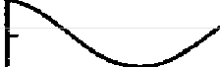
4% 4%
3% 3%
2% 2%
1% 1%
0% 0%
FIGURE 51. When there are no detectors at A or B, there is mteiference-the amount of light varies from zero to 4% (a). When there are detectors at A and B that are 100% reliable, there is no mteiference-the amount of light reaching D is a constant 2 % (b). When the detectors at A and B are not I 00 % reliable (i.e., when sometimes there is nothing left in A or in B that can be
detected), there are now three possible final conditions-A and D go off, B and D go off, and D goes off alone. The final curve is thus a mixture, made up of contributions from each possible final condition. When the detectors at A and B are less reliable, there is more inteif erence present. Thus the detectors m case (c) are less reliable than in case (d). The pnnciple regarding interference
is: The probability of each of the different possible final conditions must be independently calculated fry adding arrows and squaring the length of the final arrow; after that, the several probabilities are added together m the normal fashzon.

a limited number of bits and pieces that can be com-pounded to form all the phenomena that involve light and electrons? Is there a limited number of "letters" in this language of quantum electrodynamics that can be com-bined to form "words" and "phrases" that describe nearly every phenomenon of Nature?
The answer is yes; the number is three. There are only three basic actions needed to produce all of the phenomena associated with light and electrons.
Before I tell you what these three basic actions are, I should properly introduce you to the actors. The actors are photons and electrons. The photons, particles of light, have been discussed at length in the first two lectures. Elec-trons were discovered in 1895 as particles: you could count them; you could put one of them on an oil drop and meas-ure its electric charge. It gradually became apparent that the motion of these particles accounted for electricity in wtres.
Shortly after electrons were discovered it was thought that atoms were like little solar systems, made up of a cen-tral, heavy part (called the nucleus) and electrons, which went around in "orbits," much like the planets do when they go around the sun. If you think that's the way atoms are, then you're back in 1910. In 1924 Louis De Broglie found that there was a wavelike character associated with
electrons, and soon afterwards, C. J. Davisson and L. H.
Germer of the Bell Laboratories bombarded a nickel crystal with electrons and showed that they, too, bounced off at crazy angles Gust like X-rays do), and that these angles could be calculated from De Broglie's formula for the wave-length of an electron.
When we look at photons on a large scale-much larger than the distance required for one stopwatch turn-the phenomena that we see are very well approximated by rules such as "light travels in straight lines," because there are enough paths around the path of minimum time to rein-

force each other, and enough other paths to cancel each other out. But when the space through which a photon moves becomes too small (such as the tiny holes in the screen), these rules fail-we discover that light doesn't have to go in straight lines, there are interferences created by two holes, and so on. The same situation exists with elec-trons: when seen on a large scale, they travel like particles, on definite paths. But on a small scale, such as inside an atom, the space is so small that there is no main path, no "orbit"; there are all sorts of ways the electron could go, each with an amplitude. The phenomenon of interference becomes very important, and we have to sum the arrows to predict where an electron is likely to be.
It's rather interesting to note that electrons looked like particles at first, and their wavish character was later dis-covered. On the other hand, apart from Newton making a mistake and thinking that light was "corpuscular," light looked like waves at first, and its characteristics as a particle were discovered later. In fact, both objects behave some-what like waves, and somewhat like particles. In order to save ourselves from inventing new words such as "wavicles," we have chosen to call these objects "particles," but we all know that they obey these rules for drawing and combining arrows that I have been explaining. It appears that all the "particles" in Nature--quarks, gluons, neutrinos, and so forth (which will be discussed in the next lecture)-behave in this quantum mechanical way.
So now, I present to you the three basic actions, from which all the phenomena of light and electrons arise.
-ACTION #1: A photon goes from place to place.
-ACTION #2: An electron goes from place to place.
-ACTION #3: An electron emits or absorbs a photon.
Each of these actions has an amplitude-an arrow-that can be calculated according to certain rules. In a moment, I'll tell you those rules, or laws, out of which we can make

the whole world (aside from the nuclei, and gravitation, as always!).
Now, the stage on which these actions take place is not just space, it is space and time. Until now, I have disre-garded problems concerning time, such as exactly when a photon leaves the source and exactly when it arrives at the detector. Although space is really three-dimensional, I'm going to reduce it to one dimension on the graphs that I'm going to draw: I will show a particular object's location in space on the horizontal axis, and the time on the vertical axis.
The first event I am going to draw in space and time-orspace-time, as I might inadvertently call it-is a baseball standing still (See Fig. 52). On Thursday morning, which

Time

T31 +-

T2
r,
To. ..."':-----
Xo Space
FIGURE 52. The stage on which all ac-tions in the universe take place is space-time Usually consisting off our dimensions (three for space and one for ltme), space-time will be represented here in two dimen-sions-one for space, in the honzontal di-mension, and one for time, zn the vertical Each time we look at the baseball (such as
at time T3), it is in the same place This produces a "band of baseball" going straight up, as time goes on

I will label as T ₀, the baseball occupies a certain space, which I will label as X₀. A few moments later, at T ₁, it occupies the same space, because it's standing still. A few moments later, at T₂, the baseball is still at X₀. So the diagram of a baseball standing still is a vertical band, going straight up, with baseball all over it inside.
What happens if we have a baseball drifting in the weight-lessness of outer space, going straight toward a wall? Well,

on Thursday morning (T₀) it starts at Xo (see Fig. 53), but a little bit later, it's not in the same place-it has drifted over a little bit, to X₁. As the baseball continues to drift, it creates a slanted "band of baseball" on the diagram of space-time. When the baseball hits the wall (which is stand-ing still and is therefore a vertical band), it goes back the other way, exactly where it came from in space (Xo), but to a different point in time (T₆).

FIGURE 53. A baseball dnfting di-rectly toward a wall at nght angles and then bouncing back to its onginal loca-tzon (shown below the graph) zs moving m one dimension and appears as a slanted "band of baseball " At times T₁ and T₂, the baseball zs getting closer to the wall, at T₃ it hits the wall, and begins to go back
Time
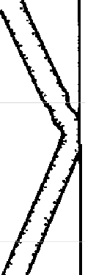
T6
T5
T4 w
A
T3 l
L
T2

T1
To L ��-;:';--.
-X3
� !WALL!

As for the time scale, it is most convenient to represent the time not in seconds, but in much smaller units. Since we will be dealing with photons and electrons, which move very rapidly, I am going to have a 45° angle represent something going the speed of light. For example, for a particle moving at the speed of light from X₁T₁ to X₂T₂, the horizontal distance between X₁ and X₂ is the same as the vertical distance between T₁ and T₂ (see Fig. 54). The factor by which time is stretched out (to make a 45° angle represent a particle going the speed of light) is called c, and you'll find e's flying around everywhere in Einstein's formulas-they are the result of the unfortunate choice of the second as the unit of time, rather than the time it takes light to go one meter.
Now, let's look at the first basic action in detail-a photon

goes from place to place. I will draw this action as a wiggly line from A to B for no good reason. I should be more careful: I should say, a photon that is known to be at a given place at a given time has a certain amplitude to get to another place at another time. On my space-time graph (see Fig. 55), the photon at point A-at X1 and T1-has an amplitude to appear at point B-X₂ and T ₂. The size of this amplitude I will call P(A to B).

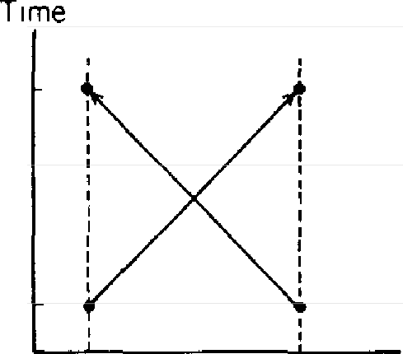
TT2
(The time
ii tokes l1gh1 to go 30cm)

J_T
I

x1 x2 Space
r--30 cm ,
FIGURE 54. The time scale I will use m these graphs wzll show particles going at the speed of lzght to be travelling at a 45-degree an-gle through space-time. The amount of tzme zt takes light to go
30 centimeters-from X1to X₂ or from X2 to X1-is about one-bil-lionth of a second.

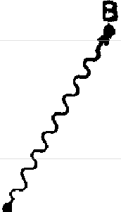
Time
A

Tz

Space
FIGURE 55. A photon (represented by a wavy lme) has an amplitude to go from a point A m space-time to another point, B. This amplitude, which I will call P(A to B), is calculated from a formula that depends only on the
difference m locatzon-(X2 - X)--and the difference of the time-(T -
1
2
T₁). In fact, it's a simple function that is the inverse of the difference of their squares-an "interval," I, that can be wntteri as (X₂ -X1)2 - (T₂ - T₁)2.

There is a formula for the size of this arrow, P(A to B). It is one of the great laws of Nature, and it's very simple. It depends on the difference in distance and the difference in time between the two points. These differences can be expressed mathematically2 as (X₂ - X₁) and (T₂ - Ti).
The major contribution to P(A to B) occurs at the con-ventional speed of light-when (X₂- X₁) is equal to (T ₂ - T ₁)-where one would expect it all to occur, but there is also an amplitude for light to go faster (or slower) than the conventional speed of light. You found out that in the last lecture that light doesn't go only in straight lines; now, you find out that it doesn't go only at the speed of light!
It may surprise you that there is an amplitude for a photon to go at speeds faster or slower than the conven-tional speed, c. The amplitudes for these possibilities are very small compared to the contribution from speed c; in fact, they cancel out when light travels over long distances. However, when the distances are short-as in many of the

2 In these lectures, I am plotting a point's location in space in one dimension, along the x-axis. To locate a point in three-dimensional space, a ''room" has to be set up, and the distance of the point from the floor and from each of two adjacent walls (all at right angles to each other) has to be measured. These three measurements can be labeled X1, Y., and Z₁. The actual distance from this point to a second point with measure-ments X2, Y2, Z2can be calculated using a "three-dimensional Pythagorean Theorem": the square of this actual distance is
(X2 - X1)2 + (Y2 - Y1)2 + (Z2 - Zi)².
The excess of this over the time difference, squared-
(X₂- X1)2 + (Y2 - Y₁)2 + (Z2 - Z1)2 - (T2 - T1)2
-is sometimes called "the Interval," or /, and is the combination that Einstein's theory of relativity says that P(A to B) must depend on. Most of the contribution to the final arrow for P(A to B) is just where you would expect it-where thedifference in distance is equal to the difference in time (that is, when / 1s zero). But in addition� there is a contribution when / is not zero, that is inversely proportional to /: it points in the direction of 3 o'clock when / is more than zero (when light is going faster than c), and points toward 9 o'clock when I is less than zero. These later contributions cancel out in many circumstances (see Fig. 56).

diagrams I will be drawing-these other possibilities be-come vitally important and must be considered.
So that's the first basic action, the first basic law of physics-a photon goes from point to point. That explains all about optics; that's the entire theory of light! Well, not quite: I left out polarization (as always), and the interaction of light with matter, which brings me to the second law.

(speedC)

I= 0

(slower than C)I<O I>O(faster than C)
FIGURE 56. When light goes at the speed C, the "interval," I, equals zero, and there is a large contribution in the 12 o'clock direction. When 1 is greater than zero, there is a small contribution in the three o'clock direction inversely proportional to I; when I is less than zero, there is a similar contribution in the nine o'clock direction. Thus light has an amplitude to go faster or slower than speed C, but these amplitudes cancel out over long distances.

The second action fundamental to quantum electrod y-namics is: An electron goes from point A to point B in space-time. (For the moment we will imagine this electron as a simplified, fake electron, with no polarization-what the physicists call a "spin-zero" electron. In reality, electrons have a type of polarization, which doesn't add anything to the main ideas; it only complicates the formulas a little bit.) The formula for the amplitude for this action, which I will call E(A to B) also depends on (X₂-X₁) and(T₂-T₁) (in the same combination as described in note 2) as well as on a number I will call "n," a number that, once determined, enables all our calculations to agree with experiment. (We will see later how we determine n's value.) It is a rather complicated formula, and I'm sorry that I don't know how

to explain it in simple terms. However, you might be in-terested to know that the formula for P(A to B)-a photon going from place to place in space-time-is the same as that for E(A to B)-an electron going from place to place-if n is set to zero.3
The third basic action is: an electron emits or absorbs a photon-it doesn't make any difference which. I will call this action a 'junction," or "coupling." To distinguish elec-trons from photons in my diagrams, I will draw each elec-tron going through space-time as a straight line. Every cou-pling, therefore, is a junction between two straight lines and a wavy line (see Fig. 58). There is no complicated for-mula for the amplitude of an electron to emit or absorb a photon; it doesn't depend on anything-it's just a number! This junction number I will call j-its value is about - 0.1: a shrink to about one-tenth, and half a turn.4
Well, that's all there is to these basic actions-except for some slight complications due to this polarization that we're

'The formula for E(A to B) is complicated, but there is an interesting way to explain what it amounts to. E(A to B) can be represented as a giant sum of a lot of different ways an electron could go from point A to point B in space-time (see Fig. 57): the electron could take a "one-hop flight," going directly from A to B; it could take a "two-hop flight," stopping at an intermediate point C; it could take a "three-hop flight," stopping at points D and E, and so on. In such an analysis, the amplitude for each "hop"-from one point F to another point G-is P(F to G), the same as the amplitude for a photon to go from a point F to a point G. The amplitude for each "stop" is represented by n2, n being the same number I mentioned before which we used to make our calculations come out right.
The formula for E(A to B) is thus a series of terms: P(A to B) [the "one-hop" flight] + P(A to C)*n2*P(C to B) ["two-hop" flights, stopping at CJ
+ P(A to D)*n2*P(D to E) * n2*P(E to B) ["three-hop" flights, stopping at D and EJ + ... for all possible intermediate points C, D, E, and so on.
Note that when n increases, the nondirect paths make a greater con-tribution to the final arrow. When n is zero (as for the photon), all terms with an n drop out (because they are also equal to zero), leaving only the first term, which is P(A to B). Thus E(A to B) and P(A to B) are closely related.
4 This number, the amplitude to emit or absorb a photon, is sometimes called the "charge" of a particle.

(a) ( b)

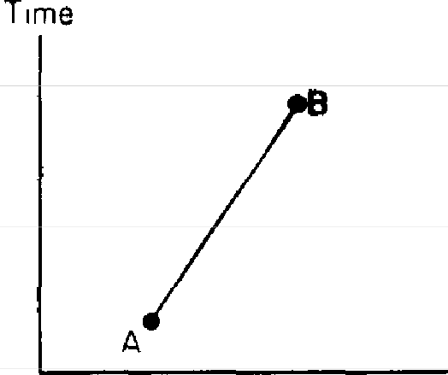
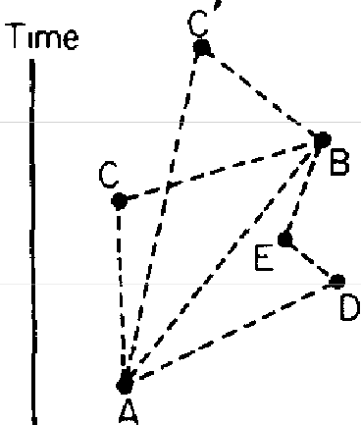
Space Space
FIGURE 57. An electron has an amplitude to go from point to point in space-time, which I will call "E(A to B)." Although I will represent E(A to B) as a straight line between two points (a), we can thmk of it as the sum of many amplitudes (b)-among them, the amplitude for the electron to change direction at points C or C' on a "two-hop" path, and the amplitude to change direction at D and E on a "three-hop" path-in addition to the direct path from A to B. The number of times an electron can change direction IS anywhere from zero to infinity, and the points at which the electron can change direction on its way from A to B in space-time are infinite. All are included in E( A
to B).

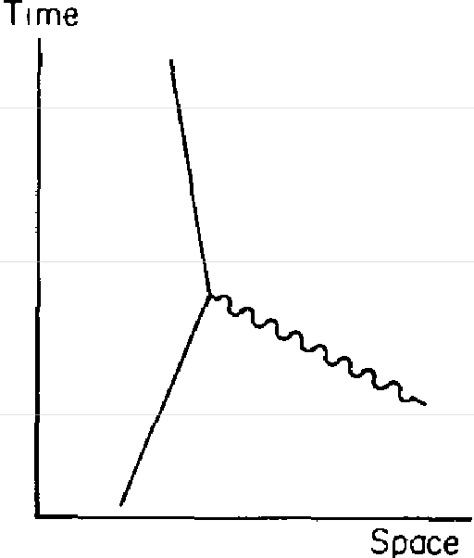
FIGURE 58. An electron, depicted by a straight line, has a certain amplitude to emit or absorb a photon, shown by a wavy line. Since the amplitude to emit or absorb
IS the same, I will call either case a "cou-pling." The amplitude for a coupling IS a number that I will call j; it is about - 0.1
for the electron (this number is sometimes called the "charge").

always leaving out. Our next job is to put these three actions together to represent circumstances that are somewhat more complicated.
For our first example, let's calculate the probability that two electrons, at points l and 2 in space-time, end up at

points 3 and 4 (see Fig. 59). This event can happen in several ways. The first way is that the electron at I goes to 3-<:omputed by putting I and 3 into the formula E(A to B), which I will write as E( I to 3)-and the electron at 2 goes to 4----<:omputed by E(2 to 4). These are two "sube-vents" happening concomitantly, so the two arrows are mul-tiplied to produce an arrow for this first way the event could happen. Therefore we write the formula for the "first-way arrow" as E(l to 3) * E(2 to 4).

4
2
3
4
2
Space Space
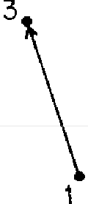
FIGURE 59. To calculate the probability that electrons at points 1 and 2 in space-time end up at points 3 and 4, we calculate the ''first way" arrow for 1 going to 3 and 2 going to 4 with the formula for E( A to B); then we calculate the "second way'' arrow for 1 going to 4 and 2 going to 3 (a "cross-over"). Finally, we add the ''first way" and "second way" arrows to arrive at a good approximation of the final arrow. (This is true for the fake, simplified "spin zero" electron. Had we included the polarization of the electron, we would have subtracted-rather than added-the two arrows.)

Another way this event could happen is that the electron at 1 goes to 4 and the electron at 2 goes to 3-again, two concomitant subevents. The "second-way arrow" is E(1 to 4) * E(2 to 3), and we add it to the "first-way" arrow.5
This is a good approximation for the amplitude of this event. To make a more exact calculation that will agree more closely with the results of experiment, we must con-
, Had I included the effects of the polarization of the electron, the ''second-way" arrow would have been "subtracted"-turned 180° and added. (More on this comes later in this lecture.)

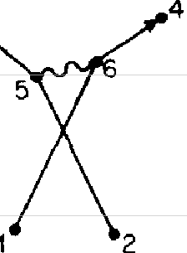
sider other ways this event could happen. For instance, for each of the two main ways the event can happen, one elec-tron could go charging off to some new and wonderful place and emit a photon (see Fig. 60). Meanwhile, the other electron could go to some other place and absorb the pho-

4
3
3
Space Space
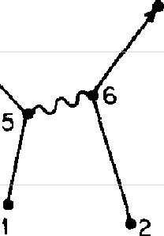
FIGURE 60. Two "other ways" the event in Fig. 59 could happen are: a photon is emitted at 5 and absorbed at 6 for each case. The final conditions of these alternatives are the same as for the other cases-two electrons went tn, and two electrons came out-and these results are indistinguishable from the other alternatives. Therefore the arrows for these "other ways" must be added to the arrows in Fig. 59 to arrive at a better approximation of the final arrow for the event.

ton. Calculating the amplitude for the first of these new ways involves multiplying the amplitudes for: an electron goes from 1 to the new and wonderful place, 5 (where it emits a photon), and then goes from 5 to 3; the other electron goes from 2 to the other place, 6 (where it absorbs the photon), and then goes from 6 to 4. We must remember to include the amplitude that the photon goes from 5 to
6. I'm going to write the amplitude for this way the event could happen in a high-class mathematical fashion, and you can follow along: E(l to 5)*}*E(5 to 3) * E(2 to 6)*}*E(6 to 4) * P(5 to 6)-a lot of shrinking and turning. (I'll let you figure out the notation for the other case, where the elec-tron at I ends up at 4, and the electron at 2 ends up at 3.)6
6 The final conditions of the experiment for these more complicated ways are the same as for the simpler ways-electrons start at points I and

But wait: positions 5 and 6 could be anywhere in space and time-yes, anywhere-and the arrows for all of those positions have to be calculated and added together. You see it's getting to be a lot of work. Not that the rules are so difficult-it's like playing checkers: the rules are simple, but you use them over and over. So our difficulty in cal-culating comes from having to pile so many arrows to-gether. That's why it takes four years of graduate work for the students to learn how to do this efficiently-and we're looking at an easy problem! (When the problems get too difficult, we just put them on the computer!)
I would like to point out something about photons being emitted and absorbed: if point 6 is later than point 5, we might say that the photon was emitted at 5 and absorbed at 6 (see Fig. 61). If 6 is earlier than 5, we might prefer to say the photon was emitted at 6 and absorbed at 5, but we could just as well say that the photon is going backwards in time! However, we don't have to worry about which way in space-time the photon went; it's all included in the for-mula for P(5 to 6), and we say a photon was "exchanged." Isn't it beautiful how simple Nature is!7
Now, in addition to the photon that is exchanged between 5 and 6, another photon could be exchanged-between two points, 7 and 8 (see Fig. 62). I'm too tired to write down all the basic actions whose arrows have to be multiplied, but-as you may have noticed-every straight line gets an
E(A to B), every wavy line gets a P(A to B), and every coupling gets a j. Thus, there are six E(A to B)'s, two P(A to B)'s, and four j's-for every possible 5, 6, 7, and 81 That makes billions of tiny arrows that have to be multiplied and then added together!

2 and end up at points 3 and 4-so we cannot distinguish between these alternatives and the first two. Therefore we must add the arrows for these two ways to the two ways just previously considered.
7 Such an exchanged photon that never really appears in the initial or final conditions of the experiment is sometimes called a "virtual photon."

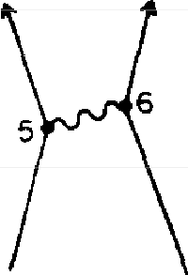
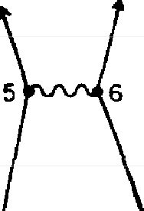
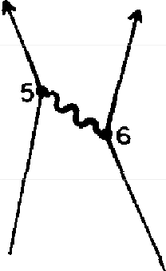
Trrne
(a)
( bl
(c)
Space
FIG URE 61. Since light has an amplitude to go faster or slower than the conventional speed of light, the photons in all three examples above can be thought of as being emitted from point 5 and absorbed at point 6, even though the photon in example (b) is emitted at the same time that it is absorbed, and the photon in (c) is emitted later than lt is absorbed-a situation in which you might have preferred to say that it was emitted by 6 and absorbed by 5; othenvise, the photon would have to go backwards in time! As far as calculating (and Nature) is concerned, it's all the same (and it's all possible), so we simply say a photon is "exchanged" and plug the locations m space-time into the formula for P(A to B).
2

4
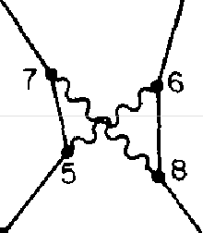

Space
FIGURE 62. Yet another way the event in Fig. 59 could happen is that two photons could be exchanged, Many diagrams of this way are possible (as we will see in more detail later); one of them is shown here. The arrow for this way involves all possible intermediate points 5, 6, 7, and 8, and is calculated with great difficulty. Because j is less than 0.1, the length of this arrow is generally less than 1 part in 10,000 (because there are four couplings in-volved) compared to the "first way" and "sec-ond way" arrows m Fig. 59 that contained no j's.

It appears that calculating the amplitude for this simple event is a hopeless business, but when you're a graduate student you've got to get your degree, so you keep on going. But there is hope for success. It is found in that magic number, j. The first two ways the event could happen had

no j's in the calculation; the next way had }*j, and the last way we looked at had }*}*j*j. Since}*} is less than 0.01, it means the length of the arrow for this way is generally less than 1% of the arrow for the first two ways; an arrow with
}*}*}*j in it is less than I% of I %-one part in 10,000-compared to the arrows that have no j. If you've got enough time on the computer, you can work out the possibilities that involve j6-one part in a million-and match the ac-curacy of the experiments. That's how the calculations of simple events are made. That's the way it works; that's all there is to it!
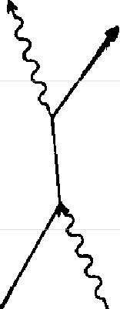
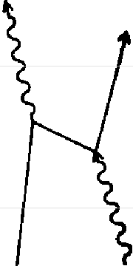
Let's look at another event now. We begin with a photon and an electron, and we end with a photon and an electron. One way this event can happen is: a photon is absorbed by an electron, the electron continues on a bit, and a new photon comes out. This process is called the scattering of light. When we make the diagrams and calculations for scattering, we must include some peculiar possibilities (see Fig. 63). For example, the electron could emit a photon before absorbing one (b). Even more strange is the possibility

(a}
(b)
( C)
Space
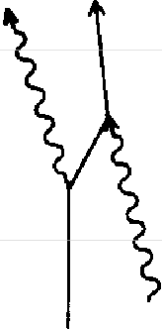
FIGURE 63. The scattering of light involves a photon going into an electron and a photon coming out-not necessarily m that order, as seen in example
(b). The example in (c) shows a strange but real possibility: the electron emits a photon, rushes backwards in time to absorb a photon, and then continues forwards in tzme.

(c) that the electron emits a photon, then travels backwards in time to absorb a photon, and then proceeds forwards in time again. The path of such a "backwards-moving" elec-tron can be so long as to appear real in an actual physical experiment in the laboratory. Its behavior is included in these diagrams and the equation for E{A to B).
The backwards-moving electron when viewed with time moving forwards appears the same as an ordinary electron, except it's attracted to normal electrons-we say it has a "positive charge." (Had I included the effects of polariza-tion, it would be apparent why the sign of j for the back-wards-moving electron appears reversed, making the charge appear positive.) For this reason it's called a "pos-itron." The positron is a sister particle to the electron, and is an example of an "anti-particle."8
This phenomenon is general. Every particle in Nature has an amplitude to move backwards in time, and therefore has an anti-particle. When a particle and its anti-particle collide, they annihilate each other and form other particles. (For positrons and electrons annihilating, it is usually a pho-ton or two.) And what about photons? Photons look exactly the same in all respects when they travel backwards in time-as we saw earlier-so they are their own anti-parti-cles. You see how clever we are at making an exception part of the rule!
I'd like to show you what this backwards-moving electron looks like to us, as we move forwards in time. With a se-quence of parallel lines to aid the eye, I'm going to divide the diagram into blocks of time, T₀ to T ₁₀ (see Fig. 64). We start at T_{O} with an electron moving toward a photon, which is moving in the opposite direction. All of a sudden-at T₃-the photon turns into two particles, a positron and an
8 Dirac proposed the reality of "anti-electrons" in 1931; in the following year, Carl Anderson found them experimentally and called them "�si-trons." Today, positrons can be easily made (for example, by making two photons collide with each other) and kept for weeks in a magnetic field.

FIGURE 64. Looking at example (c) from Fig. 63 going only forwards in tirrn! (as we are forced to do in the laboratory), from T_{O}to T J we see the electron and pho-ton moving toward each other. All of a sudden, at TJ the photon "disintegrates" and two particles appear-an electron and a new kind of particle (called a "positron") which is an electron going backwards in time and which appears to move toward the original electron (itself!). At T₅ the posi-tron annihilates with the original electron to produce a new photon. Meanwhile, the electron created by the earlier photon con-tinues forwards in space-time. This se-quence of events has been obseroed in the laboratory, and is included automatically
m the formula for E(A to B) without any
modification.
Time
Tiot -
Te +---
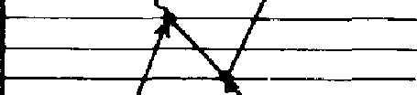
T6 i-------+ -

T4
T2 t-----+-��---
... ..... , _
To
Space

electron. The positron doesn't last very long: it soon runs into the electron-at T₅, where they annihilate and produce a new photon. Meanwhile, the electron created earlier by the original photon continues on through space-time.
The next thing I would like to talk about is an electron in an atom. In order to understand the behavior of elec-trons in atoms, we have to add one other feature, the nu-cleus-the heavy part at the center of an atom that contains at least one proton (a proton is a "Pandora's Box" that we will open in the next lecture). I will not give you the correct laws for the behavior of the nucleus in this lecture; they are very complicated. But in this case, where the nucleus is quiet, we can approximate its behavior as that of a particle with an amplitude to go from one place to another in space-time according to the formula for E(A to B), but with a much higher number for n. Since the nucleus is so heavy compared to an electron, we can deal with it approximately here by saying that it stays in essentially one place as it moves through time.

The simplest atom, called hydrogen, is a proton and an electron. By exchanging photons, the proton keeps the electron nearby, dancing around it (see Fig. 65).9 Atoms that contain more than one proton and the corresponding number of electrons also scatter light (atoms in the air scat-ter light from the sun and make the sky blue), but the diagrams for these atoms would involve so many straight and wiggly lines that they'd be a complete mess!

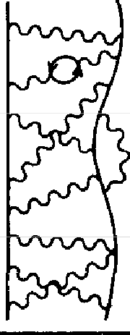
Time
prof on eleclron
FIGURE 65. Anelectroniskeptwithm a certain range of distance to the nucleus of an atom by photon exchanges wzth a proton (a ''Pandora's Box" that we will look into in Chapter 4) For now, the proton can be approximated as a station-ary particle Shown here is a hydrogen atom, consisting of a proton and an elec-tron exchanging photons.

Space

Time

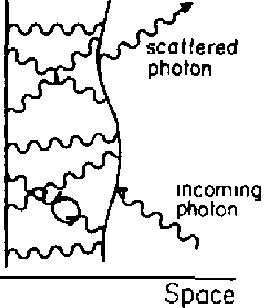
proton electron
FIGURE 66. The scattenng of light by an electron in an atom is the phenomenon that accounts fm partial reflection in a layer of glass The diagram shows one way thl.S event can happen m a hydrogen atom.

Now, I'd like to show you a diagram of an electron in a hydrogen atom scattering light (see Fig. 66). As the electron and the nucleus are exchanging photons, a photon comes
9 The amplitude for the photon exchange 1s ( - ;) * P(A - B) *;-two couplmgs and the amplitude for a photon to go from place to place. The amphtude for a proton to have a couplmg with a photon 1s - J·

from outside the atom, hits the electron and is absorbed; then a new photon is emitted. (As usual, there are other possibilities to be considered, such as the new photon is emitted before the old photon is absorbed.) The total am-plitude for all the ways an electron can scatter a photon can be summed up as a single arrow, a certain amount of shrink and turn. (Later, we will call this arrow "S.'') This amount depends on the nucleus and the arrangement of the electrons in the atoms, and is different for different materials.
Now, let's look again at the partial reflection of light by a layer of glass. How does it work? I talked about light being reflected from the front surface and the back surface. This idea of surfaces was a simplification I made in order to keep things easy at the beginning. Light is really not affected by surfaces. An incoming photon is scattered by the electrons in the atoms inside the glass, and a new photon comes back up to the detector. It's interesting that instead of adding up all the billions of tiny arrows that represent the amplitude for all the electrons inside the glass to scatter an incoming photon, we can add just two arrows-for the "front surface" and "back surface" reflections-and come out with the same answer. Let's see why.
To discuss reflection by a layer from our new point of view we must take into account the dimension of time. Previously, when we talked about light from a monochro-matic source, we used an imaginary stopwatch that times a photon as it moves-the hand of this stopwatch deter-mined the angle of the amplitude for a given path. In the formula for P(A to B) (the amplitude for a photon to go from point to point) there is no mention of any turning. What happened to the stopwatch? What happened to the turning?
In the first lecture I simply said that the light source was monochromatic. To correctly analyze partial reflection by a layer, we need to know more about a monochromatic

light source. The amplitude for a photon to be emitted by a source varies, in general, with the time: as time goes on, the angle of the amplitude for a photon to be emitted by a source changes. A source of white light-many colors mixed together-emits photons in a chaotic manner: the angle of the amplitude changes abruptly and irregularly in fits and starts. But when we construct a monochromatic source, we are making a device that has been carefully arranged so that the amplitude for a photon to be emitted at a certain time is easily calculated: it changes its angle at a constant speed, like a stopwatch hand. (Actually, this arrow turns at the same speed as the imaginary stopwatch we used before, but in the opposite direction-see Fig. 67.)

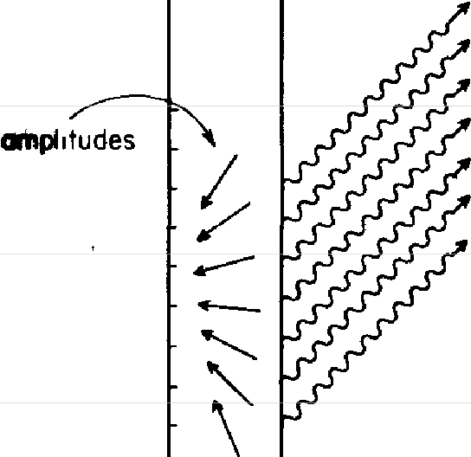

s
monochromat,c) source
(
FIGURE 67. A mono-
chromatic source is a beau-tifully constructed apparatus that emits a photon in a very predictable way: the ampli-tude for a photon to be emit-ted at a certain time rotates counterclockwise as time moves forwards. Thus the amplitude for the source to emit a photon at a later time has a lesser angle. It will be assumed that all the light emitted from the source goes at speed c (since the distances are large).

The rate of turning depends on the color of the light: the amplitude for a blue source turns nearly twice as fast as that for a red source, just as before. So the timer we used for the "imaginary stopwatch" was the monochromatic source:-in reality, the angle of the amplitude for a given

path depends on what time the photon is emitted from the source.
Once a photon has been emitted, there is no further turning of the arrow as a photon goes from one point to another in space-time. Although the formula P(A to B) says that there is an amplitude for light to go from one place to another at speeds other than c, the distance from the source to the detector in our experiment is relatively large (compared to an atom), so the only surviving contribution to P(A to B)'s length that counts comes from speed c.
To begin our new calculation of partial reflection, let's start by defining the event completely: the detector at A makes a click at a certain time, T. Then, let's divide the layer of glass into a number of very thin sections-let's say, six (see Fig. 68a). From the analysis we did in the second lecture in which we found that nearly all the light is reflected from the middle of a mirror, we know that although each elec-tron is scattering light in all directions, when all the arrows for each section are added, the only place where they don't cancel out is where light goes straight down to the middle of the section and scatters in one of two directions-straight back up to the detector or straight down through the glass. The final arrow for the event will thus be determined by adding the six arrows representing the scattering of light from the six middle points-X₁ to X₆-arranged vertically throughout the glass.
All right, let's calculate the arrow for each of these ways the light could go-via the six points, X₁ to X₆. There are four steps involved in each way (which means four arrows will be multiplied):
-STEP #l: A photon is emitted by the source at a certain time.
-STEP #2:Thephoton goes from the source to one of the points in the glass.

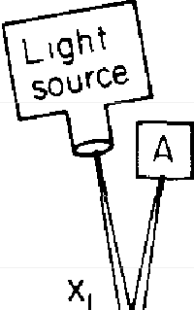
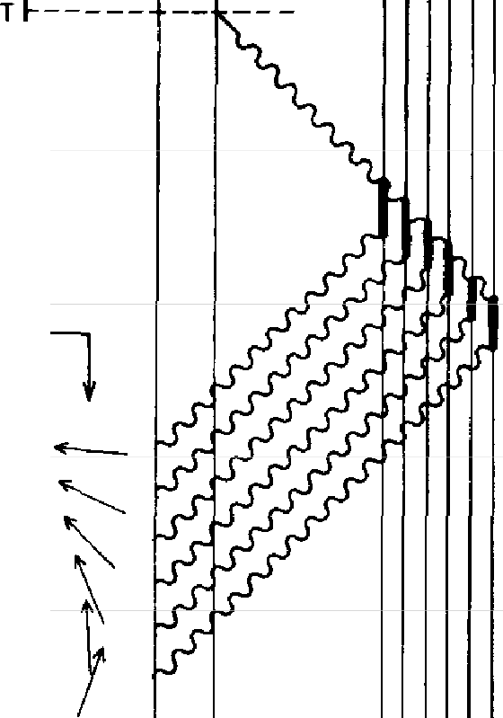
(a) ( b)

tmpl11udes

(v,o X1) T1
T2 T3 T4
T5
(VICI X6) T6

S A +gloss-i,

(mono - 5 chromot,ct
sourceP
A(de1ectar X1 X6 Space
(gloss)

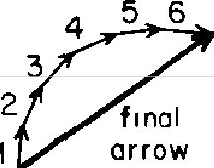
(d)
� "bock
fL. JO 2
surface"

02
11 front surface11

FIGURE 68. We begm our new analysis of partial reflection fry dividing a layer of glass into a number of sections (here, six), and looking at the various ways the light could go from the source to the glass and back up to the detector at A. The only important points in the glass (where the amplitudes for scattering light don't cancel out) are located at the middle of each section; X, to X₆ are shown m (a) at their physical location inside the glass, and in (b) as vertical lmes on the space-time graph. The event whose probability we are calculating zs: the detector at A makes a click at a certain time, T Thus the event appears as a pomt (where A and T intersect) on the space-time graph.
For each of the ways the event can happen, four steps must occur zn succes-sion, so four arrows have to be multiplied. The steps are shown zn (b) • I) a photon leaves the source al a certain time (the arrows at T₁ to T₆ represent

the amplitude to do that for su- different times); 2) the photon goes from the source to one of the points m the glass (the su- alternatives are depicted a.s wavy [mes going up to the right); 3) an electron at one of the points scatters a photon (shown as short, wide vertical lines); and 4) a new photon goes to the detector and amves at the appointed time, T (shown as a wavy line going up to the left). The amplitudes for steps 2, 3, and 4 are the same for the six alternatives, while the amplztudes for step 1 are different. compared to a photon scattered by an electron at the top of the glass (at X ₁), a photon scattered deeper in the glass-at X₂, for example-must leave the source earlier, at T₂
When we are finished multiplying the four arrows for each alternative, the resulting arrows, shown in (c), are shorter than those in (b); each has been turned 90° (m accordance with the scattenng charactenstzcs of electrons zn glass). When these szx arrows are added together in order, they form an arc; the final arrow zs zts chord. The same final arrow can be obtained by drawing two radius arrows, shown in (d), and "subtracting" them (turning the ''front suiface" arrow around zn the opposite direction and adding zt to the "back suiface" arrow). Thzs shortcut was used as a simplification m the first lecture.

-STEP #3:Thephoton is scattered by an electron at that point.
-STEP #4:A new photon makes its way up to the detector.

We will say the amplitudes for steps 2 and 4 (a photon goes to or from a point in the glass) involve no shrinking or turn-ing, because we can assume that none of the light gets lost or spread out between the source and the glass or between the glass and the detector. For step 3 (an electron scatters a photon) the amplitude for scattering is a con-stant-a shrink and a turn by a certain amount, S-and is the same everywhere in the glass. (This amount is, as I mentioned before, different for different materials. For glass, the turn of S is 90°.) Therefore, of the four arrows to be multiplied, only the arrow for step 1-the amplitude for a photon to be emitted from the source at a certain time-is different from one alternative to the next.
The time at which a photon would have to have been emitted to reach the detector A at time T (see Fig. 68b) is

not the same for the six different paths. A photon scatterd by X₂ would have to have been emitted slightly earlier than a photon scattered by X₁, because that path is longer. Thus the arrow at T ₂ is turned slightly more than the arrow at T_{I} because the amplitude for a monochromatic source to emit a photon at a certain time rotates counterclockwise as time goes on. The same goes for each arrow down to T₆: all six arrows have the same length, but they are turned at different angles-that is, they are pointing in different di-rections-because they represent a photon emitted by the source at different times.
After shrinking the arrow at T_{I} by the amounts pre-scribed in steps 2, 3 and 4-and turning it the 90° pre-scribed in step 3-we end up with arrow 1 (see Fig. 68c). The same goes for the arrows 2 through 6. Thus arrows 1 through 6 are all the same (shortened) length, and are turned relative to each other in exactly the same amount as the arrows at T_{I} through T₆.
Next, we add arrows 1 to 6. Connecting the arrows in order from 1 to 6, we get something like an arc, or part of a circle. The final arrow forms the chord of this arc. The length of the final arrow increases with the thickness of the glass-thicker glass means more sections, more arrows, and therefore more of a circle-until half a circle is reached (and the final arrow is its diameter). Then the length of the final arrow decreases as the thickness of the glass con-tinues to increase, and the circle becomes complete to begin a new cycle. The square of this length is the probability of the event, and it varies in the cycle of zero to 16%.
There is a mathematical trick we can use to get the same answer (see Fig. 68d): If we draw arrows from the center of the "circle" to the tail of arrow 1 and to the head of arrow 6, we get two radii. If the radius arrow from the center to arrow 1 is turned 180° ("subtracted"), then it can be combined with the other radius arrow to give us the



same final arrow! That's what I was doing in the first lec-ture: these two radii are the two arrows I said represented the "front surface" and "back surface'' reflections. They each have the famous length of 0.2.10
Thus we can get the correct answer for the probability of partial reflection by imagining (falsely) that all reflection comes from only the front and back surfaces. In this in-tuitively easy analysis, the "front surface" and "back sur-face" arrows are mathematical constructions that give us the right answer, whereas the analysis we just did-with the space-time drawing and the arrows forming part of a circle-is a more accurate representation of what is really going on: partial reflection is the scattering of light by elec-trons inside the glass.
Now, what about the light that goes through the layer of glass? First, there is an amplitude that the photon goes straight through the glass without hitting any electrons (see Fig. 69a). This is the most important arrow in terms of length. But there are six other ways a photon could reach the detector below the glass: a photon could hit X₁ and scatter the new photon down to B; a photon could hit X₂ and scatter the new photon down to B, and so on. These six arrows all have the same length as the arrows that formed the "circle" in the previous example: their length

10 The radius of the arc evidently depends on the length of the arrow for each section, which 1s ultimately determined by the amplitude S that an electron in an atom of glass scatters a photon. This radius can be calculated using the formulas for the three basic actions for the multitude of photon exchanges involved and summing up the amplitudes. It is a very difficult problem, but the radius has been calculated for relatively simple substances with considerable success, and the variation of the radius from substance to substance is fairly well understood usmg these ideas of quantum electrodynamics. It must be said, however, that no direct cal-culation from first principles for a substance as complex as glass has ever actually been done. In such cases, the radms is determined by experiment. For glass, it has been determmed from experiment that the radius is approximately 0.2 (when the hght shines directly onto the glass at right angles).

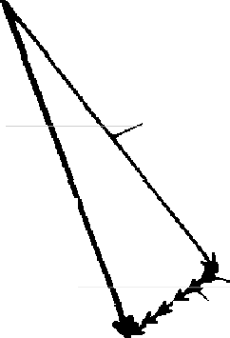
(a)

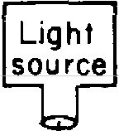
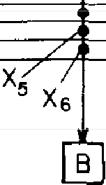
final arrow
for event-/ light goes
from S to B through glass

(b)
amplitude to reach B with no sca11er,ng

x,
"-'X2
\'x5 "- amplitude la
Xs reach B w,th
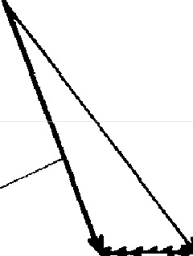
scattering from X1 thru x6

final arrow for light to go through slightly opaque material

\
scattering
with some absorption

FIGURE 69. The /,argest amplitude for light that is transmitted through the
/,ayer of glass to the detector at B comes from the part that represents no scattering by the electrons inside the glass, shown in (a). To this arrow we add six small arrows that represent the scattering of light from each of the sections, represented by points X₁ to X₆. These six arrows have the same length (because the amplitude for scattering is the same anywhere in the glass) and point in the same direction (because the length of each path from the source through any point X to B is the same). After adding the small arrows to the large one, we find the final arrow for the transmission of light through a layer of glass
is turned more than what we would have expected if the light came only directly.
For this reason it appears to us that light takes longer to go through glass than it takes to go through a vacuum or through air. The amount of turning by the final arrow caused by the electrons in a material is called the "index of refraction."
For transparent materials, the little arrows are at right angles to the main arrow (they actually curve around when we include double and triple scat-terings, keeping the final arrow from being longer than the main arrow: Nature always has it worked out so we never get more light out than we put in). For materials that are partially opc«Jue-that absorb light to an extent-the little arrows point toward the main arrow, resulting in a final arrow that is sig-nificantly shorter than expected, shown in (b). This shorter final arrow rep-resents a reduced probability of a photon being transmitted through partially
opaque material.

is based on that same amplitude of an electron in the glass to scatter a photon, S. But this time, all six arrows point in the same direction, because the length of all six paths that involve one scattering is the same. The direction of these minor arrows is at right angles to the main arrow for trans-parent substances such as glass. When the minor arrows are added to the main arrow, they result in a final arrow that has the same length as the main arrow, but is turned in a slightly different direction. The thicker the glass, the more minor arrows there are, and the more the final arrow is turned. That's how a focusing lens really works: the final arrows for all the paths can be made to point in the same direction by inserting extra thicknesses of glass into the shorter paths.
The same effect would appear if photons went slower through glass than through air: there would be extra turn-ing of the final arrow. That's why I said earlier that light appears to go slower through glass (or water) than through air. In reality, the "slowing" of the light is extra turning caused by the atoms in the glass (or water) scattering the light. The degree to which there is extra turning of the final arrow as light goes through a given material is called its "index of refraction."11
For substances that absorb light, the minor arrows are at

11 Each of the arrows for reflection by a section (that form a "circle") has the same length as each of the arrows that make the final arrow from transmission appear to turn more. Thus there is a relationship between the partial refleLtion of a material and its index of refraction.
It appears that the final arrow has become longer than I, which means that more light comes out through the glass than went into it! It looks that way because I disregarded the amplitudes for a photon to go down to one section, a new photon to scatter up to another section, and then a third photon to scatter back down through the glass-and other, more complicated possibilities-which result in the little arrows curving around and keeping the length of the final arrow between 0.92 and I (so the total probability of light being reflected or transmitted by the layer of glass is always 100%).

less than right angles to the main arrow (see Fig. 69b). This causes the final arro\\ to be shorter than the main arrow, indicating that the probability of a photon going through partially opaque glass is smaller than through transparent glass.
Thus it is that all the phenomena and the arbitrary num-bers mentioned in the first two lectures-such as partial reflection with an amplitude of 0.2, the "slowing" of light in water and glass, and so on-are explained in more detail by just the three basic actions-three actions that do, in fact, explain nearly everything else, too.
It is hard to believe that nearly all the vast apparent
variety in Nature results from the monotony of repeatedly combining just these three basic actions. But it does. I'll outline a bit of how some of this variety arises.
We may start with photons (see Fig. 70). What is the probability that two photons, at points 1 and 2 in space-time, go to two detectors, at points 3 and 4? There are two main ways this event could happen and each depends on two things happening concomitantly: the photons could go directly-P(l to 3)*P(2 to 4)-or they could "cross over"-P(l to 4)*P(2 to 3). The resulting amplitudes for these two possibilities are added, and there is interference (as we saw in the second lecture), making the final arrow vary in length, depending on the relative location of the points in space-time.
What if we make 3 and 4 the same point in space-time (see Fig. 71)? Let's say both photons end up at point 3, and see how this affects the probability of the event. Now we have P(l to 3)*P(2 to 3) and P(2 to 3)*P(l to 3), which result in two identical arrows. When added, their sum is twice the length of either one, and produces a final arrow whose square is four times the square of either arrow alone. Be-cause the two arrows are identical, they are always "lined up." In other words, the interference doesn't fluctuate ac-

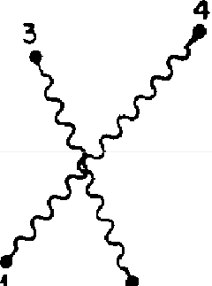
Time Time
4
3

1I
2

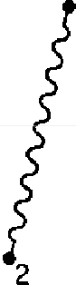
Space
Space

FIGURE 70 Photons at points 1 and 2 in space-time have an amplitude to amve at points 3 and 4 in space-time that zs approximated by considering two mazn ways the event could happen. P( 1 to 3) * P(2 to 4) and P( 1 to 4)
* P(2 to 3 ), shown above Depending on the relative locations of points 1, 2, 3, and 4, there are varying degrees of interference

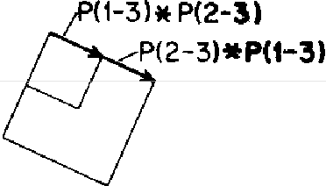
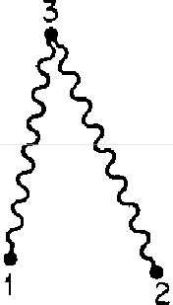
Time
Space
FIGURE 71. When points 4 and 3 are made to converge, the two arrows-p(1 to 3) * P(2 to 3) and P( 2 to 3) * P( 1 to 3 )-are identical zn length and direction When they are added they always "line uP" and form an arrow with twice the length of either arrow alone, with a square four times as large. Thus photons tend to go to the same point zn space-time This effect is magnified even more by more photons. This zs the basis of a laser's operation

cording to the relative separation between points 1 and 2; it is always positive. If we didn't think about the always positive interference of the two photons, we should have thought that we would get twice the probability, on average. Instead, we get four times the probability all the time. When

many photons are involved, this more-than-expected prob-ability increases even further.
This results in a number of practical effects. We can say that photons tend to get into the same condition, or "state" (the way the amplitude to find one varies in space). The chance that an atom emits a photon is enhanced if some photons (in a state that the atom can emit into) are already present. This phenomenon of "stimulated emission" was discovered by Einstein when he launched the quantum the-ory proposing the photon model of light. Lasers work on the basis of this phenomenon.

Time



Space
FIGURE 72. If two electrons (with the same polarization) try to go to the same point in space-time, the interference is al-ways negative becausr of the effects of po-larization: the two identical arrows-£( 1 to 3) * E(2 to 3) and E(2 to 3) * E(l to 3 )--are subtracted to make a final arrow of no kngth. The aversion of two electrons to occupy the same place in space-time is called the "Exclusion Principle," and ac-counts for the great variety of atoms in the

E(t-3l*E(2-3WE(2-3)* E ( 1-3)
universe.

If we made the same comparison with our fake, spin-zero electrons, the same thing would happen. But in the real world, where electrons are polarized, something very different happens: the two arrows, E(l to 3) * E(2 to 4) and E(l to 4) * E(2 to 3), are subtracted-one of them is turned 180° before they are added. When points 3 and 4 are the same, the two arrows have the same length and direction and thus cancel out when they are subtracted (see Fig. 72). That means electrons, unlike photons, do not like to go to the same place; they avoid each other like the plague-no

two electrons with the same polarization can be at the same point in space-time-it's called the "exclusion principle."
This exclusion principle turns out to be the origin of the great variety of chemical properties of the atoms. One pro-ton exchanging photons with one electron dancing around it is called a hydrogen atom. Two protons in the same nucleus exchanging photons with two electrons (polarized in opposite directions) is called a helium atom. You see, the chemists have a complicated way of counting: instead of saying "one, two, three, four, five protons," they say, "hy-drogen, helium, lithium, beryllium, boron."
There are only two states of polarization available to elec-trons, so in an atom with three protons in the nucleus exchanging photons with three electrons-a condition called a lithium atom-the third electron is farther away from the nucleus than the other two (which have used up the nearest available space), and exchanges fewer photons. This causes the electron to easily break away from its own nucleus under the influence of photons from other atoms. A large number of such atoms close together easily lose their individual third electrons to form a sea of electrons swimming around from atom to atom. This sea of electrons reacts to any small electrical force (photons), generating a current of electrons-I am describing lithium metal con-ducting electricity. Hydrogen and helium atoms do not lose their electrons to other atoms. They are "insulators."
All the atoms-more than one hundred different kinds-are made up of a certain number of protons exchanging photons with the same number of electrons. The patterns in which they gather are complicated and offer an enor-mous variety of properties: some are metals, some are in-sulators, some are gases, others are crystals; there are soft things, hard things, colored things, and transparent things-a terrific cornucopia of variety and excitement that comes from the exclusion principle and the repetition again

and again and again of the three very simple actions P(A to B), E(A to B), and j. (If the electrons in the world were unpolarized, all the atoms would have very similar prop-erties: the electrons would all duster together, close to the nucleus of their own atom, and would not be easily attracted to other atoms to make chemical reactions.)
You might wonder how such simple actions could pro-duce such a complex world. It's because phenomena we see in the world are the result of an enormous intertwining of tremendous numbers of photon exchanges and inter-ferences. Knowing the three fundamental actions is only a very small beginning toward analyzing any real situation, where there is such a multitude of photon exchanges going on that it is impossible to calculate-experience has to be gained as to which possibilities are more important. Thus we invent such ideas as "index of refraction" or "compres-sibility" or "valence" to help us calculate in an approximate way when there's an enormous amount of detail going on underneath. It's analogous to knowing the rules of chess-which are fundamental and simple-compared to being able to play chess well, which involves understanding the character of each position and the nature of various situ-ations-which is much more advanced and difficult.
The branches of physics that deal with questions such as
why iron (with 26 protons) is magnetic, while copper (with 29) is not, or why one gas is transparent and another one is not, are called "solid-state physics,'' or "liquid-state phys-ics," or "honest physics." The branch of physics that found these three simple little actions (the easiest part) is called "fundamental physics"-we stole that name in order to make the other physicists feel uncomfortable! The most interesting problems today-and certainly the most prac-tical problems-are obviously in solid-state physics. But someone said there is nothing so practical as a good theory, and the theory of quantum electrodynamics is definitely a good theory!

Finally, I would like to return to that number l.00115965221, the number that I told you about in the first lecture that has been measured and calculated so care-fully. The number represents the response of an electron to an external magnetic field-something called the "mag-netic moment." When Dirac first worked out the rules to calculate this number, he used the formula for E(A to B) and got a very simple answer, which we will consider in our units as 1. The diagram for this first approximation of the magnetic moment of an electron is very simple-an electron goes from place to place in space-time and couples with a photon from a magnet (see Fig. 73).

Time
2
Space
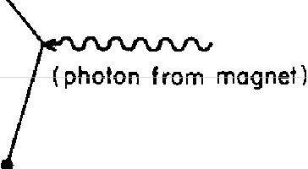
FIGURE 73. The diagram for Dirac's calculation of the magnetic motRtnt of an electron is very simple. The value represented by this diagram will be called I.

After some years it was discovered that this value was not exactly 1, but slightly more-something like 1.00116. This correction was worked out for the first time in 1948 by Schwinger as j*j divided by 2 pi, and was due to an alternative way the electron can go from place to place: instead of going directly from one point to another, the electron goes along for a while and suddenly emits a pho-ton; then (horrorsl) it absorbs its own photon (see Fig. 74). Perhaps there's something "immoral" about that, but the

electron does it! To calculate the arrow for this alternative, we have to make an arrow for every place in space-time that the photon can be emitted and every place it can be absorbed. Thus there will be two extra E(A to B)'s, a P(A to B) and two extra j's, all multiplied together. Students learn how to do this simple calculation in their elementary quantum electrodynamics course, in their second year of graduate school.

2
Space
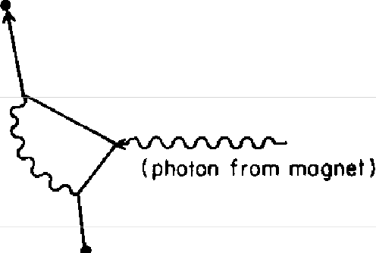
FIGURE 74. Laboratory experiments show that the actual value of the mag-netic moment of an electron is not I, but a little bit more. This zs because there are alternatives: the electron can emit a photon and then absorb it-requiring two extra E(A to B)'s, a P(A to B), and two extra j's. Schwinger calcul,ated the adjustment that takes this alternative into account to be j*j divided by 2 pi. Since this alternative is indzstinguishable experimentally from the original way the electron can go---an electron starts at point 1 and ends up at point 2-the arrows for the two alternatives are added, and there zs interference.

But wait: experiments have measured the behavior of an electron so accurately that we have to consider still other possibilities in our calculations-all the ways the electron can go from place to place with four extra couplings (see Fig. 75). There are three ways the electron can emit and absorb two photons. There's also a new, interesting possi-bility (shown at the right of Fig. 75): one photon is emitted; it makes a positron-electron pair, and-again, if you'll hold



your "moral" objections-the electron and positron anni-hilate, creating a new photon that is ultimately absorbed by the electron. That possibility also has to be figured in! It took two "independent" groups of physicists two years to calculate this next term, and then another year to find

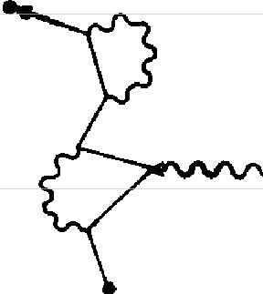
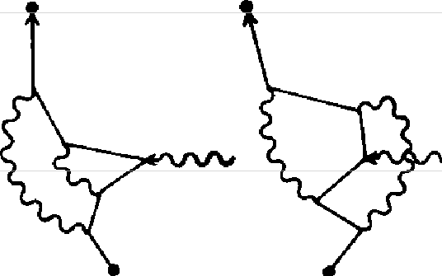
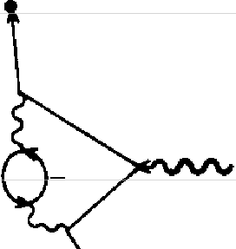
T,me
2
2
2
2
+
Space
FIGURE 75. Laboratory experiments became so accurate that further alter-natives, involving four extra couplings (over all possible intermediate points in space-time), had to be calculated, some of which are shown here. The alternative on the right involves a photon disintegrating into a positron-electron pair (as described in Fig. 64 ), which annihilates to form a new photon, which is ultimately absorbed by the electron.

out there was a mistake-experimenters had measured the value to be slightly different, and it looked for awhile that the theory didn't agree with experiment for the first time, but no: it was a mistake in arithmetic. How could two groups make the same mistake? It turns out that near the end of the calculation the two groups compared notes and ironed out the differences between their calculations, so they were not really independent.
The term with six extra j's involves even more possible ways the event can happen, and I'll draw a few of them for you now (see Fig. 76). It took twenty years to get this extra accuracy figured into the theoretical value of the magnetic

moment of an electron. Meanwhile the experimenters made even more detailed experiments and added a few more digits onto their number-and the theory still agreed with it.

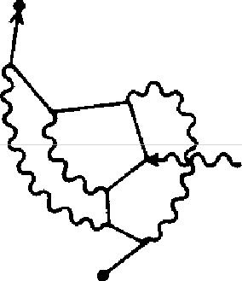
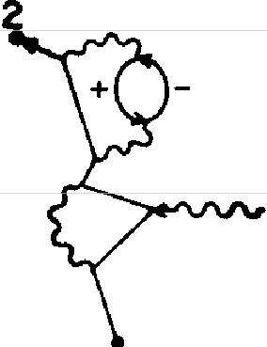
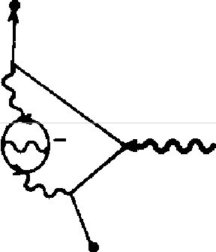
Time
2
2
+
Space
FIGURE 76. Calculations are presently going on to make the theoretical value even more accurate. The next contribution to the amplitude, which represents all possibilities with six extra couplings, involves something like
70 diagrams, three of which are shown here. As of 1983, the theoretical number was 1.00115965246, with an uncertainty of about 20 in the last two digits; the experimental number was 1.00115965221, with an uncertainty of about 4 in the last digit. This accuracy is equivalent to measuring the distance from Los Angeles to New York, a distance of over 3,000 miles, to within the width of a human hair.

So, to make our calculations we make these diagrams, write down what they correspond to mathematically, and add the amplitudes-a straightforward, "cookbook" proc-ess. Therefore, it can be done by machines. Now that we have super-duper computers, we have begun to compute the term with eight extra j's. At the present time the the-oretical number is 1.00115965246; experimentally, it's 1.00115965221, plus or minus 4 in the last decimal place. Some of the uncertainty in the theoretical value (about 4 in the last decimal place) is due to the computer's rounding off numbers; most of it (about 20) is due to the fact that

the value for j is not exactly known. The term for eight extra j's involves something like nine hundred diagrams, with a hundred thousand terms each-a fantastic calculation-and it's being done right now.
I am sure that in a few more years, the theoretical and experimental numbers for the magnetic moment of an elec-tron will be worked out to still more places. Of course, I am not sure whether the two values will still agree. That, one can never tell until one makes the calculation and does the experiments.
And so we have come full circle to the number I chose to "intimidate'' you with at the beginning of these lectures. I hope you understand the significance of this number much better now: it represents the extraordinary degree to which we've been constantly checking that the strange theory of quantum electrodynamics is indeed correct.
Throughout these lectures I have delighted in showing you that the price of gaining such an accurate theory has been the erosion of our common sense. We must accept some very bizarre behavior: the amplification and suppres-sion of probabilities, light reflecting from all parts of a mirror, light travelling in paths other than a straight line, photons going faster or slower than the conventional speed of light, electrons going backwards in time, photons sud-denly disintegrating into a positron-electron pair, and so on. That we must do, in order to appreciate what Nature is really doing underneath nearly all the phenomena we see in the world.
With the exception of technical details of polarization, I have described to you the framework by which we under-stand all these phenomena. We draw amplitudes for every way an event can happen and add them when we would have expected to add probabilities under ordinary circum-stances; we multiply amplitudes when we would have ex-pected to multiply probabilities. Thinking of everything in

terms of amplitudes may cause difficulties at first because of their abstraction, but after a while, one gets used to this strange language. Underneath so many of the phenomena we see every day are only three basic actions: one is de-scribed by the simple coupling number,j; the other two by functions-P(A to B) and E(A to B)-both of which are closely related. That's all there is to it, and from it all the rest of the laws of physics come.
However, before I finish this lecture, I would like to make a few additional remarks. One can understand the spirit and character of quantum electrodynamics without includ-ing this technical detail of polarization. But I'm sure you'll all feel uncomfortable unless I say something about what I've been leaving out. Photons, it turns out, come in four different varieties, called polarizations, that are related geo-metrically to the directions of space and time. Thus there are photons polarized in the X, Y, Z, and T directions. (Perhaps you have heard somewhere that light comes in only two states of polarization-for example, a photon going in the Z direction can be polarized at right angles, either in the X or Y direction. Well, you guessed it: in situations where the photon goes a long distance and ap-pears to go at the speed of light, the amplitudes for the Z and T terms exactly cancel out. But for virtual photons going between a proton and an electron in an atom, it is the T component that is the most important.)
In a similar manner, an electron can be in one of four conditions that are also related to geometry, but in a some-what more subtle manner. We can call these conditions 1, 2, 3, and 4. Calculating the amplitude for an electron going from point A to point B in space-time becomes somewhat more complicated, because we can now ask questions such as, "What is the amplitude that an electron liberated in condition 2 at the point A arrives in condition 3 at the point B?" The sixteen possible combinations-coming from the

four different conditions an electron can start in at A and the four different conditions it can end up in at B-are related in a simple mathematical way to the formula for that E(A to B) I told you about.
For a photon, no such modification is necessary. Thus a photon polarized in the X direction at A will still be polar-ized in the X direction at B, arriving with the amplitude P(A to B).
Polarization produces a large number of different pos-sible couplings. We could ask, for example, "What is the amplitude that an electron in condition 2 absorbs a photon polarized in the X direction and thereby turns into an elec-tron in condition 3?" All the possible combinations of po-larized electrons and photons do not couple, but those that do, do so with the same amplitude j, but sometimes with an additional turn of the arrow by some multiple of 90°.
These possibilities for the different kinds of polarization and the nature of the couplings can all be deduced in a very elegant and beautiful manner from the principles of quantum electrodynamics and two further assumptions: 1) the results of an experiment are not affected if the appa-ratus with which you are making experiments is turned in some other direction, and 2) it also doesn't make any dif-ference if the apparatus is in a spaceship moving at some arbitrary speed. (This is the principle of relativity.)
This elegant and general analysis shows that every par-ticle must be in one or another class of possible polariza-tions, which we call spin 0, spin 1/2, spin 1, spin 3/2, spin 2, and so on. The different classes behave in different ways. A spin O particle is the simplest-it has just one component, and is not effectively polarized at all. (The fake electrons and photons that we have been considering in this lecture are spin O particles. So far, no fundamental spin O particles have been found.) A real electron is an example of a spin 1/2 particle, and a real photon is an example of a spin 1

particle. Both spin 1/2 and spin 1 particles have four com-ponents. The other types would have more components, such as spin 2 particles, with ten components.
I said that the connection between relativity and polar-ization is simple and elegant, but I'm not sure I can explain it simply and elegantly! (It would take me at least one ad-ditional lecture to do it.) Although the details of polariza-tion are not essential to understanding the spirit and char-acter of quantum electrodynamics, they are, of course, essential to the correct calculation of any real process, and often have profound effects.
In these lectures we have been concentrating on relatively simple interactions between electrons and photons at very small distances, in which only a few particles are involved. But I would like to make one or two remarks about how these interactions appear in the larger world, where very, very large numbers of photons are being exchanged. On such a large scale, the calculation of arrows gets very complicated.
There are, however, some situations that are not so dif-ficult to analyze. There are circumstances, for example, where the amplitude to emit a photon by a source is in-dependent of whether another photon has been emitted. This can happen when the source is very heavy (the nucleus of an atom), or when a very large number of electrons are all moving the same way, such as up and down in the an-tenna of a broadcasting station or going around in the coils of an electromagnet. Under such circumstances a large number of photons are emitted, all of exactly the same kind. The amplitude of an electron to absorb a photon in such an environment is independent of whether it or any other electron has absorbed other photons before. There-fore its entire behavior can be given by just this amplitude for an electron to dbsorb a photon, which depend� only on the electron's position in space and time. Physicists use or-

dinary words to describe this circumstance. They say the electron is moving in an external field.
Physicists use the word "field" to describe a quantity that depends on position in space and time. Temperatures in the air provide a good example: they vary according to where and when you make your measurements. When we take polarization into account, there are more components to the field. (There are four components--corresponding to the amplitude to absorb each of the different kinds of po-larization (X, Y, Z, T) the photon might be in-technically called the vector and scalar electromagnetic potentials. From combinations of these, classical physics derives more convenient components called the electric and magnetic fields.)
In a situation where the electric and magnetic fields are
varying slowly enough, the amplitude for an electron to travel over a very long distance depends on the path it takes. As we saw earlier in the case of light, the most important paths are the ones where the angles of the amplitudes from nearby paths are nearly the same. The result is that the par-ticle doesn't necessarily go in a straight line.
This brings us all the way back to classical physics, which supposes that there are fields and that electrons move through them in such a way as to make a certain quantity least. (Physicists call this quantity "action" and formulate this rule as the "principle of least action.") This is one ex-ample of how the rules of quantum electrodynamics pro-duce phenomena on a large scale. We could expand in many directions from here, but we have to limit the scope of these lectures somewhere. I just wanted to remind you that the effects that we see on a large scale and the strange phe-nomena we see on a small scale are both produced by the interaction of electrons and photons, and are all described, ultimately, by the theory of quantum electrodynamics.

4

Loose Ends

I am going to divide this lecture into two parts. First, I am going to talk about problems associated with the theory of quantum electrodynamics itself, supposing that all there is in the world is electrons and photons. Then I will talk about the relation of quantum electrodynamics to the rest of physics.
The most shocking characteristic of the theory of quan-tum electrodynamics is the crazy framework of amplitudes, which you might think indicates problems of some sort! However, physicists have been fiddling around with am-plitudes for more than fifty years now, and have gotten very used to it. Furthermore, all the new particles and new phenomena that we are able to observe fit perfectly with everything that can be deduced from such a framework of amplitudes, in which the probability of an event is the square of a final arrow whose length is determined by com-bining arrows in funny ways (with interferences, and so on). So this framework of amplitudes has no experimental doubt about it: you can have all the philosophical worries you want as to what the amplitudes mean (if, indeed, they mean anything at all}, but because physics is an experi-mental science and the framework agrees with experiment, it's good enough for us so far.
There is a set of problems associated with the theory of
quantum electrodynamics that has to do with improving the method of calculating the sum of all the little arrows-

various techniques that are available in different circum-stances-that take the graduate students three or four years to master. Since they are technical problems, I am not going to discuss them here. It's just a matter of continuously im-proving the techniques for analyzing what the theory really has to say in different circumstances.
But there is one additional problem that is characteristic of the theory of quantum electrodynamics itself, which took twenty years to overcome. It has to do with ideal electrons and photons and the numbers n and j.

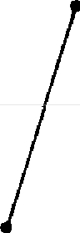
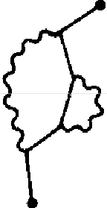
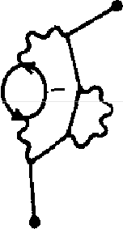
Time
direct
path
"corrections"
+

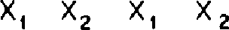
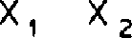
X 1 X2 Space
FIGURE 77. When we calcu/,ate the amplitude for an electron to go from point to point in space-time, we use the formu/,a for E(A to B) for the direct path. (Then we make "corrections" that include one or more photons being emitted and absorbed.) E(A to B) depends on (X₂ - X₁), (T₂ - T₁) and n, a number we stick into the formu/,a to make the answer come out right. The number n is called the "rest-mass" of an "ideal" electron, and cannot be measured experimentally because the rest-mass of a real electron, m, includes all the "corrections.'' There is a certain difficulty in calcu/,ating the n to be used in E(A to B ), that took twenty years to overcome.

If electrons were ideal, and went from point to point in space-time only by the direct path (shown at the left in Fig. 77), then there would be no problem: n would simply be the mass of an electron (which we can determine by ob-servation), and j would simply be its "charge" (the ampli-

tude for the electron to couple with a photon). It can also be determined by experiment.
But no such ideal electrons exist. The mass we observe in the laboratory is that of a real electron, which emits and absorbs its own photons from time to time, and therefore depends on the amplitude for coupling,). And the charge we observe is between a real electron and a real photon-which can form an electron-positron pair from time to time-and therefore depends on E (A to B), which involves n (see Fig. 78). Since the mass and charge of an electron

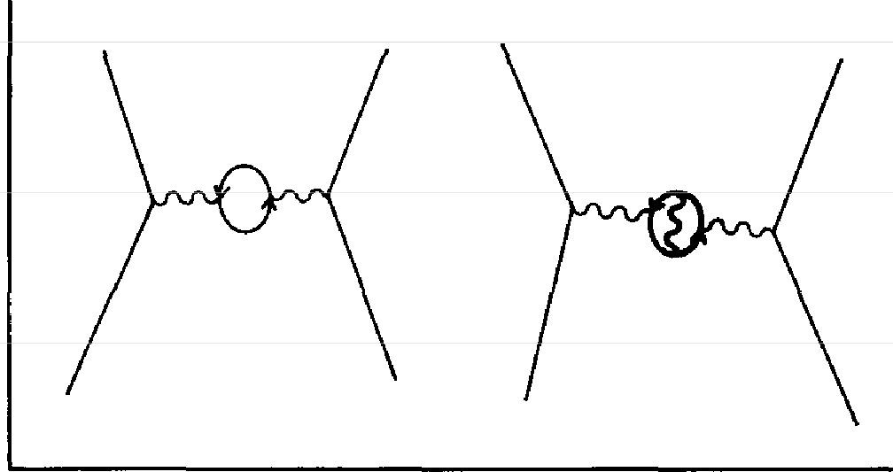
Time
Space

FIGURE 78. The experimentally measured amplitude for an electron to couple with a photon, a mysterious number, e, is a number determined uy
experiment that includes all the "corrections" for a photon going from point to point in space-time, of which two are shown here. When calculating, we need a number, j, that does not include these corrections, but includes only the photon going directly from point to point. A difficulty exists with computing this j that is similar to the difficulty in computing the value of n.

are affected by these and all other alternatives, the exper-imentally measured mass, m, and the experimentally meas-ured charge, e, of the electron are different from the num-bers we use in our calculations, n and j.
If there were a definite mathematical connection between
n and j on the one hand, and m and e on the other, there

would still be no problem: we would simply calculate what values of n and j we need to start with in order to end up with the observed values, m and e. (If our calculations didn't agree with m and e, we would jiggle the original n and j around until they did.)
Let's see how we actually calculate m. We write a series of terms that is something like the series we saw for the magnetic moment of the electron: the first term has no couplings-just E (A to B)-and represents an ideal elec-tron going directly from point to point in space-time. The second term has two couplings and represents a photon being emitted and absorbed. Then come terms with four, six, and eight couplings, and so on (some of these "correc-tions" are shown in Fig. 77).
When calculating terms with couplings, we must consider (as always) all the possible points where couplings can occur, right down to cases where the two coupling points are on top of each other-with zero distance between them. The problem is, when we try to calculate all the way down to zero distance, the equation blows up in our face and gives meaningless answers-things like infinity. This caused a lot of trouble when the theory of quantum electrodynamics first came out. People were getting infinity for every prob-lem they tried to calculatel (One should be able to go down to zero distance in order to be mathematically consistent,
but that's where there is no n or j that makes any sense;
that's where the trouble is.)
Well, instead of including all possible coupling points down to a distance of zero, if one stops the calculation when
the distance between coupling points is very small-say, 1o-30 centimeters, billions and billions of times smaller than
anything observable in experiment (presently I0-¹⁶ centi-meters)-then there are definite values for n and j that we can use so that the calculated mass comes out to match the m observed in experiments, and the calculated charge

matches the observed charge, e. Now, here's the catch: if somebody else comes along and stops their calculation at a different distance-say, 10-40 centimeters-their values for n and j needed to get the same m and e come out different! Twenty years later, in 1949, Hans Bethe and Victor Weisskopf noticed something: if two people who stopped at different distances to determine n and j from the same m and e then calculated the answer to some other problem-each using the appropriate but different values for n and j-when all the arrows from all the terms were included, their answers to this other problem came out nearly the same! In fact, the closer to zero distance that the calcula-tions for n and j were stopped, the better the final answers for the other problem would agree! Schwinger, Tomonaga, and I independently invented ways to make definite cal-culations to confirm that it is true (we got prizes for that).
People could finally calculate with the theory of quantum electrodynamics!
So it appears that the only things that depend on the small distances between coupling points are the values for n and j-theoretical numbers that are not directly obseroable any-way; everything else, which can be observed, seems not to be affected.
The shell game that we play to find n and j is technically
called "renormalization." But no matter how clever the word, it is what I would call a dippy process! Having to resort to such hocus-pocus has prevented us from proving that the theory of quantum electrodynamics is mathemat-ically self-consistent It's surprising that the theory still hasn't been proved self-consistent one way or the other by now; I suspect that renormalization is not mathematically legitimate. What is certain is that we do not have a good mathematical way to describe the theory of quantum elec-trodynamics: such a bunch of words to describe the con-

nection between n and j and m and e is not good mathe-matics.1
There is a most profound and beautiful question asso-ciated with the observed coupling constant, e-the ampli-tude for a real electron to emit or absorb a real photon. It is a simple number that has been experimentally deter-mined to be dose to -0.08542455. (My physicist friends won't recognize this number, because they like to remember it as the inverse of its square: about 137.03597 with an uncertainty of about 2 in the last decimal place. It has been a mystery ever since it was discovered more than fifty years ago, and all good theoretical physicists put this number up on their wall and worry about it.)
Immediately you would like to know where this number for a coupling comes from: is it related to pi, or perhaps to the base of natural logarithms? Nobody knows. It's one of the greatest damn mysteries of physics: a magic number that comes to us with no understanding by man. You might say the "hand of God" wrote that. number, and "we don't know how He pushed His pencil." We know what kind of a dance to do experimentally to measure this number very accurately, but we don't know what kind of a dance to do on a computer to make this number come out-without putting it in secretly!
A good theory would say that e is the square root of 3

1 Another way of describing this difficulty is to say that perhaps the idea that two points can be infinitely close together is wrong-the as-sumption that we can use geometry down to the last notch is false. If we make the minimum possible distance between two points as small as 10-100 centimeters (the smallest distance involved in any experiment today is around I 0-16 centimeters), the infinities disappear, all right-but other inconsistencies arise, such as the total probability of an event adds up to slightly more or less than 100%, or we get negative energies in infinitesimal amounts. It has been suggested that these inconsistencies arise because we haven't taken into account the effects of gravity-which are normally very, very weak, but become important at distances of 10-³³ cm.

over 2 pi squared, or something. There have been, from time to time, suggestions as to what e is, but none of them has been useful. First, Arthur Eddington proved by pure logic that the number the physicists like had to be exactly 136, the experimental number at that time. Then, as more accurate experiments showed the number to be closer to 137, Eddington discovered a slight error in his earlier ar-gument, and showed by pure logic again that the number had to be the integer 137! Every once in a while, someone notices that a certain combination of pi's and e's (the base of the natural logarithms), and 2's and S's produces the mysterious coupling constant, but it is a fact not fully ap-preciated by people who play with arithmetic that you would be surprised how many numbers you can make out of pi's and e's and so on. Therefore, throughout the history of modern physics, there has been paper after paper by peo-ple who have produced an e to several decimal places, only to have the next round of improved experiments disagree with it.
Even though we have to resort to a dippy process to calculate j today, it's possible that someday a legitimate mathematical connection between j and e will be found. That would mean thatj is the mysterious number, and from it comes e. In such a case there would doubtless be another batch of papers that tell us how to calculate j "with our bare hands," so to speak, proposing that j is 1 divided by 4 * pi, or something.
That exposes all the problems associated with quantum electrodynamics.
When I planned these lectures, I intended to concentrate only on the part of physics that we know very well-to describe it fully and to say no more. But now that we've come this far, being a professor (which means having the habit of not being able to stop talking at the right time), I

cannot resist telling you something about the rest of physics. First, I must immediately say that the rest of physics has not been checked anywhere nearly as well as electrody-namics: some of the things I'm going to tell you are good guesses, some are partly worked-out theories, and others are pure speculation. Therefore this presentation is going to look like a relative mess, compared to the other lectures; it will be incomplete and lacking in many details. Never-theless, it turns out that the structure of the theory of QED serves as an excellent basis for describing other phenomena
in the rest of physics.
I'll begin by talking about protons and neutrons, which make up the nuclei of atoms. When protons and neutrons were first discovered it was thought that they were simple particles, but very soon it became dear that they were not simple-simple in the sense that their amplitude to go from one point to another could be explained by the formula E (A to B), but with a different number for n stuck in. For example, the proton has a magnetic moment that, if cal-culated in the same way as for the electron, should be close to 1. But in fact, experimentally it comes out completely crazy-2.79! Therefore it was soon realized that some-thing's going on inside the proton that is not accounted for in the equations of quantum electrodynamics. And the neu-tron, which should have no magnetic interaction at all if it is really neutral, has a magnetic moment of about - 1.93! So it was known for a long time that something fishy is going on inside the neutron as well.
There was also the problem of what holds the neutrons and protons together inside the nucleus. It was realized right away that it could not be the exchange of photons, because the forces holding the nucleus together were much stronger-the energy required to break up a nucleus is much greater than that required to knock an electron away

from an atom in the same proportion that an atomic bomb is more destructive than dynamite: exploding dynamite is a rearrangement of the electron patterns, while an explod-ing atomic bomb is a rearrangement of the proton-neutron patterns.
To find out more about what holds the nuclei together, many experiments were made in which protons with higher and higher energies were smashed into nuclei. It was ex-pected that only protons and neutrons would come out. But when the energies became sufficiently large, new par-ticles came out. First there were pions, then lambdas, and sigmas, and rhos, and they ran out of the alphabet. Then came particles with numbers (their masses), such as sigma 1190 and sigma 1386. It soon became clear that the number of particles in the world was open-ended, and depended on the amount of energy used to break apart the nucleus. There are over four hundred such particles at present. We can't accept four hundred particles; that's too complicated!2 Great inventors like Murray Gell-Mann nearly went crazy trying to figure out the rules by which all these particles behave, and in the early 1970s they came up with the quan-tum theory of strong interactions (or "quantum chromo-dynamics"), whose main actors are particles called "quarks." All of the particles made of quarks come in two classes: some, like the proton and neutron, are made out of three quarks (and go by the horrible name of "baryons"); others, such as the pions, are made of a quark and an anti-quark
(and are called "mesons").
Let me make a table of the fundamental particles as they appear today (see Fig. 79). I'll begin with the particles that go from point to point according to the formula E(A to B)-modified by the same kind of polarization rules as an
2 Although many particles come out of the nucleus m high-energy ex-periments, m low-energy expenments-m more normal conditions-the nuclei are found to contam only protons and neutrons.

electron---<:alled "spin 1/2" particles. The first of these par-ticles is the electron, and its mass number is 0.511 in units that we use all the time, called MeV.3

spin 1/2
pho1on
0
eleclron  e  511 | -I
quark  d  -10 | -1/3
quark  u  -10 | +2/3

part1cles
!
nane
electron
e
511

symbol mass (MeV)

coupling
FIGURE 79. Our list of all the particles m the world begins with "spin 112" particles: the electron (with a mass of 0.511 MeV), and two ''flavors" of quarks, d and u (both with a mass of about 10 MeV). Electrons and quarks have a "charge"-that is, they couple with photons m the fallowing amounts
( in terms of the coupling constant, -j): - 1,- 1I3, and +213.

Under the electron I will leave a space (to be occupied later), and under that I will list two types of quarks--the d and the u. The mass of these quarks is not exactly known; a good guess is around 10 MeV for each one. (The neutron is slightly heavier than the proton, which seems to imply-as you will see in a moment-that the d quark is somewhat heavier than the u quark.)
Next to each particle I will list its charge, or coupling constant, in terms of -y, the number for couplings with photons with its sign reversed. This makes the charge for
'An MeV ts very small-appropnate to such partides--about 1.78 •
IO- 27 grams.

the electron - 1, consistent with a convention started by Benjamin Franklin that we've been stuck with ever since. For the d quark the amplitude to couple with a photon is
- 1/3, and for the u quark it is+ 2/3. (Had Benjamin Frank-lin known about quarks, he might have at least made the charge of an electron - 3!)
Now, the charge of a proton is + 1, and a neutron's charge is zero. With some fiddling about with the numbers, you can see that a proton-made of three quarks-must be two u's and a d, while a neutron-also made of three quarks-must be two d's and au (see Fig. 80).

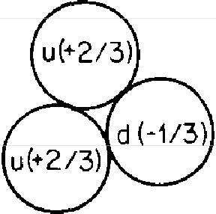
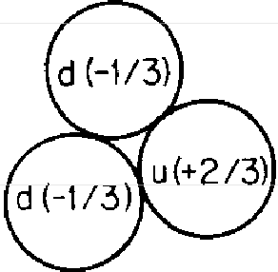
proton (+ 1 l neutron ( 0)

FIGURE 80. All particles made of quarks come in one of only two possible classes: those made of a quark and an anti-quark, and those made of three quarks, of which the proton and the neutron are the most common examples. The charge of the d and u quarks combine to make + 1 for the proton and zero for the neutron. The fact that the proton and neutron are made of charged particles going around inside them gives a clue as to why the proton has a magnetic moment higher than 1, and why the supposedly neutral neutron has a magnetic moment at all.

What holds the quarks together? Is it the photons going back and forth? (Because a d quark has a charge of - 1/3 and a u quark has a charge of + 2/3, quarks, as well as electrons, emit and absorb photons.) No, these electrical forces are far too weak to do that. Something else has been invented to go back and forth and hold quarks together; something called "gluons."4 Gluons are an example of an-
4 Notice the names: "photon" comes from the Greek word for light;

other type of particle called "spin I" (as are photons); they go from point to point with an amplitude determined by exactly the same formula as for photons, P(A to B). The amplitude for gluons to be emitted or absorbed by quarks is a mysterious number, g, that is much larger than j (see Fig. 81).

spin 1/2 part1cles
l
spin 1 particles
/1
 | photon  0 | gluon  0
eleclron  e  .511 | -1 | 0
 | 0 | 0
quork  d  -10 | -1/3 | g
quork  u  -10 | +2/3 | g

name
electron
e
5U

symbol

mass ( MeV)

couplings
FIGURE 81. "Gluons" hold quarks together to make protons and neutrons, and indirectly account for the fact that protons and neutrons hold themselves together in the nucleus of an atom. Gluons hold quarks together with forces much stronger than electrical forces. The coupling constant of gluons, g, is much larger than j, which makes the calculation of terms with couplings in them much more difficult: the best accuracy that can be hoped for so far is only 10%.

"electron" comes from the Greek word for amber, the beginning of elec-tricity. But as modern physics has progressed, the names of the particles have shown a deteriorating interest in classical Greek until we make up such words as "gluons." Can you guess why they're called "gluons?" in fact, d and u stand for words, but I don't want to confuse you-a d quark is no more "down" than au quark is "up." Incidentally, the d-ness or u-ness of a quark is called its "flavor."

The diagrams we make of quarks exchanging gluons are very similar to the pictures we draw for electrons exchang-ing photons (see Fig. 82). So similar, in fact, that you might say that the physicists have no imagination-that they just copied the theory of quantum electrodynamics for the strong interactions! And you're right: that's what we did, but with a little twist.

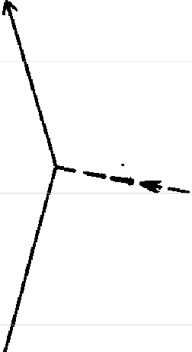
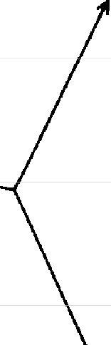
FIGURE 82. The diagram of one way that two quarks can exchange a gluon is so similar to a diagram of two electrons exchanging a photon that you might think the physicists just copied the theory of quantum electrodynamics for the "strong interactions" holding the quarks inside protons and neutrons. Well, they did-almost.

The quarks have an additional type of polarization that is not related to geometry. The idiot physicists, unable to come up with any wonderful Greek words anymore, call this type of polarization by the unfortunate name of"color," which has nothing to do with color in the normal sense. At a particular time, a quark can be in one of three conditions, or "colors"-R, G, or B (can you guess what they stand for?). A quark's "color" can be changed when the quark emits or absorbs a gluon. The gluons come in eight dif-ferent types, according to the "colors" they can couple with. For example, if a red quark changes to green, it emits a red-antigreen gluon-a gluon that takes the red from the quark and gives it green ("antigreen" means the gluon is

carrying green in the opposite direction). This gluon could be absorbed by a green quark, which changes to red (see Fig. 83). There are eight different possible gluons, such as red-antired, red-antiblue, red-antigreen, and so on (you'd think there'd be nine, but for technical reasons, one is miss-ing). The theory is not very complicated. The complete rule of gluons is: gluons couple with things having "color"-it just requires a little bookkeeping to keep track of where the "colors'' go.

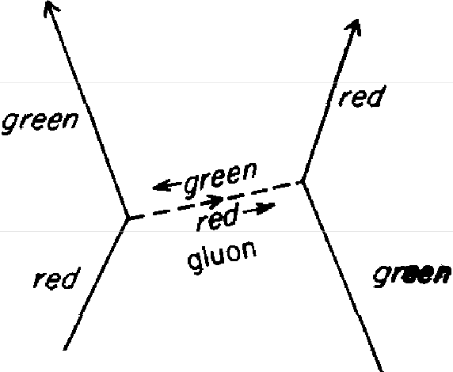
u quark d quark

u quark d quark

FIG u RE 83 . Gluon theory differs from electrodynamics in that gluons couple with things that are "colored" (m one of three possible conditions-"red," "green," and "blue"). Here, a red u quark changes to green by emitting a red-antigreen gluon that is absorbed by a green d quark changing to red. (If the "color" is being carried backwards in time, it takes the prefix "anti.")

There is, however, an interesting possibility created by this rule: gluons can couple with other gluons (see Fig. 84). For instance, a green-antiblue gluon meeting a red-anti-green gluon results in a red-antiblue gluon. Gluon theory is very simple-you just make the diagram and follow the "colors." The strengths of the couplings in all the diagrams is determined from the coupling constant for gluons, g.
Gluon theory is really not a great deal different in form from quantum electrodynamics. How, then, does it com-

pare with experiment? For example, how does the observed magnetic moment of the proton compare with the value calculated from the theory?
The experiments are very accurate-they show the mag-netic moment to be 2.79275. At the very best, the theory

"I'
I red-ontiblue
lrtJ,�
I

,,./
I
/'",
/41/. ' ',-1=>
'
/
/ �
� ..

// 6 ',
red-'onl1green

green- ant,blue

FIGURE 84. Since gluons are themselves "colored," they can couple to each other. Here a green-antiblue gluon couples with a red-antigreen gluon to form a red-antiblue gluon. Gluon theory is easy to understand-you just follow the "colors."

can only come up with 2.7 plus or minus 0.3-if you're sufficiently optimistic about the accuracy of your analysis-an error of 10% which is 10,000 times less accurate than experiment! We have a simple, definite theory that is sup-posed to explain all the properties of protons and neutrons, yet we can't calculate anything with it, because the math-ematics is too hard for us. (You can guess what I'm working on, and I'm not getting anywhere.) The reason we can't calculate to any great accuracy is because the coupling con-stant for gluons, g, is so much larger than for electrons. Terms with two, four, and even six couplings are not just minor corrections to the main amplitude; they represent considerable contributions that can't be ignored. Thus there are arrows from so many different possibilities that we haven't been able to organize them in a reasonable way to find out what the final arrow is.

In lx>oks it says that science is simple: you make up a theory and compare it to experiment; if the theory doesn't work, you throw it away and make a new theory. Here we have a definite theory and hundreds of experiments, but we can't compare them! It's a situation that has never before existed in the history of physics. We're boxed in, tempo-rarily, unable to come up with a method of calculation. We're snowed under by all the little arrows.
Despite our difficulties in calculating with the theory, we do understand some things qualitatively about quantum chromodynamics (strong interactions of quarks and gluons). The objects made of quarks that we see are "col-ored" neutral: groups of three quarks contain one quark of each "color," and quark-antiquark pairs have an equal amplitude to be red-antired, green-antigreen, or blue-an-tiblue. We also understand why quarks can never be pro-duced as individual particles-why, no matter how much energy is used to hit a nucleus against a proton, instead of seeing individual quarks come out, we see a jet of mesons and baryons (quark-antiquark pairs and groups of three quarks).
Quantum chromodynamics and quantum electrody-namics aren't all there is to physics. According to them, a quark cannot change its "flavor": once a u quark, always a u quark; once a d quark, always a d quark. But Nature behaves differently, sometimes. There is a form of radio-activity that happens slowly-the kind that people worry about leaking out of nuclear reactors----called beta decay, which involves a neutron changing into a proton. Since a neutron consists of two d's and a u-type quark while a pro-ton is made of two u's and ad, what really happens is that one of the neutron's d-type quarks changes into a u-type quark (see Fig. 85). Here's how it happens: the d quark emits a new thing like a photon called a W, which has a coupling with an electron and with another new particle

called an anti-neutrino, a neutrino going backwards in time. The neutrino is another spin 1/2 type particle (like the electron and the quarks), but it has no mass and no charge (it does not interact with photons). It also does not interact with gluons; it only couples with the W (see Fig. 86).

u(+2/3l

d(-1/3)
neutrino electron
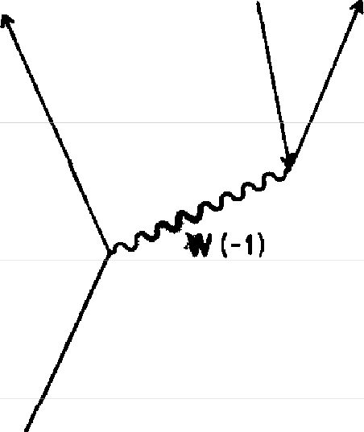
11(0) e(-1)

Jib-�
neutron proton

FIGURE 85. When a neutron disintegrates into a proton (a process called "beta decay"), the only thing that changes is the "flavor" of one quark-from d to u-with an electron and an anti-neutrino coming out. This process happens relatively slowly, so an intermediate particle (called a "W-znterme-diate-boson") with a very high mass (about 80,000 MeV) and a charge of
-1 was proposed

The W is a spin I type particle (like the photon and the gluon), that changes the "flavor" of a quark and takes away its charge-the d, charged -1/3, changes into au, charged

+2/3, a difference of -1. (It doesn't change the quark's "color.'') Because the W _ takes away a charge of -1 (and its anti-particle, the W+, takes away a charge of +l), it can also couple with a photon. Beta decay takes much longer than the interactions of photons and electrons, so it is thought that the W must have a very high mass (about 80,000 MeV), unlike the photon and gluon. We have not been able to see

the W by itself because of the very high energy required to knock loose a particle with such a very high mass.5
There is another particle, which we could think of as a neutral W, called Z₀. The Z₀ does not change the charge of a quark, but does couple with a d quark, a u quark, an

spin 1 particles

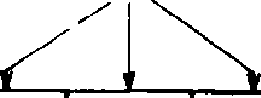
name
spin 1/2 particles
photon gluon w
0 0 80
neulrmo
Ve
0
qtJOrk
d
-10
quark
u +2/3 g
-10
g
-1/3
0
0

0
-1
electron
e
511

symbol
elec1ron
e
511

moss (MeV

couplings

FIGURE 86. The W couples with the electron and neutrino on the one hand, and the d and u quark on the other.

electron, or a neutrino (see Fig. 87). This interaction has the misleading name of "neutral currents," and caused a lot of excitement when it was discovered a few years ago. The theory of W's is nice and neat if you allow for a three-way coupling between the three types of W's (see Fig. 88). The observed coupling constant for W's is much the same as that for the photon-in the neighborhood of j.

5 After these lectures were given, high enough energies were achieved to produce a W by itself, and its mass was measured to be very close to the value predicted by the theory.

u(+2/3l d(-1/3)
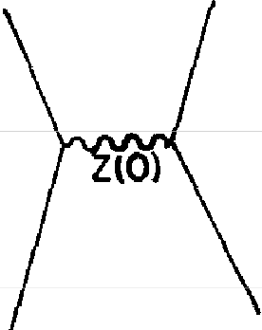
u(+2/3) d(-1/3)
v(Ol e(-11

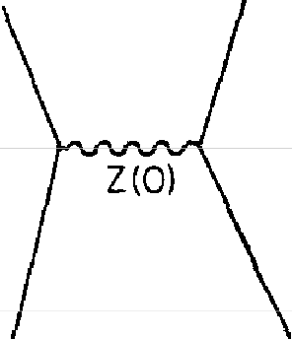
e(-1)

FIGURE 87. When there is no change m the charge of any of the particles, the W also ha.s no charge (it is called Z₀ in this case). Such interactions are called "neutral currents." Two possibilities are shown here.

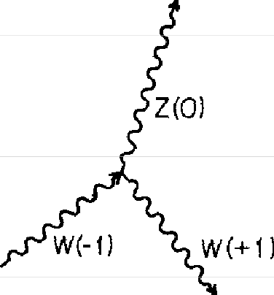
FIGURE 88. A coupling between a W -J. its anh-partide (a W+ 1, and a neutral W {Z₀) is possible. The coupling constant for W's is in the neighborhood of j, suggesting that W's and pho-tons may be different aspects of the same thing.

Therefore the possibility exists that the three W's and the photon are all different aspects of the same thing. Stephen Weinberg and Abdus Salam tried to combine quantum electrodynamics with what's called the "weak interactions" (interactions with W's) into one quantum theory, and they did it. But if you just look at the results they get you can see the glue, so to speak. It's very clear that the photon and the three W's are interconnected somehow, but at the present level of understanding, the connection is difficult to see clearly-you can still see the "seams" in the theories; they have not yet been smoothed out so that the connection becomes more beautiful and, therefore, probably more correct.
So there you are: quantum theory has three main types

of interaction-the "strong interactions" of quarks and gluons, the "weak interactions" of the W's, and the "elec-trical interactions" of photons. The only particles in the world (according to this picture) are quarks (in "flavors" u and d with three "colors'' each), gluons (eight combinations of R, G, and B), W's (charged ± 1 and 0), neutrinos, elec-trons, and photons-about twenty different particles of six different types (plus their anti-particles). That's not so bad-about twenty different particles-except that's not all. As nuclei were hit with protons of higher and higher energies, new particles kept coming out. One such particle was the muon, which is in every way exactly the same as the electron, except that its mass is much higher-I 05.8 MeV, compared to 0.511 for the electron, or about 206 times heavier. It's just as if God wanted to try out a different number for the mass[ All of the properties of the muon are completely describable by the theory of electrody-namics-the coupling constant} is the same and E(A to B)
is the same; you just put in a different value for n.6 Because the muon has a mass about 200 times higher
than the electron, the "stopwatch hand" for a muon turns 200 times more rapidly than that of an electron. This has enabled us to test whether electrodynamics still behaves according to the theory at distances 200 times smaller than we've been able to test before-although these distances
6 The magnetic moment of a muon has been measured very accurately-it has been found to be I 001165924 (with an uncertaint, of 9 in the last digit), while the value for the electron is 1.00115965221 (wtth an uncer-tainty of 3 m the last digit). You might be curious as to why the magnetic moment of the muon is slightly higher than that of the electron. One of the diagrams we dr-ew had the electron emitting a photon that disinte-grates mto a positron-electron pair (see Fig. 89). There ts also a small am-plitude that the emitted photon could make a muon-antimuon pair, which 1s heavier than the original electron This is unsymmetrical, because when the muon emits a photon, 1f that photon makes a positron-electron pair, that pair is lighter than the original muon. The theory of quantum electro-dynamics accurately describes every electncal property of the muon as well as the electron.

2

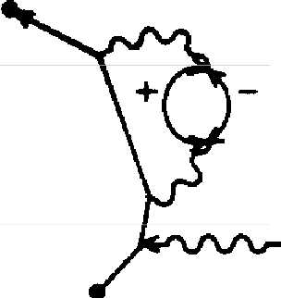
electron - positron or
muon - onl1muon pair

electron or muon

FIGURE 89. In the process of bombarding nuclei with protons of higher and higher enerFJ:Y, new particles appear. One of these particles is the muon, or heavy electron. The theory describing the muon's interactions is exactly the same as for the electron, except that you just put in a higher number for n into E(A to BJ. The magnetic moment of a muon should be slightly different than that of an electron because of two particular alternatives: when the electron emits a photon that disintegrates into an electron-positron or muon-antimuon pair, the disintegration creates a pair that is close to or much heavier in mass than the electron. On the other hand, when the muon emits a photon that disintegrates into a muon-antimuon or positron-electron pair, this pair is close to or much lighter in mass than the muon. Experiments confirm this slight difference.

are still more than eighty decimal places larger than the distances at which the theory alone might run into trouble with infinities (see footnote on p. 129).
We have learned that an electron can couple with a W (see Fig. 85). When ad-quark changes into au-quark, emitting a W, can the W then couple with a muon instead of an electron? Yes (see Fig. 90). And what about the anti-neutrino? In the case of the W coupling with a muon, a particle called a mu-neutrino takes the place of the ordinary neutrino (which we will now call an electron neutrino). So now our table of particles has two additional particles next to the electron and the neutrino-the muon and the mu-neutrino.
What about the quarks? Very early on, particles were known that had to be made of heavier quarks than u or d. Thus a third quark, called s (for "strange") was included

in the list of fundamental particles. The s quark has a mass of about 200 MeV, compared to about 10 MeV for the u and d quarks.

u(+2/3)
(mu-neutrino)
z,,fL(Ol µH)(muon)

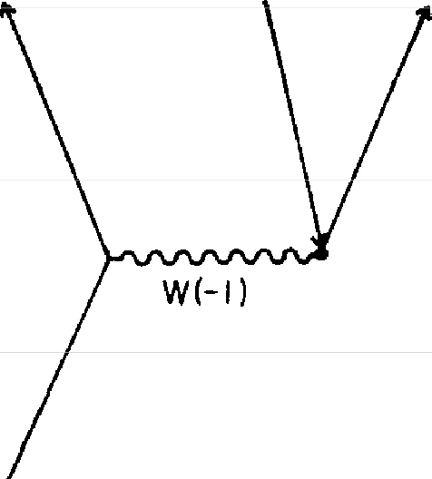
d(-1/3)
F1cuRE 90. The W has an amplitude to emit a muon instead of a11 tl«tron.
In this case a mu-neutrino talus the place of an electron-neutrino.

For many years we thought that there were just three "flavors" of quarks-u, d, ands-but in 1974 a new particle called a psi-meson was discovered that could not be made out of the three quarks. There was also a very good the-oretical argument that there had to be a fourth quark, coupled to the s quark by a W in the same way that the u and d quark are coupled (see Fig. 91). The "flavor" of this quark is called c, and I haven't got the guts to tell you what c stands for, but you may have read it in the newspaper. The names are getting worse and worse!
This repetition of particles with the same properties but
heavier masses is a complete mystery. What is this strange duplication of the pattern? As Professor I. I. Rabi said of the muon when it was discovered, "Who ordered that?"
Recently another repetition of the list has begun. As we

spm 1
spin1/2 particles particles


name
photon gluon w
0 0
µ.
105 8
neutrino neutrmo
'NOil
11,_,.
0
quork
s
~200
quark
C
~1800
lie
0
quork
d
-10
quorll
u
-10
+2/3 g
0

g
0

-1/3
0
-1
eleclron
e
511

symbo!-
electron
e
5U

moss(MeV

coupltngs

FIG URE 91. Nature seems to be repeating the spin 112 particles. In addition to the muon and mu-neutrino, there are two new quarlu-s and c-that have the same charge but higher masses than their counterparts in the next column.

go to higher and higher energies, Nature seems to keep piling on these particles as if to drug us. I have to tell you about them because I want you to see how apparently com-plicated the world really looks. It would be very misleading if I were to give you the impression that since we've solved 99% of the phenomena in the world with electrons and photons, that the other 1% of the phenomena will take only I% as many additional particles! It turns out that to explain that last 1%, we need ten or twenty times as many additional particles.
So here we go again: with even higher energies used in the experiments, an even heavier electron, called the "tau," has been found; it has a mass of about 1,800 MeV, heavy as two protons! A tau-neutrino has also been inferred. And now a funny particle has been found implying a new "fla-vor" of quark-this time it's "b," for "beauty," and it has a

charge of - 1/3 (see Fig. 92). Now, I want you to become high-class, fundamental theoretical physicists for a mo-ment, and predict something: a new flavor of quark will be found, called_ (for" "), with a charge of_, a mass of_ MeV-and we certainly hope it's true that it's therel7

spin 1
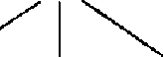
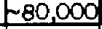
spin 1/2 particles particles
photon gluon w
0 0
tau muon
T
~1860
µ
105 8
neutrino neutrino
ZIT ZI,-;.
0 0
quark quark
b s
~4800 ~200
quark quark
C u +2/3 g
~1800 -10
g
-1/3
quark
d
-10
0
0
neutrino
lie
0
0
-1
electron
e
.511

name

symbol
electron
e
511

mass ( MeV)

couplings

FIGURE 92. Here we go again! Another repetition of the spin 112 particles has begun at even higher energies. This repetition will be complete if a particle with the right properties to imply the existence of a new flavor of quark is
found. Meanwhile, preparations are underway to look for the beginning of yet another repetition at even higher energies. What causes these re�titions is a complete mystery.

Meanwhile, experiments are being done to see if the cycle repeats yet again. At the present time machines are being built to look for an even heavier electron than the tau. If the mass of this supposed particle is 100,000 MeV, they won't be able to produce it. If it is around 40,000 MeV, they might make it.
7 Since these lectures were given, some evidence has been found for the existence of a t quark with a very high mass-around 40,000 MeV.

Mysteries like these repeating cycles make it very inter-esting to be a theoretical physicist: Nature gives us such wonderful puzzles! Why does She repeat the electron at 206 umes and 3,640 times its mass?
I'd like to make one last remark to make things absolutely complete about the particles. When ad quark coupling to a W changes into a u quark, it also has a small amplitude to change into a c quark instead. When au quark goes to a d quark, it also has a small amplitude to change into an s quark, and an even smaller amplitude to change into a b quark (see Fig. 93). Thus the W "screws things up" a little

u (orcl!+2/3l c(oru){+2/3)

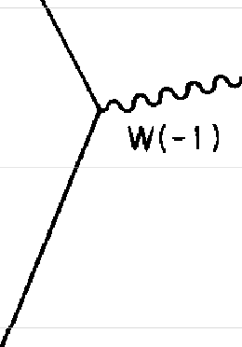
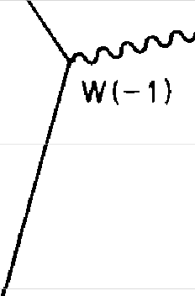
d(-1/3) s(-1 /3)

FIGURE 93. A d quark has a small amplitude to change into a c quark instead of a u quark, and an s quark has a small amplitude to change into a u quark instead of a c quark, with the emission of a W in both cases Thus the W seems to be able to change a quark's flavor from one column of the table to another (see Fig 92)

bit and allows quarks to change from one column of the table to another. Why the quarks have these relative pro-portions for their amplitude to change to another type of quark is utterly unknown.
So that's everything about the rest of quantum physics. It's a terrible mix-up, and you might say it's a hopeless mess physics has got itself worked into. But it has always looked

like this. Nature has always looked like a horrible mess, but as we go along we see patterns and put theories together; a certain clarity comes and things get simpler. The mess l just showed you is much smaller than the mess I would have had to make ten years ago, telling you about the more than four hundred particles. And think about the mess at the beginning of this century, when there was heat, magnetism, electricity, light, X-rays, ultraviolet rays, indices of refrac-tion, coefficients of reflection and other properties of var-ious substances, all of which we have since put together into one theory, quantum electrodynamics.
I would like to emphasize something. The theories about the rest of physics are very similar to the theory of quantum electrodynamics: they all involve the interaction of spin 1/2 objects (like electrons and quarks) with spin 1 objects (like photons, gluons, or W's) within a framework of am-plitudes by which the probability of an event is the square of the length of an arrow. Why are all the theories of physics so similar in their structure?
There are a number of possibilities. The first is the lim-ited imagination of physicists: when we see a new phenom-enon we try to fit it into the framework we already have-until we have made enough experiments, we don't know that it doesn't work. So when some fool physicist gives a lecture at UCLA in 1983 and says, "This is the way it works, and look how wonderfully similar the theories are," it's not because Nature is really similar; it's because the physicists have only been able to think of the same damn thing, over and over again.
Another possibility is that it zs the same damn thing over and over again-that Nature has only one way of doing things, and She repeats her story from time to time.
A third possibility is that thmgs look similar because they are aspects of the same thing-some larger picture under-neath, from which things can be broken into parts that look

different, like fingers on the same hand. Many physicists are working very hard trying to put together a grand pic-ture that unifies everything into one super-duper model. It's a delightful game, but at the present time none of the speculators agree with any of the other speculators as to what the grand picture is. I am exaggerating only slightly when I say that most of these speculative theories have no more deep sense to them than your guess about the pos-sibility of a t quark, and I guarantee you that they are no better at guessing the mass of a t quark than you are!
For example, it appears that the electron, the neutrino, the d quark, and the u quark all go together-indeed, the first two couple with the W, as do the last two. At present it is thought that a quark can only change "colors" or "fla-vors." But perhaps a quark could disintegrate into a neu-trino by coupling with an undiscovered particle. Nice idea. What would happen? That would mean protons are unstable.
Somebody makes up a theory: The proton is unstable. They make a calculation and find that there would be no protons in the universe anymore! So they fiddle around with the numbers, putting a higher mass into the new par-ticle, and after much effort they predict that the proton will decay at a rate slightly less than the last measured rate the proton has been shown not to decay at.
When a new experiment comes along and measures the proton more carefully, the theories adjust themselves to squeeze out from the pressure. The most recent experi-ment showed that the proton doesn't decay at a rate that is five times slower than what was predicted in the last stand of the theories. What do you think happened? The phoenix just rose again with a new modification of the theory that requires even more accurate experiments to check it. Whether the proton decays or not is not known. To prove that it does not decay is very difficult.

In all of these lectures I did not discuss gravitation. The reason is, gravitational influence between objects is extremely small: it is a force that is weaker by 1 followed by 40 zeros than the electrical force between two electrons (perhaps it's 41 zeros). In matter, nearly all of the electrical forces are spent holding the electrons close to the nucleus of their atom, creating a finely balanced mixture of pluses and mi-nuses that cancel out. But with gravitation, the only force is attraction, and it keeps adding and adding as there are more and more atoms until at last, when we get to these ponderously large masses that we are, we can begin to meas-ure the effects of gravity-on planets, on ourselves, and so on.
Because the gravitational force is so much weaker than any of the other interactions, it is impossible at the present time to make any experiment that is sufficiently delicate to measure any effect that requires the precision of a quantum theory of gravitation to explain it.8 Even though there is no way to test them, there are, nevertheless, quantum the-ories of gravity that involve "gravitons" (which would ap-pear under a new category of polarizations, called "spin 2"), and other fundamental particles (some with spin 3/2). The best of these theories is not able to include the particles that we do find, and invents a lot of particles that we don't find. The quantum theories of gravity also have infinities in the terms with couplings, but the "dippy process" that is successful in getting rid of the infinities in quantum elec-trodynamics doesn't get rid of them in gravitation. So not only have we no experiments with which to check a quan-tum theory of gravitation, we also have no reasonable theory.

8 When Einstein and others tried to unify gravitation with electrody-namics, both theories were classical approximations. In other words, they were wrong. Neither of these theories had the framework of amplitudes that we have found to be so necessary today.

Throughout this entire story there remains one espe-cially unsatisfactory feature: the observed masses of the particles, m. There is no theory that adequately explains these numbers. We use the numbers in all our theories, but we don't understand them-what they are, or where they come from. I believe that from a fundamental point of view, this is a very interesting and serious problem.
I'm sorry if all this speculation about new particles con-fused you, but I decided to complete my discussion of the rest of physics to show you how the character of those laws-the framework of amplitudes, the diagrams that represent the interactions to be calculated, and so on-appears to be the same as for the theory of quantum electrodynamics, our best example of a good theory.
Note Added in Proofreading, November 1984:
Since these lectures were given, suspicious events observed in experiments make it appear possible that some other particle or phenomenon, new and unexpected (and there-fore not mentioned in these lectures), may soon be discovered.
Note Added in Proof reading, April 1985:
At this moment, the "suspicous events" mentioned above appear to be a false alarm. The situation no doubt will have changed again by the time you read this book. Things change faster in physics than in the book publishing business.

Index

actions: fundamental, 90, 114; three basic, ll0
alternative ways, 37, 59, 63, 78, 82 amplitude: arrow, 68; changes,
102; for a coupling, 92;J, 121; P(A to B), 121; for photon ex-change, 100; probability, 33
Anderson, Carl, 98
angle: of incidence, 38; relative, 30,32
arrow(s): adding, 26, 53, 56, 83;
amplitude, 68; combining, 83,
85, 124; drawing, 37; final, 59;
identical, I 12; multiplying, 63;
radius, 106; reflection, 27-32,
71; representing probabilities,
25; transmission, 71; unit, 60-
65, 68-69, 82
atom(s): helium, I 13; hydrogen, 100, 113; lithium, 113; oxygen,
5; sodium, 48 atomic bomb, I 32
b quark, 148
baryons, 132
Bell Laboratories, 84
beta decay, 139-40, 144
Bethe, Hans, 128

c (speed oflight), 87, 89--90
c quark, 148
charge: calculated, l 27; electric, 84; observed, 128; of quarks, 134
chemical properties, 113 chemistry, fundamental theoreti-
cal, 5
chromodynamics, quantum, 139
"color": ofgluons, 137; ofquarb,
136
colors, 33, l 13
complex numbers, 63
compound events, 59
conditions: final, 81; initial, 81
coupling: amplitude for, 92, 130; d
quark, 148; observed, 129;
three-way, 14 I
coupling constant: for gluons, 137;
j, 120, 130, 143; with a muon,
W, 144; for W's, 141, 142
crystal: nickel, 84; salt, 48, 49
currents, neutral, 141, 142
cycle, repeating, 22, 33

d quark, 133-41, 145, 148, 150
Davisson, C. J., 84
De Broglie, Louis, 84; formula, 84
decay, beta, 139, 140, 144
diagrams, 118
difference, time, 89
diffraction: grating, 46-49, 59; through a small hole, 55
Dirac, Paul, 6, 98, 115; theory, 6
duality, wave-particle, 23, 37
dynamite, exploding, 132

E (A to B), formula for, 91 eclipses, lunar, 11
Eddington, Arthur, 130 Einstein, Albert, 112; theory of
relativity, 5, 87, 89
electricity and magnetism: Max-well's theory of, 5; quantum the-ory of, 7

electrodynamics, quantum, see quantum electrodynamics theory
electromagnetic potentials, scalar, 123; vector, 123
electron(s): backwards-moving, 98;
exchanging photons, 100, 136;
fake, 90; heavy, 146, 147; mag-
netic moment of, 7, 115, 118;
moving, 98, 123; neutrino, 144-
45; patterns, 132; polarization
of, 120; relativistic theory of, 6; spin-zero, 112; theory of matter, 4; wavelike character of, 84
electron-positron pair, 126
energies, negative, 129 event(s): analyzing, 75; com-
pound, 60; observed physical, 83; probability cf an, 37, 63;
suspicious, 151
exchanges, photon, 95, 100, 107,
114
exclusion principle, 112-13
experiment(s): high-energy, 132;
laboratory, 116-17; low-energy,
132; measuring reflection, 28; results of Newton's, 23
eye, human, 14

final conditions, 81-82
"flavor," 150; of quarks, 135
focusing lens, 16, 58, l 09
force(s): electrical, 113, 134-35,
151; gravitational, 151; nuclear,
131
formula: De Broglie's, 84; for E (A to B), 91, 132; for P (A to B), 88, 90-91
Franklin, Benjamin, 134

gamma rays, 13
Gell-Mann, Murray, 132 Germer, L. H., 84
glass: opaque, 110; thick sheet of, 30, 105; thin sheet of, 20, 95;
transparent, 110; scatters, l 07
gluon(s), 134-38; color of, 137;
coupling constant, 135, 137; quarks exchanging, 136; theory, 137-38
grating, diffraction, 46-48, 59 gravitation, theory of, 4 gravitons, 151
gravity, quantum theories of, 15 l Greeks, point of view of, 61

Hanbury-Brown-Twiss effect, 75
heat phenomena, 4 history, of physics, 6
holes: and spots theory, 18; tiny, 78-79,85
holograms, 48
hummingbirds, 34

/ (the "interval"), 88-90
ideas: old-fashioned, 56; of quart· tum mechanics, 3; revolution-ary, 55
incidence, angle of, 38 Indians, Maya, 11
infinities, l 27, 151
initial conditions, 81
initial state, 82
interaction(s): "color"-changing, 136; electrical, 143; of light and matter, theory of, 6; strong, 136; types of, 142; weak, 142,
143
interference: colors, 33; effects, 81; principle of, 81, 83
interval, /, 88-90
iridescence, 34
irrational numbers, 63

j, 91, 120-21, 125-30, 143; value
of, 91
junction number, J, 91, 120-21,
125-30, 143

knowledge, precise, 55

lambda particle, 132
lasers, 112
laws: mechanical, 5; of Nature,
89; Newton's, 5
lens, focusing, 16, 58, 109
light, 13, 23; blue, 33; dim, 14, 15; in everyday circumstances, 15; infrared, 13; particles of, 36; photon model of, l I 2; speed of, c, 87, 89-90; speed of, in water and air, 51; ultraviolet, 13,149; weak monochromatic, 36; white, 35,102
line: unit, 62; wavy, 88, 91, 92,
95, 105
lines, multiplying, 62
lithium metal conducting electric-ity, 113
location: physical, 105; relative, 110

m and e, observed values, 127 magic number, 96, 129
magnetic field, 98, 115, 123
magnetic interaction, 131 magnetic moment: of electron, 7,
115, ll8;ofneutron, l3l;of
proton, 131, 138
mass(es): calculated (n), 127; of heavier particles, 145; of muon, 143; number, 133; observed
(m), 151-52; oft quark, 147; of
tau, 146; of W, 140 material: opaque, 108; reflec-
tive, 18
mathematicians, 63
matter, electron theory of, 4 Mautner, Alix, 3
Maxwell, James Clerk, 4; theory, 5
Maya Indians, 11
mesons, 132
MeV, 133
mirage, 52
mirror, 15, 38; etched, 47
monochromatic source, 101-102,
106
motion, phenomena of, 4 mu-neutrino, 144
muon(s), 143-44; mass of, 143; W
coupling with a, I 44
muon-antimuon pair, 143-44

n, 125
n and j, calculated numbers, 125 Nature: analysis of, 78; laws of,
89; particle in, 98; phenomenon
of, 84; strangeness of, 80; vari-
ety in, 110
neutral currents, 141, 142
neutral W, 141
neutrino, electron, 144, 145
neutrons, 131
New Zealand, 3
Newton,Sirlsaac,5, 13-14, 18,
21-23,37,85
nuclear: forces, 131; particles, 9,
131; phenomena, 8, 77; physics,
8; reactors, 139
nucleus, 5; atomic, 7; exchanging
photons, 113
number(s): complex, 63; irra-tional, 63;junction (j), 91; mass (m), 133; m and e, 126--28; mys-terious, 126, 130, I 35; n and J,
125-30

oil film, 33, 35
opaque material, 108
optical phenomena, 49

P (A to B), formula for, 88, 90 pair(s): muon-antimuon, 143, 144;
positron-electron, 116,119,126,
143; quark-antiquark, 139
partial reflection, 15-25, 36, 47,
64,66,69, 72, 75, 77, 100-110;
colors produced by, 33; de-pending on thickness of glass, 22, 34; of many surfaces, 22;

partial reflecbon (cont ) suggested theones for, 18, by two surfaces, 24, wave theory of, 22
part1cle(s) fundamental, 132, 145,
151, mdlVldual, 139, intermedi-ate, 140, of hght, 36, hght be-haves hke, 13, 15, m Nature,
98, nuclear, 9, 131, repetmon of, 145, spm l, 140, spm l/2, 121, 133, 140, 146-47, stauon-
ary, 100, undiscovered, 150 path(s) definite, 85, of least time,
52, ne1ghbormg, 45, 53-55,
123, stra1ght-lme, 53-55 patterns electron, 132, proton-
neutron, 132
peacocks, 34
phenomena at the atomic level, 5, celestial, 11, familiar, 16, 38, of heat, 4, of motion, 4, of Na-ture, 84, nuclear, 8, 77, opucal, 49, that QED theory descnbes, 7, rad10act1ve, 8, simplest, 82, ofsound,4
ph1losoph1cal wornes, 124
phonograph record, 48
photographic plates, 13
photomulupher, 14
photon, 14, 36, bouncing, 28-29, detecung a smgle, 14, d1v1des, 80, emmed, 143, exchanges, 95,
100, 107, 113-14, 136, front re-
flection, 29, 1dent1cal, 19, in-coming, l O I, model of hght, 112, reflecung, 30--31, relauon
to W's, 142, virtual, 95, 120 physical event, observed, 83, loca-
tmn, 105, world, 8
phys1C1st(s), theoretical, 129, 147-
48
physics classical, 123, 1s probab1-hstic, 19, hqmd-state, 114, nu-
clear, 8, quantum, 55, 78, 148,
sohd-state, 114, students of, 9,
75, theoretical, 82
p10ns, 132
points, coupling, 127-28
polanzauon, 13, 120, of electrons,
120, of photons, 120
positron, 98
positron-electron pair, 116-17,
119, 143
pred1Ct1ons, absolute, 25
probab1hty(1es) amphtude, 33, 37, calculatmg, 78, essential m quantum physics, 19, of an event, 37, 63, as the square of an amplitude, 24, 37
proton(s), 131, exchanging pho-tons, 113, and neutrons, theory of, 138, observed magneuc mo-ment of, 138, stab1hty of, 150
proton-neutron patterns, 132
psi-meson, 145
Pythagoras, 31
Pythagorean Theorem, three-d1-mens10nal, 89

QED,4
quantum chromodynamICs, 132,
139
quantum electrodynamics theory accuracy of, 7, expenments to test, 8, shocking charactensuc of, 124, structure of, 131, unsat-isfactory feature of, 151
quantum mechantcal behavior, 85 quantum mechanics, ideas of, 3,
5,40
quantum physICs, 55, 78, 148
quantum theory, 7, 39, 50, 53, cal-culating probab1ht1es in, 24, of electnc1ty and magnetism, 7, of gravity, 151, of strong interac-tions, 132
quark(s), 132, b, 148, c, 148, "color" of, I 36, coupling to a W, 148, d, 133-41, 145, 148,
150, exchanging gluons, 136,
"flavor" of, 135, heavier, 144,
isolated md1v1dual, 139, s, 145,

148, t, 147, 150, u, 133-41, 144,
148, 150
quark-ant1quark pa1rs, 139

Rabi, I I , 145
rad10 waves, 13, 34, 75
rad1oact1ve phenomena, 8, 144
radms arrow, 106
rays gamma, 13, ultraviolet, 149,
X-, 13
reactions, chemical, 114 reduct10n, of a wave packet, 76 reflecuon arrow, 28-32, 71, back,
29, front, 28, front surface, 66,
partial, 16-25, 36, 47, 64, 66,
69, 72, 75, 77, I00---110, surface,
31, 60
reflective material, 18
refracuon, 49
relat1v1st1c theory of the electron, 6 relat1v1ty Emstem's theory of, 5,
87, 89, pnnctple of, 121
renormahzauon, 128 repeuuon of particles, 145 rho meson, 132
rules that fad, 85, peculiar, 78, for quantum calculations, 37

s quark, 145, 148
Salam, Abdus, 142
salt crystal, 48-49
scattering, 100, 105-107
Schwmger,Jultan, 6, 15, 116, 128
sigma particle, 132
soap bubbles, 33
sodmm atoms, 48, streetlights, 35
solar systems, 84
sound, phenomena of, 4 space, three-d1mens10nal, 89
space-ume, 85-86, 99, I IO, draw-
ing, 107,graph,88, 105
spm, 121
spm l parudes, 135, 140
spm 1/2 parudes, 133, 140, 146--
47,149
spm 2 parucles, 122
spm 3/2 particles, 151
spm-zero electrons, 112, parucles, 93
square absolute, 63, of an ampli-tude, 37
steps, successive, 64, 67, 82
stopwatch, 1magmary, 27, 101-102 subevents concomitant, 93, sim-
pler, 83
successive steps, 64, 67, 82, trans-
formauons, 62, 63, turnmgs, 69,
turns, 63
surface(s) back, l05, 107, front,
105, 107, grooved, 48-49, re-flect10n, 31, partial reflection by two or more, 19, transm1ss10n through, 17
t quark, 147, 150 tau, mass of, 146 telev1S1on waves, 13
theory(1es) Dirac's, 6, electron, 4, gluon, 137-38, of gravttauon, 4, of gravity, quantum, 151, of holes and spots, 18, of the m-teracuon of hght and malter, 6, Maxwell's, 5, quantum, see quantum theory, of quantum electrodynamics, see quantum electrodynamics theory, of quantum mechanics, 5, relauv-1suc, 6, of relat1V1ty, 5, 87, 89, stmilanty of vanous, 149, spec-u)auve, 150, of strong mterac-uons, 138, umficauon of, 150,
of W's, 141, wave, 23, 26, of weak and electromagnetic forces, 142
ume curve, 57, difference, 88-89,
path of least, 52, scale, 87-88, on the vertical axis, 86
Tomonaga, Sm-Iuro, 6, 128
transformations, successive, 62-63 transm1ss10n arrows, 71, through
a surface, 17
transparent matenals, 108,110,113

